

**Capstone Project Report**

**Report 4 – Software Design Document**

– Ho Chi Minh, January 2021 –

**Table of Contents**

I. Project Report 3

1. Status Report 3

2. Team Involvements 3

3. Issues/Suggestions 3

II. System Requirement Specification 4

1. Overall Description 4

1.1 Product Overview 4

1.2 Business Rules 5

2. User Requirements 9

2.1 Overview 9

2.2 User case specification 11

3. Other Requirements 57

3.1 Messages List 57

# I. Project Report

## 1. Status Report

|  |  |  |  |
| --- | --- | --- | --- |
| **#** | **Work Item** | **Status** | **Notes (Work Item in Details)** |
| 1 | Overall Description |  |  |
| 2 | User Requirements |  |  |
| 3 | Functional Requirements |  |  |
| 4 | Non-Functional Requirements |  |  |
| 5 | Others Requirements |  |  |

## 2. Team Involvements

|  |  |  |  |
| --- | --- | --- | --- |
| **#** | **Task** | **Member** | **Notes (Task Details, etc.)** |
| 1 | Overall Description |  |  |
| 2 | User Requirements |  |  |
| 3 | Functional Requirements |  |  |
| 4 | Non-Functional Requirements |  |  |
| 5 | Others Requirements |  |  |

## 3. Issues/Suggestions

|  |  |  |  |
| --- | --- | --- | --- |
| **#** | **Issue** | **Status** | **Notes (Solution, Suggestion, etc.)** |
| 1 |  |  |  |

# III. System Requirement Specification

## 1. Overall Description

### 1.1 Product Overview

#### Unauthenticated User Requirements

Unauthenticated user who has not been identified by CFFA system. Unauthenticated user has limited access to the system with the following feature:

* Login

#### Authenticated User Requirements

Authenticated User who has been logged into the CFFA system. Authenticated user can use the following functions:

* Logout
* Change account's password
* Watch the video
* Save the video
* Delete the video
* View the reports
* View report detail
* Export the report file

#### Manager Requirements

Manager is a person who accesses to the system as manager role. Manager can use the following functions:

* View the shelves
* View shelf detail
* Search the shelf
* Create new shelf
* Update the shelf
* Delete the shelf
* View the stacks
* View stack detail
* Search the stacks
* Create new stack
* Update the stack
* Delete the stack
* View the products
* View product detail
* Search the products
* Create new product
* Update the product
* Delete the product
* View the cameras
* View camera detail
* Search the cameras
* Create new camera
* Update the camera
* Delete the camera
* View the categories
* Create new category
* Update the category
* Delete the category

#### Admin Requirements

Admin is a person who accesses to the system as admin role. Admin can use the following functions:

* View the managers
* View manager detail
* Search the manager
* Create new manager
* Update the manager
* Delete the manager
* View the accounts
* View account detail
* Search the account
* Create new account
* Update the account
* Delete the account
* View the stores
* View store detail
* Search the store
* Create new store
* Update the store
* Delete the account
* Send the mail to the manager

#### Camera Requirements

Camera is an actor which can do:

* Send the videos to the server

#### System AI Requirements

System AI is an actor which can do:

* Analyze facial expression
* Detect the "hotspot"

### 1.2 Business Rules

|  |  |
| --- | --- |
| ID | Rule Definition |
| BR-001 | User logs in using username and password are registered. If the username and password are correct, CFFA system redirects users to corresponding home page:   * User logs in as “manager” role, CFFA system will display the manager's home page. * User logs in as “admin” role, CFFA system will display the admin's home page. |
| BR-002 | After logging in as "manager" role, if the manager has not yet mapped to any store, CFFA system will display the "You don't have a store to manage" message and log out CFFA system. |
| BR-003 | The newly created manager's status is active. |
| BR-004 | After logging out successfully, user becomes the “Unauthenticated User” and CFFA system will direct to login page. |
| BR-005 | JSON web token will be removed on the client-side. |
| BR-006 | Cookies will be destroyed on the client-side. |
| BR-007 | The password must be SHA256 encrypted before sending it to the server. |
| BR-008 | Exporting a file is PDF format for the user with the file name is current time that has hh:mm-DD/MM/YY format and store name separated by '_'. |
| BR-009 | CFFA system only allows users to download the report which has data. |
| BR-010 | CFFA system only allows users to play video that has been analyzed and stored. |
| BR-011 | CFFA system only allows to play the "hotspots" on a specific shelf or the emotions on a specific shelf/stack/product/camera video. |
| BR-012 | Password must be at least 8 characters and must contain the following:   * At least one uppercase letter * At least one lowercase letter * At least one digits |
| BR-013 | Time must be hh:mm dd/mm/yyyy format. |
| BR-014 | Shelf combobox can select multiple values that include:   * All shelves * Specific shelves ( including active, pending, and inactive shelves that sort by shelf's name)   Default value is all shelves. |
| BR-015 | Stack combobox can select multiple values that include:   * All stacks * Specific stacks ( including active, pending, and inactive stacks that sort by shelf's name and No   Default value is all stacks |
| BR-016 | Product combobox can select multiple values that include:   * All products * Specific products ( including active, and inactive products that sort by product's name)   Default value is all products |
| BR-017 | Camera combobox can select multiple values that include:   * All cameras * Specific cameras ( including active, pending, and inactive cameras that sort by camera's name   Default value is all cameras |
| BR-018 | Analyzed options checkbox can select multiple values that include:   * Emotions * Hotspots   Default value is emotions and hotspots. |
| BR-019 | Time filter only selects single value that includes:   * Hour * Day * Week * Month * Quarter * Year   Default value is hour. |
| BR-020 | Selecting all values cannot select specific values and vice versa. |
| BR-021 | Start time is always less than End time.  Default period of the start and end time is one week. |
| BR-022 | Video options check box only selects single value that includes:   * Emotions * Hotspots   Default value is emotions. |
| BR-023 | Set time combobox only selects single value that includes from 0 to 23 hours. |
| BR-024 | Using pagination to display 15 lines / page. |
| BR-025 | When changing the manager status from active to inactive, there must be a reason and sure that this manager are removed from store. |
| BR-026 | Manager can search the shelves with following conditions:   * Shelf name * Status ( Shelf's status includes all status, active, and inactive)   Status's default value is all status. |
| BR-027 | Displays a list of shelves with the following information:   * No (List of shelves order by shelf name) * Shelf name * Number of stacks * Last Updated * Status |
| BR-028 | Displays the shelf detail with the following information:   * Id * Shelf name * Description * Maximum of stacks * Created * Last Updated * Reason inactive * Status * Camera detail * Number of stack * List of stacks |
| BR-029 | Shelf's status has three options:   * Active (Shelf is active and has the camera set up) * Pending (Shelf is active and hasn't the camera set up) * Inactive (Shelf is inactive) |
| BR-030 | When changing the shelf's status from inactive, there must be a reason and sure that all the stacks and cameras on the shelf are removed. |
| BR-031 | A shelf information required fields:   * Name: between 1 - 100 characters, unique * Description: between 1 - 250 characters * Maximum of stacks: between 1 - 30 stacks * Status: active/inactive |
| BR-032 | After updating or deleting, CFFA system updates the last update time. |
| BR-033 | Deletion is a change to inactive status |
| BR-034 | The newly created shelf's status is active. |
| BR-035 | After creation, CFFA system stores the create time. |
| BR-036 | Manager can search the stacks with following conditions:   * Status ( Shelf's status includes all status, active, pending, and inactive)   Status's default value is all status. |
| BR-037 | Displays a list of stacks with the following information:   * Position (List of stacks order by position) * Shelf name * Product * Camera * Status |
| BR-038 | Displays the stack detail with the following information:   * Id * Position * Product detail * Camera detail * Created time * Reason inactive * Status |
| BR-039 | Manager only can select a pending camera, product to set up on the shelf, stack. |
| BR-040 | Stack’s status has three options:   * Active * Pending * Inactive |
| BR-041 | When changing the stack status from pending to inactive, there must be a reason and sure that the product and camera on the stack are removed. |
| BR-042 | If the product and camera already on stack, the stack's status will change to active automatically.  If the product or camera on the stack is missed, the stack's status will change to pending automatically. |
| BR-043 | The newly created stack's status is pending. |
| BR-044 | Manager can search the products with following conditions:   * Product name * Product category * Status (Product's status includes all status, active, pending, and inactive)   Product category's default value is all categories.  Status's default value is all status. |
| BR-045 | Displays a list of products with the following information:   * No (List of stacks order by product name) * Product name * Product image * Product category * Last update * Status |
| BR-046 | Displays the product detail with the following information:   * Id * Product name * Product image * Category * Description * List of stack * Created * Last Updated * Reason inactive * Status |
| BR-047 | A product information required fields:   * Name: between 1 - 100 characters, unique * Image: must be png, jpg, jpeg format * Category: at least one category * Description: between 1 - 250 characters * Status: active/inactive |
| BR-048 | Product’s status has two options:   * Active * Inactive |
| BR-049 | When changing the product status from active to inactive, there must be a reason and sure that this product on all stacks are removed. |
| BR-050 | Stack's No is the position on the shelf that is automatically generated by the CFFA system in the order of creation. |
| BR-051 | The newly created product's status is active. |
| BR-052 | Manager can search the cameras with following conditions:   * Camera name * Status ( Camera's status includes all status, active, pending, and inactive)   Status's default value is all status. |
| BR-053 | Displays a list of cameras with the following information:   * No (List of stacks order by camera name) * Camera name * Camera image * IP address * Last update * Status |
| BR-054 | Displays the camera detail with the following information:   * Id * Camera name * Camera image * Ip address * RTSP string Shelf * Stack Created * Last Updated * Reason inactive * Status |
| BR-055 | A camera information required fields:   * Name: between 1 - 100 characters, unique * Image: must be png, jpg, jpeg format * IP address: x.x.x.x ( x is number between 0 to 255), unique * RTSP string: at least 1 characters, unique * Status: active/pending/inactive |
| BR-056 | Camera status has two options:   * Active * Pending * Inactive |
| BR-057 | When changing the camera status from pending to inactive, there must be a reason and sure that this camera are removed from stack. |
| BR-058 | When changing the camera status from active to inactive, there must be a reason and sure that this camera are removed from the stack. |
| BR-059 | The newly created camera's status is pending. |
| BR-060 | When the camera does not setup on any stack, the camera's status is changed to pending |
| BR-061 | Displays a list of cameras with the following information:   * No (List of stacks order by category name) * Category name |
| BR-062 | Displays the category detail with the following information:   * ID * Category name * Products belongs to the category |
| BR-063 | A category information required fields:   * Name: between 1 - 100 characters, unique |
| BR-064 | Admin can search the stores with following conditions:   * Store name * City * District * Status (Store's status includes all status, active and inactive) Status's default value is all status. |
| BR-065 | Displays a list of stores with the following information:   * No (List of stacks order by store name) * Store name * Image * Manager * Address * Last update * Status |
| BR-066 | Displays the store detail with the following information:   * Id * Store name * Image * Manager * Address * City * District * Created * Last Updated * Reason inactive * Status |
| BR-067 | A store information required fields:   * Name: between 1 - 100 characters, unique * Image: must be png, jpg, jpeg format * Address: between 1 - 250 character * City * District * Analyzed time * Status: active/inactive |
| BR-068 | Store status has three options:   * Active * Pending * Inactive |
| BR-069 | When changing the store status from active to inactive, there must be a reason and sure that this manager are removed from store. |
| BR-070 | The newly created camera's status is pending. |
| BR-071 | Admin can search the manager with following conditions:   * Employee code * Manager name * Username * Status (Manager's status includes all status, active and inactive)   Status's default value is all status. |
| BR-072 | Displays a list of manager with the following information:   * No (List of stacks order by Employee code) * Employee code * Manager name * Username * Store * Image * Identify card * Last update * Status |
| BR-073 | Displays the store detail with the following information:   * Id * Employee code * Manager name * Username * Image * Gender * BirthDate * Identify Card * Phone * Email * Store * Address * City * District * Created * Last Updated * Reason inactive * Status |
| BR-074 | A manager information required fields:   * Employee code: unique * Email: match regex ^\(?([0-9]{3})\)?[-. ]?([0-9]{3})[-. ]?([0-9]{4})$ * Status: active/inactive |
| BR-075 | Manager status has two options:   * Active * Inactive |
| BR-076 | If the camera already on shelf, the shelf's status will change to active automatically.  If the camera on the shelf is missed, the shelf's status will change to pending automatically. |
| BR-077 | The newly created product contain as least one category. |
| BR-078 | If the pending camera is used by any shelf or stack, the camera's status will change to active automatically. If the active camera is removed from any shelf or stack, the camera's status will change to pending automatically. |
| BR-079 | Manager can not see the the camera are using by another manager. |

*Table 1 - Business rules*

## 2. User Requirements

### 2.1 Overview

#### Use Case Diagram

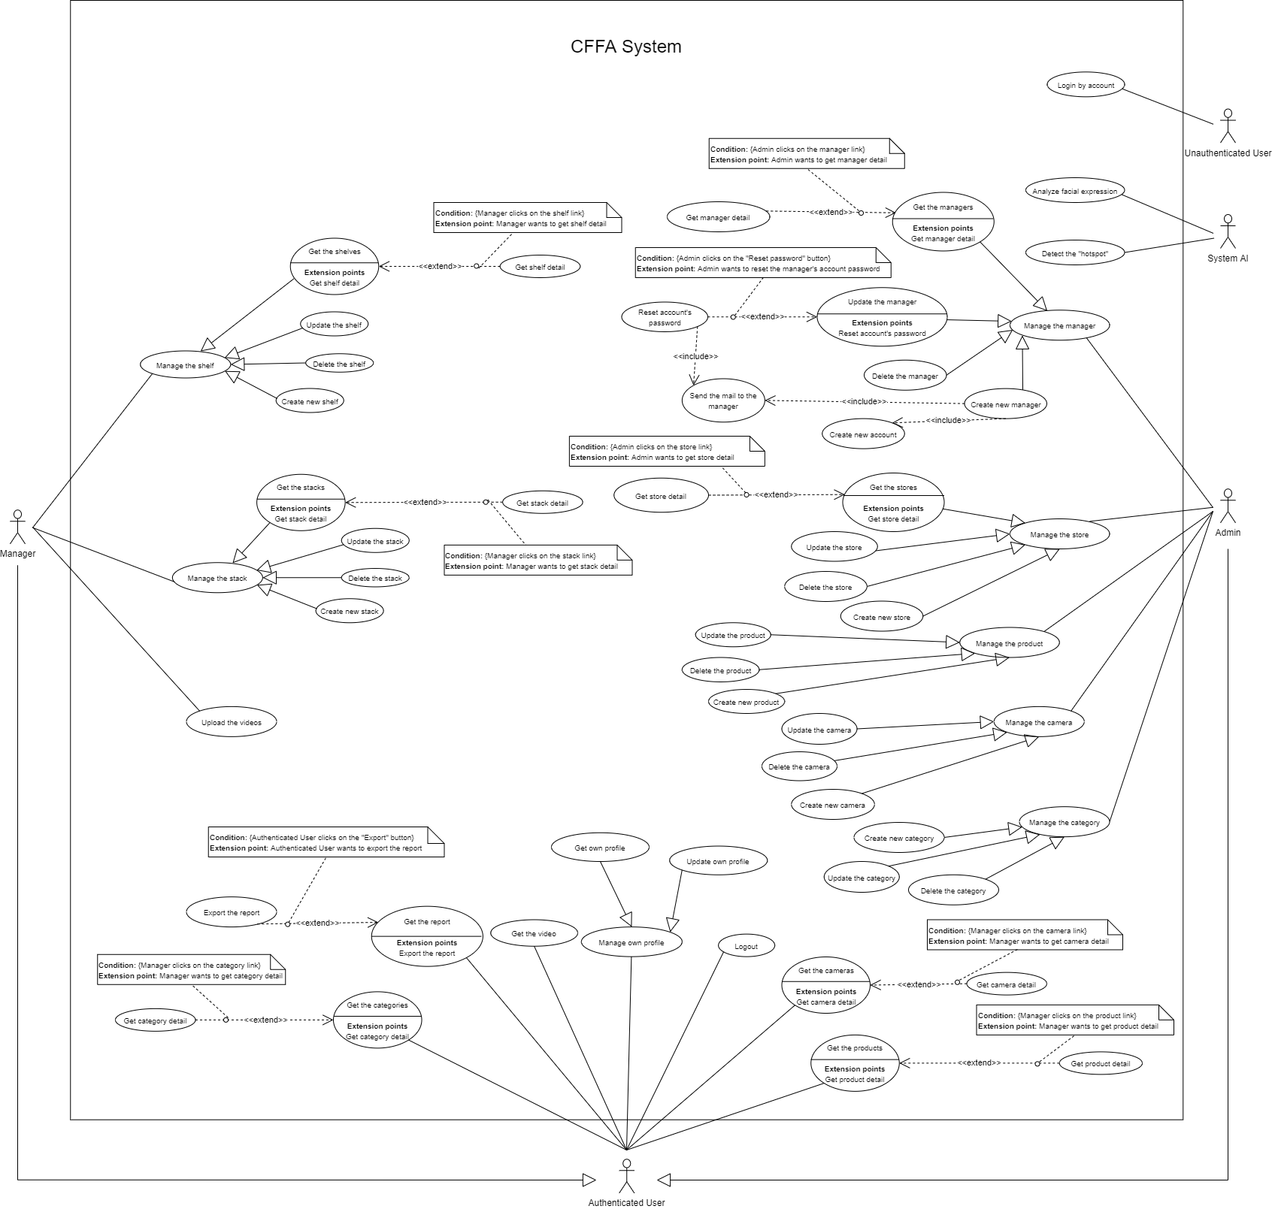

*Figure 1 - <Use Case Overview> Overview*

#### System Actors

|  |  |  |
| --- | --- | --- |
| **#** | **Actor** | **Description** |
| 1 | Unauthenticated User | Unauthenticated User is person who has no account. |
| 2 | Authenticated User | Authenticated User is a person who has an account in the system (There are two roles that are admin and manager). |
| 3 | Manager | Manager manages the store's products, shelves, stacks, and cameras. |
| 4 | Admin | Admin manages the managers, accounts, and stores in the system. |
| 5 | System AI | System AI analyzes customers' emotions and detects the "hotspot" in the stores. |

*Table 2 - System actors*

#### Use Case List

|  |  |  |  |
| --- | --- | --- | --- |
| **ID** | **Use Case** | **Primary Actors** | **Secondary Actors** |
| UC-01 | **Login by account** | Unauthenticated user | N/A |
| UC-02 | **Logout** | Authenticated user | N/A |
| UC-03 | **Change account's password** | Authenticated user | N/A |
| UC-04 | **Get the report** | Authenticated user | N/A |
| UC-05 | **Export the report** | Authenticated user | N/A |
| UC-06 | **Get the video** | Authenticated user | N/A |
| ~~UC-07~~ | **~~Set time to analyze the videos~~** | ~~Admin~~ | ~~N/A~~ |
| UC-08 | **Get the shelves** | Manager | N/A |
| UC-09 | **Get shelf detail** | Manager | N/A |
| UC-10 | **Update the shelf** | Manager | N/A |
| UC-11 | **Delete the shelf** | Manager | N/A |
| UC-12 | **Create new shelf** | Manager | N/A |
| UC-13 | **Get the stacks** | Manager | N/A |
| UC-14 | **Get stack detail** | Manager | N/A |
| UC-15 | **Update the stack** | Manager | N/A |
| UC-16 | **Delete the stack** | Manager | N/A |
| UC-17 | **Create new stack** | Manager | N/A |
| UC-18 | **Get the products** | Authenticated user | N/A |
| UC-19 | **Get product detail** | Authenticated user | N/A |
| UC-20 | **Update the product** | Admin | N/A |
| UC-21 | **Delete the product** | Admin | N/A |
| UC-22 | **Create new product** | Admin | N/A |
| UC-23 | **Get the cameras** | Authenticated user | N/A |
| UC-24 | **Get camera detail** | Authenticated user | N/A |
| UC-25 | **Update the camera** | Admin | N/A |
| UC-26 | **Delete the camera** | Admin | N/A |
| UC-27 | **Create new camera** | Admin | N/A |
| UC-28 | **Get the categories** | Authenticated user | N/A |
| UC-29 | **Get category detail** | Authenticated user | N/A |
| UC-30 | **Update the category** | Admin | N/A |
| UC-31 | **Create new category** | Admin | N/A |
| UC-32 | **Get the stores** | Admin | N/A |
| UC-33 | **Get store detail** | Admin | N/A |
| UC-34 | **Update the store** | Admin | N/A |
| UC-35 | **Delete the store** | Admin | N/A |
| UC-36 | **Create new store** | Admin | N/A |
| UC-37 | **Get the managers** | Admin | N/A |
| UC-38 | **Get manager detail** | Admin | N/A |
| UC-39 | **Update the manager** | Admin | N/A |
| UC-40 | **Delete the manager** | Admin | N/A |
| UC-41 | **Create new manager** | Admin | N/A |
| UC-42 | **Reset account's password** | Admin | N/A |
| UC-43 | **Create new account** | Admin | N/A |
| UC-44 | **Send the mail to the manager** | Admin | N/A |
| UC-45 | **Analyze facial expression** | System AI | N/A |
| UC-46 | **Upload the videos** | Manager | N/A |
| UC-47 | **Get own profile** | Authenticated user | N/A |
| UC-48 | **Update own profile** | Authenticated user | N/A |

UC-4*Table 3 - Use case list*

### User case specification



#### 2.2.1 <Unauthenticated User> Overview Use Case

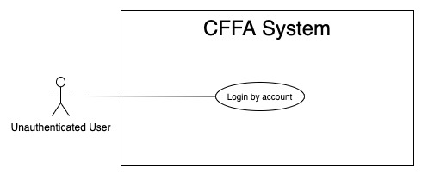

*Figure 2 - <Overview Use Case> Unauthenticated User*

##### 2.2.1.1 <Unauthenticated User> Login by account



*Figure 3 - <Use Case> Login by account*

|  |  |  |  |
| --- | --- | --- | --- |
| ID and Name: | **UC-01 Login by account** | | |
| Created By: | TruongTN | Date Created: | 25/01/2021 |
| Primary Actor: | Unauthenticated User | Secondary Actors: | N/A |
| Description: | This feature allows the unauthenticated user to login to CFFA system to verify the role and gives them access to more features. | | |
| Trigger: | Unauthenticated User sends a request to login to CFFA system. | | |
| Pre-conditions: | PRE-01. User's account has been created.  PRE-02. User's account has been authorized as Admin or Manager role.  PRE-03. User has not logged in to CFFA system. | | |
| Post-conditions: | POST-01. User has successfully logged into CFFA system. | | |
| Normal Flow: | **1.0 Login by account**   1. Unauthenticated User send a request to login to the CFFA system. 2. CFFA system requires information from Unauthenticated User:  * “Username”: text input, blank * “Password”: text input, blank  1. Unauthenticated User inputs a login form: username, password. 2. Unauthenticated User clicks to “Login” button. 3. CFFA system validates the username and password. (see 1.0.E1, 1.0.E2) 4. CFFA system determines the user’s identity, role, and permission then redirects to the home page. | | |
| Alternative Flows: | N/A | | |
| Exceptions: | **1.0.E1 Unauthenticated User does not enter the required fields**   1. CFFA system returns to Unauthenticated User to fill the required fields again (MSG-001, MSG-002). 2. If Unauthenticated User inputs the required fields again, CFFA system returns to step 3 of normal flow. 3. Else if Unauthenticated User cancels the login process, then CFFA system terminates this use case.   **1.0.E2 Unauthenticated User enters wrong username or password.**   1. CFFA system returns to Unauthenticated User to fill the required fields again (MSG-003). 2. If Unauthenticated User inputs username and password again, CFFA system returns to step 3 of normal flow. 3. Else if Unauthenticated User cancels the login process, then CFFA system terminates this use case. | | |
| Priority: | High | | |
| Frequency of Use: | Always | | |
| Business Rules: | BR-001, BR-002, BR-008, BR-012 | | |
| Other Information: | In case of internet connection failure, Unauthenticated User cannot finish this use case. | | |
| Assumptions: | N/A | | |

*Table 4 - <Use Case> Login by account*

#### 2.2.2 <Authenticated User> Overview Use Case

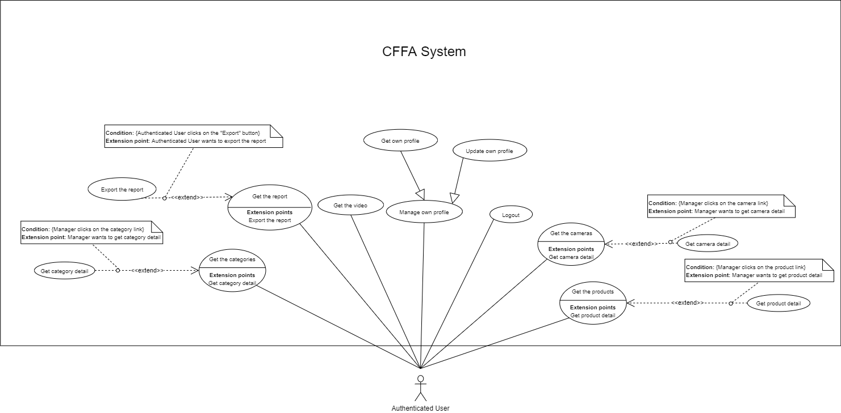

*Figure 4 - <Overview Use Case> Authenticated User*

##### 2.2.2.1 <Authenticated User> Logout

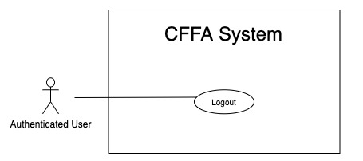

*Figure 5 - <Use Case> Logout*

|  |  |  |  |
| --- | --- | --- | --- |
| ID and Name: | **UC-02 Logout** | | |
| Created By: | TruongTN | Date Created: | 25/01/2021 |
| Primary Actor: | Authenticated User | Secondary Actors: | N/A |
| Description: | This feature allows Authenticated User to log out from CFFA system. | | |
| Trigger: | Authenticated user sends a request to log out from CFFA system. | | |
| Pre-conditions: | PRE-01. User has logged into CFFA system. | | |
| Post-conditions: | POST-01. User has successfully logged out CFFA system. | | |
| Normal Flow: | **2.0 Logout**   1. Authenticated user clicks on “Logout” button. 2. CFFA system deletes their cookies. 3. CFFA system redirects to "Login" page. | | |
| Alternative Flows: | N/A | | |
| Exceptions: | N/A | | |
| Priority: | Medium | | |
| Frequency of Use: | Sometimes | | |
| Business Rules: | BR-004, BR-005, BR-006 | | |
| Other Information: | In case of internet connection failure, Authenticated User cannot finish this use case. | | |
| Assumptions: | N/A | | |

*Table 5 - <Use Case> Logout*

##### 2.2.2.2 <Authenticated User> Change account's password

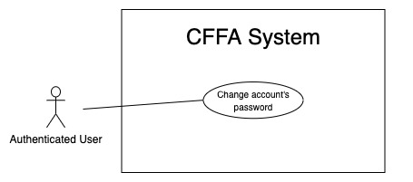

*Figure 6 - <Use Case> Change account's password*

|  |  |  |  |
| --- | --- | --- | --- |
| ID and Name: | **UC-03 Change account's password** | | |
| Created By: | HuuDN | Date Created: | 10/05/2021 |
| Primary Actor: | Authenticated User | Secondary Actors: | N/A |
| Description: | This feature allows Authenticated User to change the account's password. | | |
| Trigger: | Authenticated User sends a request to change the account's password. | | |
| Pre-conditions: | PRE-01. User has logged into CFFA system. | | |
| Post-conditions: | POST-01. Authenticated User has successfully changed the account's password. | | |
| Normal Flow: | **3.0 Change account's password**   1. Authenticated User sends a request to change the account's password. 2. CFFA system requires information from Authenticated User:  * “Old password”: text input, blank * “New Password”: text input, blank * “Re-enter New Password”: text input, blank  1. Authenticated User inputs a changing password form: old password, new password, and re-enter new password. 2. Authenticated User clicks to "Save" button. 3. CFFA system validates the old password, new password, and re-enter new password. (see 3.0.E1, 3.0.E2) 4. CFFA system will stores changing information. | | |
| Alternative Flows: | N/A | | |
| Exceptions: | **3.0.E1 Authenticated User does not enter the required fields**   1. CFFA system returns to Authenticated User to fill the required fields again (MSG-004, MSG-005, MSG-006, MSG-007). 2. If Authenticated User inputs the required fields again, CFFA system returns to step 3 of normal flow. 3. Else if Unauthenticated User cancels the login process, then CFFA system terminates this use case.   **3.0.E2 Authenticated User enters the required fields that are not valid**   1. CFFA system returns to Authenticated User to fill the required fields again (MSG-003). 2. If Authenticated User inputs the required fields again, CFFA system returns to step 3 of normal flow. 3. Else if Unauthenticated User cancels the login process, then CFFA system terminates this use case. | | |
| Priority: | Medium | | |
| Frequency of Use: | Sometimes | | |
| Business Rules: | BR-002, BR-007, BR-008, BR-012 | | |
| Other Information: | In case of internet connection failure, Authenticated User cannot finish this use case. | | |
| Assumptions: | N/A | | |

*Table 6 - <Use Case> Change account's password*

##### 2.2.2.3 <Authenticated User> Get the report

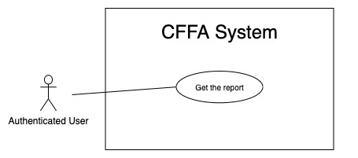

*Figure 7 - <Use Case> Get the report*

|  |  |  |  |
| --- | --- | --- | --- |
| ID and Name: | **UC-04 Get the report** | | |
| Created By: | HuuDN | Date Created: | 11/05/2021 |
| Primary Actor: | Authenticated User | Secondary Actors: | N/A |
| Description: | This feature allows the Authenticated User to get the report. | | |
| Trigger: | Authenticated User sends a request to get the report. | | |
| Preconditions: | PRE-01. User has logged into CFFA system as admin or manager role. | | |
| Post-conditions: | POST-01. Authenticated User has successfully got the report. | | |
| Normal Flow: | **4.0 Get the report**   1. Authenticated User sends a request to get the report. 2. CFFA system requires the report's information from Authenticated User:  * “Start Time”: text input, blank * “End Time”: text input, blank * “Shelf”: combobox * “Stack”: combobox * “Product”: combobox * “Camera”: combobox * “Analyzed Options”: checkbox * “Time Filter”: checkbox  1. Authenticated User inputs/selects a form: start time, end time, shelf, stack, product, camera, analyzed options, and time filter. 2. CFFA system returns the reports (see 4.0.E1). | | |
| Alternative Flows: | N/A | | |
| Exceptions: | **4.0.E1 The report has no data.**   1. CFFA system returns the message (MSG-010). | | |
| Priority: | High | | |
| Frequency of Use: | Often | | |
| Business Rules: | BR-013, BR-014, BR-015, BR-016, BR-017, BR-018, BR-019, BR-020, BR-021. | | |
| Other Information: | In case of internet connection failure, Authenticated User cannot finish this use case properly. | | |
| Assumptions: | N/A | | |

*Table 7 - <Use Case> Get the report*

##### 2.2.2.4 <Authenticated User> Export the report

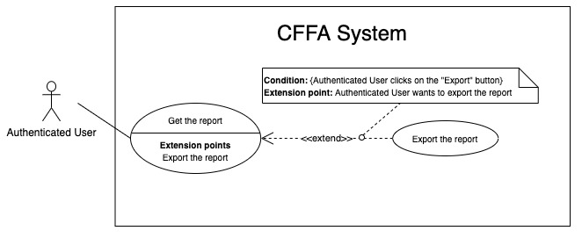

*Figure 8 - <Use Case> Export the report*

|  |  |  |  |
| --- | --- | --- | --- |
| ID and Name: | **UC-05 Export the report** | | |
| Created By: | HuuDN | Date Created: | 18/01/2021 |
| Primary Actor: | Authenticated User | Secondary Actors: | N/A |
| Description: | This feature allows Authenticated User to export the report. | | |
| Trigger: | Authenticated User sends a request to export the report. | | |
| Preconditions: | PRE-01. User has logged into CFFA system as admin or manager role.  PRE-02. Authenticated User has got the report. | | |
| Post-conditions: | POST-01. Authenticated User has successfully exported the report. | | |
| Normal Flow: | **5.0 Export the report**   1. Authenticated User clicks on "Export" button. 2. CFFA system returns the report file for Authenticated User (see 5.0.E1) | | |
| Alternative Flows: | N/A | | |
| Exceptions: | **5.0.E1 The report has no data**   1. CFFA system returns the message (MSG-010). | | |
| Priority: | High | | |
| Frequency of Use: | Often | | |
| Business Rules: | BR-008, BR-009. | | |
| Other Information: | In case of internet connection failure, Authenticated User cannot finish this use case properly. | | |
| Assumptions: | N/A | | |

*Table 8 - <Use Case> Export the report*

##### 2.2.2.5 <Authenticated User> Get the video

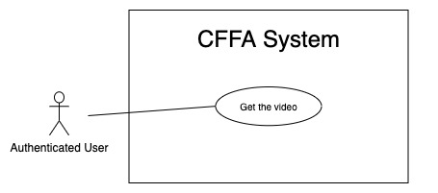

*Figure 9 - <Use Case> Get the video*

|  |  |  |  |
| --- | --- | --- | --- |
| ID and Name: | **UC-06 Get the video** | | |
| Created By: | HuuDN | Date Created: | 11/05/2021 |
| Primary Actor: | Authenticated User | Secondary Actors: | N/A |
| Description: | This feature allows Authenticated User to get the video. | | |
| Trigger: | Authenticated User sends a request to get the video. | | |
| Preconditions: | PRE-01. User has logged into CFFA system as admin or manager role. | | |
| Post-conditions: | POST-01. Authenticated User has successfully played the video. | | |
| Normal Flow: | **6.0 Get the video**   1. Authenticated User sends a request to get the report. 2. CFFA system requires the report's information from Authenticated User:  * “Start Time”: text input, blank * “End Time”: text input, blank * “Shelf”: combobox * “Stack”: combobox * “Product”: combobox * “Camera”: combobox * “Video Options”: checkbox  1. Authenticated User inputs/selects a form: start time, end time, shelf, stack, product, camera, video options. 2. Authenticated User clicks on "Play" button. 3. CFFA system plays the video (see 6.0.E1). | | |
| Alternative Flows: | N/A | | |
| Exceptions: | **6.0.E1 The video has no data to play.**   1. CFFA system returns the message (MSG-011). | | |
| Priority: | High | | |
| Frequency of Use: | Often | | |
| Business Rules: | BR-010, BR-011, BR-013, BR-021, BR-022. | | |
| Other Information: | In case of internet connection failure, Authenticated User cannot finish this use case properly. | | |
| Assumptions: | N/A | | |

*Table 9 - <Use Case> Get the video*

##### 2.2.3.6 < Authenticated User > Get the products

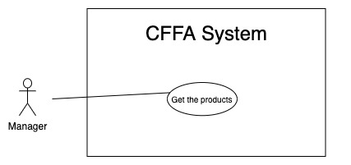

*Figure 22 - <Use Case> Get the products*

|  |  |  |  |
| --- | --- | --- | --- |
| ID and Name: | **UC-18 Get the products** | | |
| Created By: | HieuNT | Date Created: | 08/05/2021 |
| Primary Actor: | Authenticated User | Secondary Actors: | N/A |
| Description: | This feature allows authenticated user to get the products. | | |
| Trigger: | authenticated user sends a request to get the products. | | |
| Pre-conditions: | PRE-01. User has logged into the system as admin or manager role. | | |
| Post-conditions: | POST-01. CFFA system returns the list of products. | | |
| Normal Flow: | **18.0 Get the products**   1. Authenticated user sends a request to get the products. 2. CFFA system requires the product information:  * “Product name”: input text, blank * “Category”: combobox * “Status”: combobox  1. Authenticated user inputs/selects the fields: product name, category, status. 2. Authenticated user clicks on "Search" button. 3. CFFA system returns the list of products based on below conditions and display them (see 18.0.E1). | | |
| Alternative Flows: | N/A | | |
| Exceptions: | **18.0.E1 The list of product has no data.**   1. CFFA system returns the message (MSG-009). | | |
| Priority: | High | | |
| Frequency of Use: | Usually | | |
| Business Rules: | BR-024, BR-044, BR-045 | | |
| Other Information: | In case of internet connection failure, authenticated user cannot finish this use case properly. | | |
| Assumptions: | N/A | | |

*Table 21 - <Use Case> Get the products*

##### 2.2.3.7 < Authenticated User > Get product detail

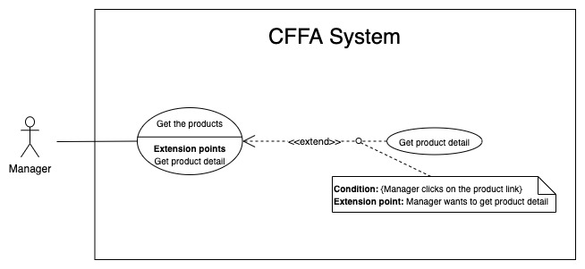

*Figure 23 - <Use Case> Get product detail*

|  |  |  |  |
| --- | --- | --- | --- |
| ID and Name: | **UC-19 Get product detail** | | |
| Created By: | HieuNT | Date Created: | 10/05/2021 |
| Primary Actor: | Authenticated User | Secondary Actors: | N/A |
| Description: | This feature allows the authenticated user to getproductdetail. | | |
| Trigger: | Authenticated user sends a request to get product detail. | | |
| Preconditions: | PRE-01. User has logged in the system as admin or manager role.  PRE-02. There is at least one the product link. | | |
| Post-conditions: | POST-01. CFFA system returns product information and redirect to product detail page. | | |
| Normal Flow: | **19.0 Get product detail**   1. Authenticated user clicks on the product link. 2. CFFA system validates the product exists (see 19.0.E1) 3. CFFA system returns the product information and redirects to product detail page. | | |
| Alternative Flows: | N/A | | |
| Exceptions: | **19.0.E1 The stack does not exist.**  1. CFFA system returns the message (MSG-0023) and terminates this use case. | | |
| Priority: | High | | |
| Frequency of Use: | Usually | | |
| Business Rules: | BR-046 | | |
| Other Information: | In case of internet connection failure, Authenticated user cannot finish this use case properly. | | |
| Assumptions: | N/A | | |

*Table22 - <Use Case> Get product detail*

##### 2.2.3.8 < Authenticated User > Get the categories

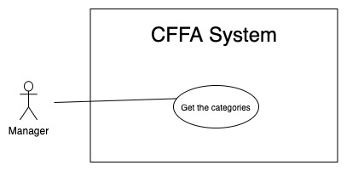

*Figure 32 - <Use Case> Get the categories*

|  |  |  |  |
| --- | --- | --- | --- |
| ID and Name: | **UC-28 Get the categories** | | |
| Created By: | TruongTN | Date Created: | 08/05/2021 |
| Primary Actor: | Authenticated user | Secondary Actors: | N/A |
| Description: | This feature allows manager to get the categories. | | |
| Trigger: | Authenticated user sends a request to get the categories. | | |
| Pre-conditions: | PRE-01. User has logged into the system as admin or manager role. | | |
| Post-conditions: | POST-01. CFFA system returns the list of categories. | | |
| Normal Flow: | **28.0 Get the categories**   1. Authenticated user sends a request to get the categories. 2. CFFA system requires the camera information:  * “Category name”: input text, blank  1. Authenticated user inputs/selects the fields: category name 2. Authenticated user clicks on "Search" button. 3. CFFA system returns the list of products based on below conditions and display them (see 28.0.E1). | | |
| Alternative Flows: | N/A | | |
| Exceptions: | **28.0.E1 The list of categories has no data.**   1. CFFA system returns the message (MSG-009). | | |
| Priority: | High | | |
| Frequency of Use: | Usually | | |
| Business Rules: | BR-024, BR-061 | | |
| Other Information: | In case of internet connection failure, authenticated user cannot finish this use case properly. | | |
| Assumptions: | N/A | | |

*Table 31 - <Use Case> Get the categories*

##### 2.2.3.9 < Authenticated User > Get category detail

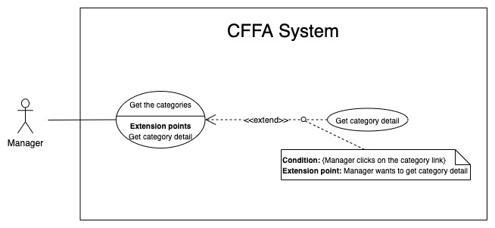

*Figure 33 - <Use Case> Get category detail*

|  |  |  |  |
| --- | --- | --- | --- |
| ID and Name: | **UC-29 Get category detail** | | |
| Created By: | HuuDN | Date Created: | 10/05/2021 |
| Primary Actor: | Authenticated User | Secondary Actors: | N/A |
| Description: | This feature allows the authenticated user to getcategorydetail. | | |
| Trigger: | Authenticated user sends a request to get categorydetail. | | |
| Preconditions: | PRE-01. User has logged in the system as admin or manager role.  PRE-02. There is at least one the categorylink. | | |
| Post-conditions: | POST-01. CFFA system returns categoryinformation and redirect to categorydetail page. | | |
| Normal Flow: | **29.0 Get product detail**   1. Authenticated user clicks on the categorylink. 2. CFFA system validates the categoryexists (see 24.0.E1) 3. CFFA system returns the categoryinformation and redirects to categorydetail page. | | |
| Alternative Flows: | N/A | | |
| Exceptions: | **29.0.E1 The category does not exist.**  1. CFFA system returns the message (MSG-0033) and terminates this use case. | | |
| Priority: | High | | |
| Frequency of Use: | Usually | | |
| Business Rules: | BR-062 | | |
| Other Information: | In case of internet connection failure, authenticated user cannot finish this use case properly. | | |
| Assumptions: | N/A | | |

*Table 32 - <Use Case> Get camera detail*

##### 2.2.3.10 < Authenticated User > Get the cameras

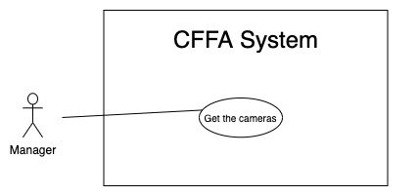

*Figure 27 - <Use Case> Get the cameras*

|  |  |  |  |
| --- | --- | --- | --- |
| ID and Name: | **UC-23 Get the cameras** | | |
| Created By: | HuuDN | Date Created: | 08/05/2021 |
| Primary Actor: | Authenticated user | Secondary Actors: | N/A |
| Description: | This feature allows authenticated user to get the cameras. | | |
| Trigger: | Authenticated user sends a request to get the cameras. | | |
| Pre-conditions: | PRE-01. User has logged into the system as admin or manager role. | | |
| Post-conditions: | POST-01. CFFA system returns the list of cameras. | | |
| Normal Flow: | **23.0 Get the cameras**   1. Authenticated user sends a request to get the cameras. 2. CFFA system requires the camera information:  * “Camera name”: input text, blank * “Status”: combobox  1. Authenticated user inputs/selects the fields: product name, status. 2. Authenticated user clicks on "Search" button. 3. CFFA system returns the list of products based on below conditions and display them (see 23.0.E1). | | |
| Alternative Flows: | N/A | | |
| Exceptions: | **23.0.E1 The list of cameras has no data.**   1. CFFA system returns the message (MSG-009). | | |
| Priority: | High | | |
| Frequency of Use: | Usually | | |
| Business Rules: | BR-024, BR-052, BR-053, BR-079 | | |
| Other Information: | In case of internet connection failure, authenticated user cannot finish this use case properly. | | |
| Assumptions: | N/A | | |

*Table 26 - <Use Case> Get the products*

##### 2.2.3.11 < Authenticated User > Get camera detail

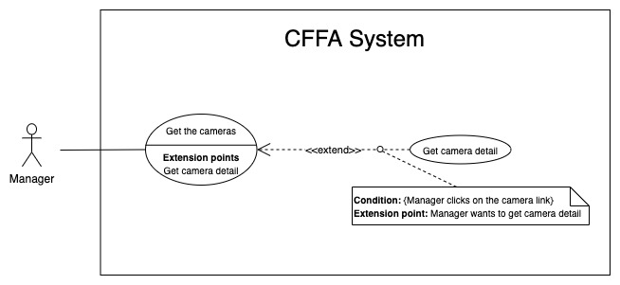

*Figure 28 - <Use Case> Get camera detail*

|  |  |  |  |
| --- | --- | --- | --- |
| ID and Name: | **UC-24 Get camera detail** | | |
| Created By: | HuuDN | Date Created: | 10/05/2021 |
| Primary Actor: | Authenticated User | Secondary Actors: | N/A |
| Description: | This feature allows the authenticated user to getcameradetail. | | |
| Trigger: | Authenticated user sends a request to get camera detail. | | |
| Preconditions: | PRE-01. User has logged in the system as admin or manager role.  PRE-02. There is at least one the camera link. | | |
| Post-conditions: | POST-01. CFFA system returns camera information and redirect to camera detail page. | | |
| Normal Flow: | **24.0 Get product detail**   1. Authenticated user clicks on the camera link. 2. CFFA system validates the camera exists (see 24.0.E1) 3. CFFA system returns the camera information and redirects to camera detail page. | | |
| Alternative Flows: | N/A | | |
| Exceptions: | **24.0.E1 The camera does not exist.**  1. CFFA system returns the message (MSG-0024) and terminates this use case. | | |
| Priority: | High | | |
| Frequency of Use: | Usually | | |
| Business Rules: | BR-054, BR-079 | | |
| Other Information: | In case of internet connection failure, authenticated user cannot finish this use case properly. | | |
| Assumptions: | N/A | | |

*Table 27 - <Use Case> Get camera detail*

#### 2.2.3 <Manager> Overview Use Case

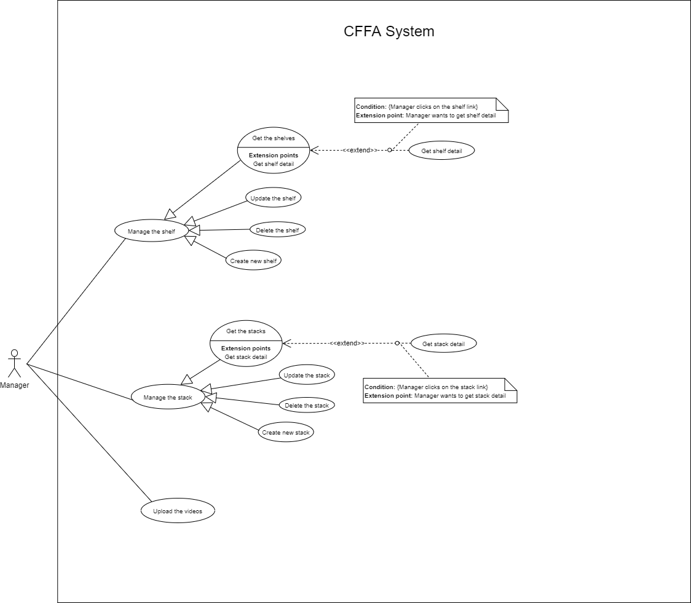

*Figure 11 - <Overview Use Case> Manager*

##### 2.2.3.1 <Manager> Get the shelves

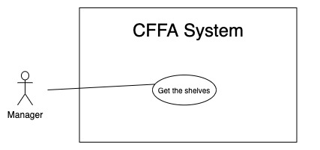

*Figure 12 - <Use Case> Get the shelves*

|  |  |  |  |
| --- | --- | --- | --- |
| ID and Name: | **UC-08 Get the shelves** | | |
| Created By: | TruongTN | Date Created: | 08/05/2021 |
| Primary Actor: | Manager | Secondary Actors: | N/A |
| Description: | This feature allows manager to get the shelves. | | |
| Trigger: | Manager sends a request to get the shelves. | | |
| Pre-conditions: | PRE-01. User has logged into the system as manager role.  PRE-02. Manager is managing a store. | | |
| Post-conditions: | POST-01. CFFA system returns the list of shelves. | | |
| Normal Flow: | **8.0 Get the shelves**   1. Manager sends a request to get the shelves. 2. CFFA system requires the shelf information from Manager:  * “Name”: text input, blank * “Status”: combobox  1. Manager inputs/selects a form: name and status. 2. Manager clicks on "Search" button. 3. CFFA system returns the shelves based on below conditions and display them (see 8.0.E1). | | |
| Alternative Flows: | N/A | | |
| Exceptions: | **8.0.E1 The list of shelves has no data.**   1. CFFA system returns the message (MSG-009). | | |
| Priority: | High | | |
| Frequency of Use: | Usually | | |
| Business Rules: | BR-024, BR-026, BR-027 | | |
| Other Information: | In case of internet connection failure, Manager cannot finish this use case properly. | | |
| Assumptions: | N/A | | |

*Table 11 - <Use Case> Get the shelves*

##### 2.2.3.2 <Manager> Get shelf detail

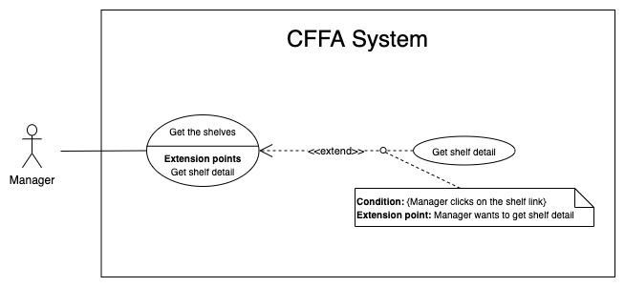

*Figure 13 - <Use Case> Get shelf detail*

|  |  |  |  |
| --- | --- | --- | --- |
| ID and Name: | **UC-09 Get shelf detail** | | |
| Created By: | TruongTN | Date Created: | 10/05/2021 |
| Primary Actor: | Manager | Secondary Actors: | N/A |
| Description: | This feature allows the Manager to get shelf detail. | | |
| Trigger: | Manager sends a request to get shelf detail. | | |
| Preconditions: | PRE-01. User has logged in the system as manager role.  PRE-02. There is at least one the shelf link. | | |
| Post-conditions: | POST-01. CFFA system returns shelf information and redirect to shelf detail page. | | |
| Normal Flow: | **9.0 Get shelf detail**   1. Manager clicks on the shelf link. 2. CFFA system validates the shelf exists (see 9.0.E1) 3. CFFA system returns the shelf information and redirects to shelf detail page. | | |
| Alternative Flows: | N/A | | |
| Exceptions: | **9.0.E1 The shelf does not exist.**  1. CFFA system returns the message (MSG-0012) and terminates this use case. | | |
| Priority: | High | | |
| Frequency of Use: | Usually | | |
| Business Rules: | BR-028 | | |
| Other Information: | In case of internet connection failure, Manager cannot finish this use case properly. | | |
| Assumptions: | N/A | | |

*Table 12 - <Use Case> Get shelf detail*

##### 2.2.3.3 <Manager> Update the shelf

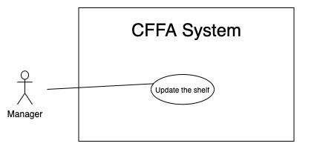

*Figure 14 - <Use Case> Update the shelf*

|  |  |  |  |
| --- | --- | --- | --- |
| ID and Name: | **UC-10 Update the shelf** | | |
| Created By: | TruongTN | Date Created: | 18/01/2021 |
| Primary Actor: | Manager | Secondary Actors: | N/A |
| Description: | This feature allows Manager to update shelf information in CFFA system. | | |
| Trigger: | Manager sends a request to update the shelf. | | |
| Preconditions: | PRE-01. User has logged in the system as manager role.  PRE-02. Manager is on “Shelf detail” page. | | |
| Post-conditions: | POST-01. CFFA system updates shelf information.  POST-02. CFFA system returns the message. | | |
| Normal Flow: | **10.0 Update the shelf**   1. Manager sends a request to update the shelf. 2. CFFA system requires shelf information that includes:  * “Shelf name”: input text, blank. * “Description”: input text, blank. * “Maximum of stacks:” input text, blank. * “Status”: combobox. * “Camera”: popup.  1. Manager inputs/selects the required fields. 2. Manager clicks on “Save” button. 3. CFFA system validates the required fields (see 10.0.E1, 10.0.E2) 4. CFFA system updates shelf information and returns the message (MSG-013). | | |
| Alternative Flows: | N/A | | |
| Exceptions: | **10.0.E1 Manager does not enter the required fields**   1. CFFA system returns to Manager to fill the required fields again (MSG-014, MSG-016, MSG-018). 2. If Manager inputs the required fields again, CFFA system returns to step 3 of normal flow. 3. Else if Manager cancels the login process, then CFFA system terminates this use case.   **10.0.E2 Manager enters the required fields that are not valid**   1. CFFA system returns to Authenticated User to fill the required fields again (MSG-015, MSG-017, MSG-018, MSG-020, MSG-034). 2. If Manager inputs the required fields again, CFFA system returns to step 3 of normal flow. 3. Else if Manager cancels the login process, then CFFA system terminates this use case. | | |
| Priority: | Medium | | |
| Frequency of Use: | Often | | |
| Business Rules: | BR-029, BR-030, BR-031, BR-032, BR-039, BR-076 | | |
| Other Information: | In case of internet connection failure, Manager cannot finish this use case properly. | | |
| Assumptions: | N/A | | |

*Table 13 - <Use Case> Update the shelf*

##### 2.2.3.4 <Manager> Delete the shelf

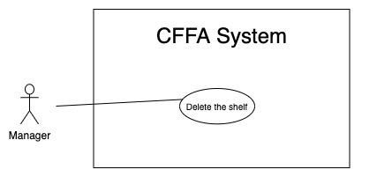

*Figure 15 - <Use Case> Delete the shelf*

|  |  |  |  |
| --- | --- | --- | --- |
| ID and Name: | **UC-11 Delete the shelf** | | |
| Created By: | TruongTN | Date Created: | 18/01/2021 |
| Primary Actor: | Manager | Secondary Actors: | N/A |
| Description: | This feature allows Manager to delete the shelf. | | |
| Trigger: | Manager sends a request to delete the shelf. | | |
| Preconditions: | PRE-01. User has logged in the system as manager role.  PRE-02. Manager is on “Shelf detail” page. | | |
| Post-conditions: | POST-01. CFFA system updates shelf information.  POST-02. CFFA system returns the message. | | |
| Normal Flow: | **11.0 Delete the shelf**   1. Manager sends a request to delete the shelf. 2. CFFA system shows delete popup with message: "Are you sure?" and two buttons for Manager can select:  * "Yes" button * "No" button   1. Manager clicks on "Yes" button, CFFA system updates shelf information and returns the message (MSG-021) (see 11.0.E1).   2. Manager clicks on "No" button, close popup and nothing change. | | |
| Alternative Flows: | N/A | | |
| Exceptions: | **11.0.E1 The shelf does not exist**   1. CFFA system returns a message (MSG-012). 2. CFFA system redirects to manage shelf page and terminates this use case. | | |
| Priority: | Medium | | |
| Frequency of Use: | Often | | |
| Business Rules: | BR-030, BR-032, BR-033 | | |
| Other Information: | In case of internet connection failure, Manager cannot finish this use case properly. | | |
| Assumptions: | N/A | | |

*Table 14 - <Use Case> Delete the shelf*

##### 2.2.3.5 <Manager> Create new shelf

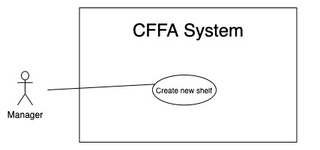

*Figure 16 - <Use Case> Create new shelf*

|  |  |  |  |
| --- | --- | --- | --- |
| ID and Name: | **UC-12 Create new shelf** | | |
| Created By: | TruongTN | Date Created: | 10/05/2021 |
| Primary Actor: | Manager | Secondary Actors: | N/A |
| Description: | This feature allows Manager to create new shelf. | | |
| Trigger: | Manager sends a request to create new shelf. | | |
| Preconditions: | PRE-01. User has logged in the system as manager role.  PRE-02. Manager is on “Manage Shelf” page. | | |
| Post-conditions: | POST-01. CFFA system stores newly shelf information.  POST-02. CFFA system returns the message. | | |
| Normal Flow: | **12.0 Create new shelf**   1. Manager sends a request to create new shelf. 2. CFFA system requires shelf information that includes:  * “Shelf name”: input text, blank. * “Description”: input text, blank. * “Maximum of stacks:” input text, blank.  1. Manager inputs/selects the required fields. 2. Manager clicks on “Create” button. 3. CFFA system validates the required fields (see 12.0.E1, 12.0.E2). 4. CFFA system stores newly shelf information and returns the message (MSG-013). | | |
| Alternative Flows: | N/A | | |
| Exceptions: | **12.0.E1 Manager does not enter the required fields**   1. CFFA system returns to Manager to fill the required fields again (MSG-014, MSG-016, MSG-018). 2. If Manager inputs the required fields again, CFFA system returns to step 3 of normal flow. 3. Else if Manager cancels the login process, then CFFA system terminates this use case.   **12.0.E2 Manager enters the required fields that are not valid**   1. CFFA system returns to Authenticated User to fill the required fields again (MSG-015, MSG-017, MSG-018, MSG-020, MSG-034). 2. If Manager inputs the required fields again, CFFA system returns to step 3 of normal flow. 3. Else if Manager cancels the login process, then CFFA system terminates this use case. | | |
| Priority: | Medium | | |
| Frequency of Use: | Often | | |
| Business Rules: | BR-031, BR-034, BR-035 | | |
| Other Information: | In case of internet connection failure, Manager cannot finish this use case properly. | | |
| Assumptions: | N/A | | |

*Table 15 - <Use Case> Create new shelf*

##### 2.2.3.6 <Manager> Get the stacks

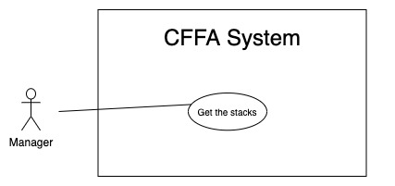

*Figure 17 - <Use Case> Get the stacks*

|  |  |  |  |
| --- | --- | --- | --- |
| ID and Name: | **UC-13 Get the stacks** | | |
| Created By: | LuanNM | Date Created: | 08/05/2021 |
| Primary Actor: | Manager | Secondary Actors: | N/A |
| Description: | This feature allows manager to get the stacks. | | |
| Trigger: | Manager sends a request to get the stacks. | | |
| Pre-conditions: | PRE-01. User has logged into the system as manager role.  PRE-02. Manager is managing a store. | | |
| Post-conditions: | POST-01. CFFA system returns the list of stacks. | | |
| Normal Flow: | **13.0 Get the stacks**   1. Manager sends a request to get the stacks. 2. CFFA system requires the stack information from Manager:  * “Status”: combobox  1. Manager selects a status. 2. Manager clicks on "Search" button. 3. CFFA system returns the stacks based on below conditions and display them (see 13.0.E1). | | |
| Alternative Flows: | **13.1 Get the stacks on a shelf**   1. Manager clicks on the shelf link to redirect to shelf detail page. 2. CFFA system returns the stacks on the shelf based on below conditions and display them (see 13.0.E1). | | |
| Exceptions: | **13.0.E1 The list of stacks has no data.**   1. CFFA system returns the message (MSG-009). | | |
| Priority: | High | | |
| Frequency of Use: | Usually | | |
| Business Rules: | BR-024, BR-036, BR-037 | | |
| Other Information: | In case of internet connection failure, Manager cannot finish this use case properly. | | |
| Assumptions: | N/A | | |

*Table 16 - <Use Case> Get the stacks*

##### 2.2.3.7 <Manager> Get stack detail

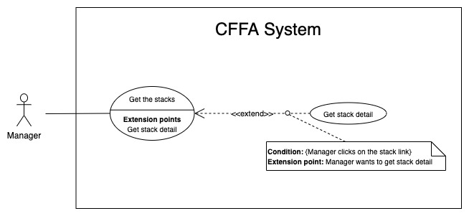

*Figure 18 - <Use Case> Get stack detail*

|  |  |  |  |
| --- | --- | --- | --- |
| ID and Name: | **UC-14 Get stack detail** | | |
| Created By: | LuanNM | Date Created: | 10/05/2021 |
| Primary Actor: | Manager | Secondary Actors: | N/A |
| Description: | This feature allows the Manager to getstackdetail. | | |
| Trigger: | Manager sends a request to get stack detail. | | |
| Preconditions: | PRE-01. User has logged in the system as manager role.  PRE-02. There is at least one the stack link. | | |
| Post-conditions: | POST-01. CFFA system returns stack information and redirect to stack detail page. | | |
| Normal Flow: | **14.0 Get stack detail**   1. Manager clicks on the stack link. 2. CFFA system validates the stack exists (see 14.0.E1) 3. CFFA system returns the stack information and redirects to stack detail page. | | |
| Alternative Flows: | N/A | | |
| Exceptions: | **14.0.E1 The stack does not exist.**  1. CFFA system returns the message (MSG-022) and terminates this use case. | | |
| Priority: | High | | |
| Frequency of Use: | Usually | | |
| Business Rules: | BR-038 | | |
| Other Information: | In case of internet connection failure, Manager cannot finish this use case properly. | | |
| Assumptions: | N/A | | |

*Table 17 - <Use Case> Get stack detail*

##### 2.2.3.8 <Manager> Update the stack

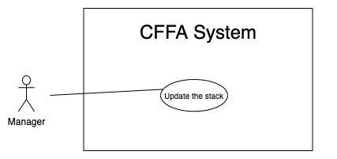

*Figure 19 - <Use Case> Update the stack*

|  |  |  |  |
| --- | --- | --- | --- |
| ID and Name: | **UC-15 Update the stack** | | |
| Created By: | LuanNM | Date Created: | 18/01/2021 |
| Primary Actor: | Manager | Secondary Actors: | N/A |
| Description: | This feature allows Manager to update stack information in CFFA system. | | |
| Trigger: | Manager sends a request to update the stack. | | |
| Preconditions: | PRE-01. User has logged in the system as manager role.  PRE-02. Manager is on “Stack detail” page. | | |
| Post-conditions: | POST-01. CFFA system updates stack information.  POST-02. CFFA system returns the message. | | |
| Normal Flow: | **15.0 Update the stack**   1. Manager sends a request to update the stack. 2. CFFA system requires stack information that includes:  * “Product”: popup. * “Camera”: popup. * “Status”: combobox.  1. Manager selects the fields. 2. Manager clicks on “Save” button. 3. CFFA system validates the fields (see 15.0.E1) 4. CFFA system updates stack information and returns the message (MSG-013). | | |
| Alternative Flows: | N/A | | |
| Exceptions: | **15.0.E1 Manager inputs/selects the fields that are not valid**   1. CFFA system returns to Manager to input/select the fields again (MSG-023, MSG-024). 2. If Manager selects the fields again, CFFA system returns to step 3 of normal flow. 3. Else if Manager cancels the login process, then CFFA system terminates this use case. | | |
| Priority: | Medium | | |
| Frequency of Use: | Often | | |
| Business Rules: | BR-032, BR-039, BR-040, BR-041, BR-042, BR-078 | | |
| Other Information: | In case of internet connection failure, Manager cannot finish this use case properly. | | |
| Assumptions: | N/A | | |

*Table 18 - <Use Case> Update the stack*

##### 2.2.3.9 <Manager> Delete the stack

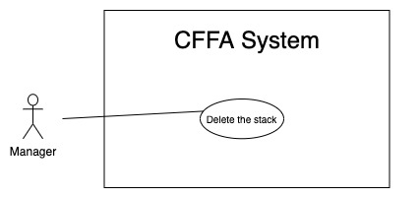

*Figure 20 - <Use Case> Delete the shelf*

|  |  |  |  |
| --- | --- | --- | --- |
| ID and Name: | **UC-16 Delete the stack** | | |
| Created By: | LuanNM | Date Created: | 10/05/2021 |
| Primary Actor: | Manager | Secondary Actors: | N/A |
| Description: | This feature allows Manager to delete the stack. | | |
| Trigger: | Manager sends a request to delete the stack. | | |
| Preconditions: | PRE-01. User has logged in the system as manager role.  PRE-02. Manager is on “Stack detail” page. | | |
| Post-conditions: | POST-01. CFFA system updates stack information.  POST-02. CFFA system returns the message. | | |
| Normal Flow: | **16.0 Delete the stack**   1. Manager sends a request to delete the stack. 2. CFFA system shows delete popup with message: "Are you sure?" and two buttons for Manager can select:  * "Yes" button * "No" button   1. Manager clicks on "Yes" button, CFFA system updates stack information and returns the message (MSG-021) (see 11.0.E1).   2. Manager clicks on "No" button, close popup and nothing change. | | |
| Alternative Flows: | N/A | | |
| Exceptions: | **16.0.E1 The stack does not exist**   1. CFFA system returns a message (MSG-022). 2. CFFA system redirects to manage stack page and terminates this use case. | | |
| Priority: | Medium | | |
| Frequency of Use: | Often | | |
| Business Rules: | BR-032, BR-033, BR-041 | | |
| Other Information: | In case of internet connection failure, Manager cannot finish this use case properly. | | |
| Assumptions: | N/A | | |

*Table 19 - <Use Case> Delete the stack*

##### 2.2.3.10 <Manager> Create new stack

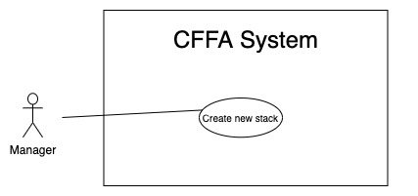

*Figure 21 - <Use Case> Create new stack*

|  |  |  |  |
| --- | --- | --- | --- |
| ID and Name: | **UC-17 Create new stack** | | |
| Created By: | LuanNM | Date Created: | 10/05/2021 |
| Primary Actor: | Manager | Secondary Actors: | N/A |
| Description: | This feature allows Manager to create new stack. | | |
| Trigger: | Manager sends a request to create new stack. | | |
| Preconditions: | PRE-01. User has logged in the system as manager role.  PRE-02. Manager is on “Shelf detail” page.  PRE-03. This shelf has total of stacks less than maximum of stacks. | | |
| Post-conditions: | POST-01. CFFA system stores newly created stack information.  POST-02. CFFA system returns the message. | | |
| Normal Flow: | **17.0 Create new stack**   1. Manager sends a request to create new stack. 2. CFFA system stores newly created stack information and returns the message (MSG-013) (see 17.0.E1). | | |
| Alternative Flows: | N/A | | |
| Exceptions: | **17.0.E1 The shelf is full**   1. CFFA system returns a message (MSG-025) and terminates this use case. | | |
| Priority: | Medium | | |
| Frequency of Use: | Often | | |
| Business Rules: | BR-035, BR-043, BR-50, BR-077 | | |
| Other Information: | In case of internet connection failure, Manager cannot finish this use case properly. | | |
| Assumptions: | N/A | | |

*Table 20 - <Use Case> Create new stack*

#### 2.2.4 <Admin> Overview Use Case

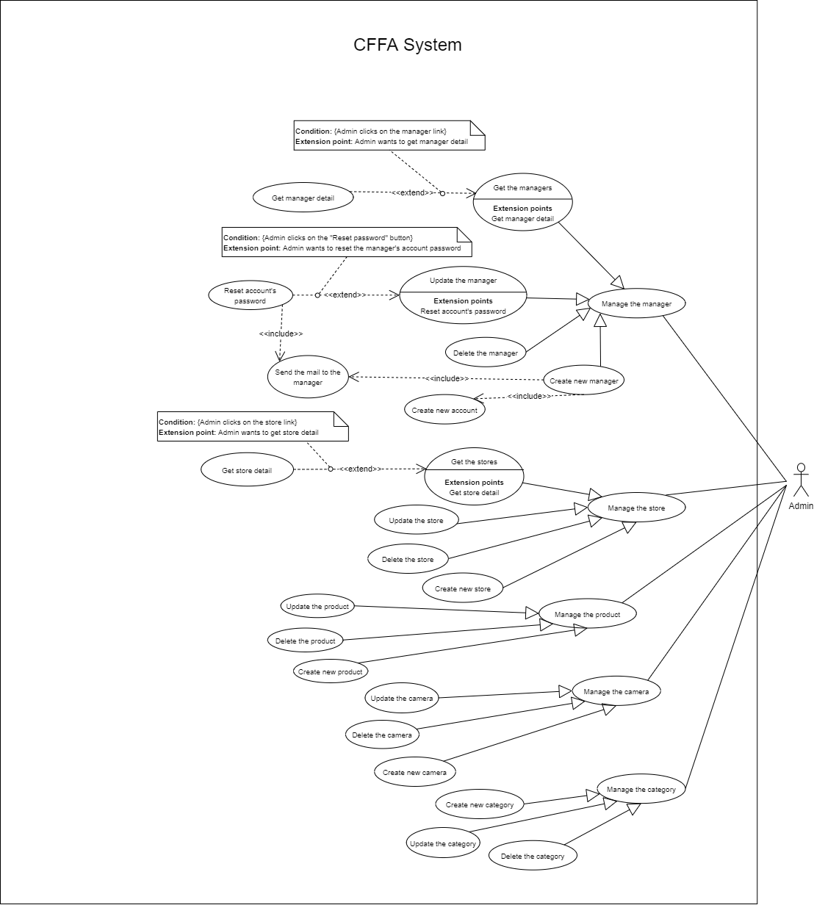

*Figure 36 - <Use Case> Get the cameras*

##### 2.2.4.1 <Admin> Get the stores



*Figure 37 - <Use Case> Get the stores*

|  |  |  |  |
| --- | --- | --- | --- |
| ID and Name: | **UC-32 Get the stores** | | |
| Created By: | LuanNM | Date Created: | 08/05/2021 |
| Primary Actor: | Admin | Secondary Actors: | N/A |
| Description: | This feature allows admin to get the stores. | | |
| Trigger: | Admin sends a request to get the stores. | | |
| Pre-conditions: | PRE-01. User has logged into the system as admin role. | | |
| Post-conditions: | POST-01. CFFA system returns the list of stores. | | |
| Normal Flow: | **32.0 Get the stores**   1. Admin sends a request to get the stores. 2. CFFA system requires the store information from Admin:  * “Store name”: input text, blank * “City”: combobox * “District”: combobox * “Status”: combobox  1. Admin inputs/selects the fields: Store name, city, district, and status. 2. Admin clicks on "Search" button. 3. CFFA system returns the list of stores based on below conditions and display them (see 32.0.E1). | | |
| Alternative Flows: | N/A | | |
| Exceptions: | **32.0.E1 The list of stores has no data.**   1. CFFA system returns the message (MSG-009). | | |
| Priority: | High | | |
| Frequency of Use: | Usually | | |
| Business Rules: | BR-024, BR-064, BR-065 | | |
| Other Information: | In case of internet connection failure, Admin cannot finish this use case properly. | | |
| Assumptions: | N/A | | |

*Table 35 - <Use Case> Get the stores*

##### 2.2.4.2 <Admin> Get store detail

*Figure 38 - <Use Case> Get store detail*

|  |  |  |  |
| --- | --- | --- | --- |
| ID and Name: | **UC-33 Get store detail** | | |
| Created By: | LuanNM | Date Created: | 10/05/2021 |
| Primary Actor: | Admin | Secondary Actors: | N/A |
| Description: | This feature allows the admin to getstoredetail. | | |
| Trigger: | Admin sends a request to get store detail. | | |
| Preconditions: | PRE-01. User has logged in the system as admin role.  PRE-02. There is at least one the store link. | | |
| Post-conditions: | POST-01. CFFA system returns stores information and redirect to store detail page. | | |
| Normal Flow: | **33.0 Get store detail**   1. Admin clicks on the admin link. 2. CFFA system validates the store exists (see 33.0.E1) 3. CFFA system returns the stores information and redirects to store detail page. | | |
| Alternative Flows: | N/A | | |
| Exceptions: | **33.0.E1 The stores does not exist.**  1. CFFA system returns the message (MSG-035) and terminates this use case. | | |
| Priority: | High | | |
| Frequency of Use: | Usually | | |
| Business Rules: | BR-066 | | |
| Other Information: | In case of internet connection failure, Admin cannot finish this use case properly. | | |
| Assumptions: | N/A | | |

*Table 36 - <Use Case> Get camera detail*

##### 2.2.4.3 <Admin> Update the store

*Figure 39 - <Use Case> Update the store*

|  |  |  |  |
| --- | --- | --- | --- |
| ID and Name: | **UC-34 Update the store** | | |
| Created By: | LuanNM | Date Created: | 18/01/2021 |
| Primary Actor: | Admin | Secondary Actors: | N/A |
| Description: | This feature allows Admin to update store information in CFFA system. | | |
| Trigger: | Admin sends a request to update the store. | | |
| Preconditions: | PRE-01. User has logged in the system as admin role.  PRE-02. Admin is on “Store detail” page. | | |
| Post-conditions: | POST-01. CFFA system updates store information.  POST-02. CFFA system returns the message. | | |
| Normal Flow: | **34.0 Update the store**   1. Admin sends a request to update the store. 2. CFFA system requires store information that includes:  * “Store Name”: input text * “Image”: button * “Address”: input text * “City”: combobox * “District”: combobox * “Manager”: combobox * “Status”: combobox.  1. Admin inputs/selects the required fields. 2. Admin clicks on “Save” button. 3. CFFA system validates the fields (see 34.0.E1, 34.0.E2) 4. CFFA system updates store information and returns the message (MSG-013). | | |
| Alternative Flows: | N/A | | |
| Exceptions: | **34.0.E1 Admin does not input/select the required fields**   1. CFFA system returns to Admin to input/select the required fields again (MSG-014, MSG-026, MSG-036, MSG-038, MSG-039). 2. If Admin inputs/selects the required fields again, CFFA system returns to step 3 of normal flow. 3. Else if Admin cancels the login process, then CFFA system terminates this use case.   **34.0.E2 Admin inputs/selects the fields that are not valid**   1. CFFA system returns to Manager to input/select the fields again (MSG-015, MSG-027, MSG-037, MSG-034). 2. If Admin inputs/selects the fields again, CFFA system returns to step 3 of normal flow. 3. Else if Admin cancels the login process, then CFFA system terminates this use case. | | |
| Priority: | Medium | | |
| Frequency of Use: | Often | | |
| Business Rules: | BR-032, BR-067, BR-68, BR-69 | | |
| Other Information: | In case of internet connection failure, Admin cannot finish this use case properly. | | |
| Assumptions: | N/A | | |

*Table 37 - <Use Case> Update the store*

##### 2.2.4.4 <Admin> Delete the store

*Figure 40 - <Use Case> Delete the store*

|  |  |  |  |
| --- | --- | --- | --- |
| ID and Name: | **UC-35 Delete the store** | | |
| Created By: | LuanNM | Date Created: | 10/05/2021 |
| Primary Actor: | Admin | Secondary Actors: | N/A |
| Description: | This feature allows Admin to delete the store. | | |
| Trigger: | Admin sends a request to delete the store. | | |
| Preconditions: | PRE-01. User has logged in the system as admin role.  PRE-02. Admin is on “Store detail” page. | | |
| Post-conditions: | POST-01. CFFA system updates store information.  POST-02. CFFA system returns the message. | | |
| Normal Flow: | **35.0 Delete the store**   1. Admin sends a request to delete the camera. 2. CFFA system shows delete popup with message: "Are you sure?" and two buttons for Admin can select:  * "Yes" button * "No" button   1. Admin clicks on "Yes" button, CFFA system updates store information and returns the message (MSG-021) (see 35.0.E1).   2. Admin clicks on "No" button, close popup and nothing change. | | |
| Alternative Flows: | N/A | | |
| Exceptions: | **35.E1 The store does not exist**   1. CFFA system returns a message (MSG-035). 2. CFFA system redirects to manage store page and terminates this use case. | | |
| Priority: | Medium | | |
| Frequency of Use: | Often | | |
| Business Rules: | BR-032, BR-033, BR-069 | | |
| Other Information: | In case of internet connection failure, Admin cannot finish this use case properly. | | |
| Assumptions: | N/A | | |

*Table 38 - <Use Case> Delete the store*

##### 2.2.4.5 <Admin> Create new store

*Figure 41 - <Use Case> Create new store*

|  |  |  |  |
| --- | --- | --- | --- |
| ID and Name: | **UC-36 Create new store** | | |
| Created By: | LuanNM | Date Created: | 10/05/2021 |
| Primary Actor: | Admin | Secondary Actors: | N/A |
| Description: | This feature allows Admin to create new store. | | |
| Trigger: | Admin sends a request to create new store. | | |
| Preconditions: | PRE-01. User has logged in the system as admin role.  PRE-02. Admin is on “Manage store” page. | | |
| Post-conditions: | POST-01. CFFA system stores newly created store information.  POST-02. CFFA system returns the message. | | |
| Normal Flow: | **36.0 Create new store**   1. Admin sends a request to create new store. 2. CFFA system requires the store information:    * "Store name": input text, blank    * "Image": button    * "Address": input text    * "City": combobox    * "District": combobox 3. Admin inputs/selects the required fields. 4. Admin clicks on the "Create" button to create new store. 5. CFFA system validates the required fields (see 36.0.E1, 36.0.E2). 6. CFFA system stores newly created camera information and returns the message (MSG-013). | | |
| Alternative Flows: | N/A | | |
| Exceptions: | **36.0.E1 Admin does not input/select the required fields**   1. CFFA system returns to Admin to input/select the required fields again (MSG-014, MSG-026, MSG-036, MSG-038, MSG-39). 2. If Admin inputs/selects the required fields again, CFFA system returns to step 3 of normal flow. 3. Else if Admin cancels the login process, then CFFA system terminates this use case.   **36.0.E1 Admin** **inputs/selects the fields that are not valid**   1. CFFA system returns to Admin to input/select the fields again (MSG-015, MSG-027, MSG-034, MSG-037). 2. If Admin inputs/selects the fields again, CFFA system returns to step 3 of normal flow. 3. Else if Admin cancels the login process, then CFFA system terminates this use case. | | |
| Priority: | Medium | | |
| Frequency of Use: | Often | | |
| Business Rules: | BR-035, BR-067, BR-070 | | |
| Other Information: | In case of internet connection failure, Admin cannot finish this use case properly. | | |
| Assumptions: | N/A | | |

*Table 39 - <Use Case> Create new store*

##### 2.2.4.6 <Admin> Get the managers

*Figure 37 - <Use Case> Get the stores*

|  |  |  |  |
| --- | --- | --- | --- |
| ID and Name: | **UC-37 Get the managers** | | |
| Created By: | HieuNT | Date Created: | 08/05/2021 |
| Primary Actor: | Admin | Secondary Actors: | N/A |
| Description: | This feature allows admin to get the managers. | | |
| Trigger: | Admin sends a request to get the managers. | | |
| Pre-conditions: | PRE-01. User has logged into the system as admin role. | | |
| Post-conditions: | POST-01. CFFA system returns the list of stores. | | |
| Normal Flow: | **37.0 Get the managers**   1. Admin sends a request to get the managers. 2. CFFA system requires the manager information from Admin:  * “Employee code”: input text, blank * “Manager name”: input text, blank * “Username”: input text, blank * “Status”: combobox  1. Admin inputs/selects the fields: Manager name, and status. 2. Admin clicks on "Search" button. 3. CFFA system returns the list of stores based on below conditions and display them (see 37.0.E1). | | |
| Alternative Flows: | N/A | | |
| Exceptions: | **37.0.E1 The list of managers has no data.**   1. CFFA system returns the message (MSG-009). | | |
| Priority: | High | | |
| Frequency of Use: | Usually | | |
| Business Rules: | BR-024, BR-071, BR-072 | | |
| Other Information: | In case of internet connection failure, Admin cannot finish this use case properly. | | |
| Assumptions: | N/A | | |

*Table 40 - <Use Case> Get the managers*

##### 2.2.4.7 <Admin> Get manager detail

*Figure 43 - <Use Case> Get store detail*

|  |  |  |  |
| --- | --- | --- | --- |
| ID and Name: | **UC-38 Get manager detail** | | |
| Created By: | HieuNT | Date Created: | 10/05/2021 |
| Primary Actor: | Admin | Secondary Actors: | N/A |
| Description: | This feature allows the admin to getmanagerdetail. | | |
| Trigger: | Admin sends a request to get manager detail. | | |
| Preconditions: | PRE-01. User has logged in the system as admin role.  PRE-02. There is at least one the manager link. | | |
| Post-conditions: | POST-01. CFFA system returns manager information and redirect to manager detail page. | | |
| Normal Flow: | **38.0 Get manager detail**   1. Admin clicks on the manager link. 2. CFFA system validates the manager exists (see 38.0.E1) 3. CFFA system returns the manager information and redirects to manager detail page. | | |
| Alternative Flows: | N/A | | |
| Exceptions: | **38.0.E1 The manager does not exist.**  1. CFFA system returns the message (MSG-041) and terminates this use case. | | |
| Priority: | High | | |
| Frequency of Use: | Usually | | |
| Business Rules: | BR-073 | | |
| Other Information: | In case of internet connection failure, Admin cannot finish this use case properly. | | |
| Assumptions: | N/A | | |

*Table 42 - <Use Case> Get manager detail*

##### 2.2.4.8 <Admin> Update the manager

*Figure 44 - <Use Case> Update the manager*

|  |  |  |  |
| --- | --- | --- | --- |
| ID and Name: | **UC-39 Update the manager** | | |
| Created By: | HieuNT | Date Created: | 18/01/2021 |
| Primary Actor: | Admin | Secondary Actors: | N/A |
| Description: | This feature allows Admin to update manager information in CFFA system. | | |
| Trigger: | Admin sends a request to update the manager. | | |
| Preconditions: | PRE-01. User has logged in the system as admin role.  PRE-02. Admin is on “Manager detail” page. | | |
| Post-conditions: | POST-01. CFFA system updates manager information.  POST-02. CFFA system returns the message. | | |
| Normal Flow: | **39.0 Update the manager**   1. Admin sends a request to update the store. 2. CFFA system requires store information that includes:  * “Employee code”: input text * “Manager name”: input text * “Store”: combobox * “Identify card”: input text * “Phone”: input text * “Gender”: checkbox * “BirthDate”: combobox * “Email”: input text * “Image”: button * “Address”: input text * “City”: combobox * “District”: combobox * “Status”: combobox.  1. Admin inputs/selects the required fields. 2. Admin clicks on “Save” button. 3. CFFA system validates the fields (see 39.0.E1, 39.0.E2) 4. CFFA system updates manager information and returns the message (MSG-013). | | |
| Alternative Flows: | N/A | | |
| Exceptions: | **39.0.E1 Admin does not input/select the required fields**   1. CFFA system returns to Admin to input/select the required fields again (MSG-014, MSG-042, MSG-044). 2. If Admin inputs/selects the required fields again, CFFA system returns to step 3 of normal flow. 3. Else if Admin cancels the login process, then CFFA system terminates this use case.   **39.0.E2 Admin inputs/selects the fields that are not valid**   1. CFFA system returns to Manager to input/select the fields again (MSG-015, MSG-043, MSG-045). 2. If Admin inputs/selects the fields again, CFFA system returns to step 3 of normal flow. 3. Else if Admin cancels the login process, then CFFA system terminates this use case. | | |
| Priority: | Medium | | |
| Frequency of Use: | Often | | |
| Business Rules: | BR-032, BR-074, BR-075, BR-025 | | |
| Other Information: | In case of internet connection failure, Admin cannot finish this use case properly. | | |
| Assumptions: | N/A | | |

*Table 37 - <Use Case> Update the store*

##### 2.2.4.9 <Admin> Delete the manager

*Figure 45 - <Use Case> Delete the manager*

|  |  |  |  |
| --- | --- | --- | --- |
| ID and Name: | **UC-40 Delete the manager** | | |
| Created By: | LuanNM | Date Created: | 10/05/2021 |
| Primary Actor: | Admin | Secondary Actors: | N/A |
| Description: | This feature allows Admin to delete the manager. | | |
| Trigger: | Admin sends a request to delete the manager. | | |
| Preconditions: | PRE-01. User has logged in the system as admin role.  PRE-02. Admin is on “Manager detail” page. | | |
| Post-conditions: | POST-01. CFFA system updates manager information.  POST-02. CFFA system returns the message. | | |
| Normal Flow: | **40.0 Delete the manager**   1. Admin sends a request to delete the manager. 2. CFFA system shows delete popup with message: "Are you sure?" and two buttons for Admin can select:  * "Yes" button * "No" button   1. Admin clicks on "Yes" button, CFFA system updates manager information and returns the message (MSG-021) (see 40.0.E1).   2. Admin clicks on "No" button, close popup and nothing change. | | |
| Alternative Flows: | N/A | | |
| Exceptions: | **40.E1 The manager does not exist**   1. CFFA system returns a message (MSG-041). 2. CFFA system redirects to manage store page and terminates this use case. | | |
| Priority: | Medium | | |
| Frequency of Use: | Often | | |
| Business Rules: | BR-032, BR-033, BR-025 | | |
| Other Information: | In case of internet connection failure, Admin cannot finish this use case properly. | | |
| Assumptions: | N/A | | |

*Table 38 - <Use Case> Delete the store*

##### 2.2.4.10 <Admin> Create new manager

*Figure 46 - <Use Case> Create new manager*

|  |  |  |  |
| --- | --- | --- | --- |
| ID and Name: | **UC-41 Create new manager** | | |
| Created By: | LuanNM | Date Created: | 10/05/2021 |
| Primary Actor: | Admin | Secondary Actors: | N/A |
| Description: | This feature allows Admin to create new manager. | | |
| Trigger: | Admin sends a request to create new manager. | | |
| Preconditions: | PRE-01. User has logged in the system as admin role.  PRE-02. Admin is on “Manage manager” page. | | |
| Post-conditions: | POST-01. CFFA system stores newly created store information.  POST-02. CFFA system returns the message. | | |
| Normal Flow: | **41.0 Create new manager**   1. Admin sends a request to create new store. 2. CFFA system requires the manager information:    * "Manager name": input text, blank    * "Employee code": input text, blank    * "Identify card": input text, blank    * "Email": input text, blank    * "Phone": input text, blank    * "BirthDate": datepicker    * "Gender": checkbox    * "Image": button    * "Address": input text    * "City": combobox    * "District": combobox 3. Admin inputs/selects the required fields. 4. Admin clicks on the "Create" button to create new store. 5. CFFA system validates the required fields (see 41.0.E1, 41.0.E2). 6. CFFA system stores newly created camera information and returns the message (MSG-013). | | |
| Alternative Flows: | N/A | | |
| Exceptions: | **41.0.E1 Admin does not input/select the required fields**   1. CFFA system returns to Admin to input/select the required fields again (MSG-014, MSG-042, MSG-044). 2. If Admin inputs/selects the required fields again, CFFA system returns to step 3 of normal flow. 3. Else if Admin cancels the login process, then CFFA system terminates this use case.   **41.0.E2 Admin inputs/selects the fields that are not valid**   1. CFFA system returns to Manager to input/select the fields again (MSG-015, MSG-043, MSG-045). 2. If Admin inputs/selects the fields again, CFFA system returns to step 3 of normal flow. 3. Else if Admin cancels the login process, then CFFA system terminates this use case. | | |
| Priority: | Medium | | |
| Frequency of Use: | Often | | |
| Business Rules: | BR-035, BR-074, BR-070, BR-003 | | |
| Other Information: | In case of internet connection failure, Admin cannot finish this use case properly. | | |
| Assumptions: | N/A | | |

*Table 47 - <Use Case> Create new manager*

##### 2.2.3.11 <Admin> Update the product

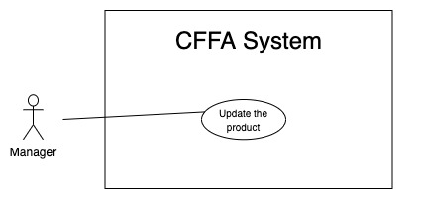

*Figure 24 - <Use Case> Update the product*

|  |  |  |  |
| --- | --- | --- | --- |
| ID and Name: | **UC-20 Update the product** | | |
| Created By: | HieuNT | Date Created: | 18/01/2021 |
| Primary Actor: | Admin | Secondary Actors: | N/A |
| Description: | This feature allows admin to update product information in CFFA system. | | |
| Trigger: | Admin sends a request to update the product. | | |
| Preconditions: | PRE-01. User has logged in the system as admin role.  PRE-02. Admin is on “Product detail” page. | | |
| Post-conditions: | POST-01. CFFA system updates product information.  POST-02. CFFA system returns the message. | | |
| Normal Flow: | **20.0 Update the product**   1. Admin sends a request to update the product. 2. CFFA system requires product information that includes:  * “Product Name”: input text * “Image”: button * “Category”: combobox * “Description”: input text * “Status”: combobox.  1. Admin inputs/selects the required fields. 2. Admin clicks on “Save” button. 3. CFFA system validates the fields (see 20.0.E1, 20.0.E2) 4. CFFA system updates product information and returns the message (MSG-013). | | |
| Alternative Flows: | N/A | | |
| Exceptions: | **20.0.E1 Admin does not input/select the required fields**   1. CFFA system returns to Manager to input/select the required fields again (MSG-014, MSG-016, MSG-026, MSG-028). 2. If Admin inputs/selects the required fields again, CFFA system returns to step 3 of normal flow. 3. Else if Admin cancels the login process, then CFFA system terminates this use case.   **20.0.E2 Admin inputs/selects the fields that are not valid**   1. CFFA system returns to Admin to input/select the fields again (MSG-015, MSG-017, MSG-027, MSG-029, MSG-034). 2. If Admin inputs/selects the fields again, CFFA system returns to step 3 of normal flow. 3. Else if Admin cancels the login process, then CFFA system terminates this use case. | | |
| Priority: | Medium | | |
| Frequency of Use: | Often | | |
| Business Rules: | BR-032, BR-047, BR-048, BR-049 | | |
| Other Information: | In case of internet connection failure, Admin cannot finish this use case properly. | | |
| Assumptions: | N/A | | |

*Table 13 - <Use Case> Update the product*

##### 2.2.3.12 <Admin> Delete the product

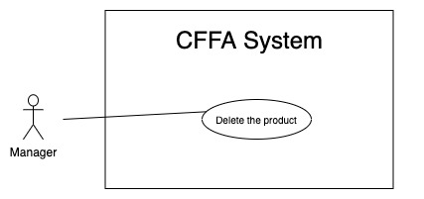

*Figure 24 - <Use Case> Delete the product*

|  |  |  |  |
| --- | --- | --- | --- |
| ID and Name: | **UC-21 Delete the product** | | |
| Created By: | HieuNT | Date Created: | 10/05/2021 |
| Primary Actor: | Admin | Secondary Actors: | N/A |
| Description: | This feature allows Admin to delete the product. | | |
| Trigger: | Admin sends a request to delete the product. | | |
| Preconditions: | PRE-01. User has logged in the system as Admin role.  PRE-02. Admin is on “Product detail” page. | | |
| Post-conditions: | POST-01. CFFA system updates product information.  POST-02. CFFA system returns the message. | | |
| Normal Flow: | **21.0 Delete the product**   1. Admin sends a request to delete the product. 2. CFFA system shows delete popup with message: "Are you sure?" and two buttons for Manager can select:  * "Yes" button * "No" button   1. Admin clicks on "Yes" button, CFFA system updates product information and returns the message (MSG-021) (see 21.0.E1).   2. Admin clicks on "No" button, close popup and nothing change. | | |
| Alternative Flows: | N/A | | |
| Exceptions: | **21.E1 The product does not exist**   1. CFFA system returns a message (MSG-023). 2. CFFA system redirects to manage product page and terminates this use case. | | |
| Priority: | Medium | | |
| Frequency of Use: | Often | | |
| Business Rules: | BR-032, BR-033, BR-049 | | |
| Other Information: | In case of internet connection failure, Admin cannot finish this use case properly. | | |
| Assumptions: | N/A | | |

*Table 24 - <Use Case> Delete the product*

##### 2.2.3.13 <Admin> Create new product

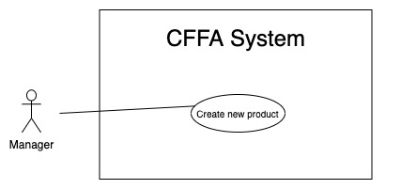

*Figure 26 - <Use Case> Create new product*

|  |  |  |  |
| --- | --- | --- | --- |
| ID and Name: | **UC-22 Create new product** | | |
| Created By: | HieuNT | Date Created: | 10/05/2021 |
| Primary Actor: | Admin | Secondary Actors: | N/A |
| Description: | This feature allows Admin to create new product. | | |
| Trigger: | Admin sends a request to create new product. | | |
| Preconditions: | PRE-01. User has logged in the system as Admin role.  PRE-02. Admin is on “Manage product” page. | | |
| Post-conditions: | POST-01. CFFA system stores newly created product information.  POST-02. CFFA system returns the message. | | |
| Normal Flow: | **22.0 Create new product**   1. Admin sends a request to create new product. 2. CFFA system requires the product information:    * "Product name": input text, blank    * "Description": input text, blank    * "Category": combobox    * "Image": button 3. Admin inputs/selects the required fields. 4. Admin clicks on the "Create" button to create new product. 5. CFFA system validates the required fields (see 22.0.E1, 22.0.E2) 6. CFFA system stores newly created product information and returns the message (MSG-013). | | |
| Alternative Flows: | N/A | | |
| Exceptions: | **22.0.E1 Admin does not input/select the required fields**   1. CFFA system returns to Admin to input/select the required fields again (MSG-014, MSG-016, MSG-026, MSG-028). 2. If Admin inputs/selects the required fields again, CFFA system returns to step 3 of normal flow. 3. Else if Admin cancels the login process, then CFFA system terminates this use case.   **22.0.E1 Admin inputs/selects the fields that are not valid**   1. CFFA system returns to Manager to input/select the fields again (MSG-015, MSG-017, MSG-027, MSG-029, MSG-034). 2. If Admin inputs/selects the fields again, CFFA system returns to step 3 of normal flow. 3. Else if Admin cancels the login process, then CFFA system terminates this use case. | | |
| Priority: | Medium | | |
| Frequency of Use: | Often | | |
| Business Rules: | BR-035, BR-051 | | |
| Other Information: | In case of internet connection failure, Admin cannot finish this use case properly. | | |
| Assumptions: | N/A | | |

*Table 25 - <Use Case> Create new product*

##### 2.2.3.14 <Admin> Update the camera

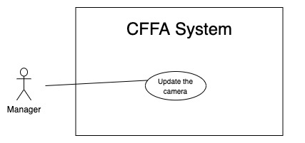

*Figure 29 - <Use Case> Update the camera*

|  |  |  |  |
| --- | --- | --- | --- |
| ID and Name: | **UC-25 Update the camera** | | |
| Created By: | HuuDN | Date Created: | 18/01/2021 |
| Primary Actor: | Admin | Secondary Actors: | N/A |
| Description: | This feature allows Admin to update camera information in CFFA system. | | |
| Trigger: | Admin sends a request to update the camera. | | |
| Preconditions: | PRE-01. User has logged in the system as Admin role.  PRE-02. Manager is on “Camera detail” page. | | |
| Post-conditions: | POST-01. CFFA system updates camera information.  POST-02. CFFA system returns the message. | | |
| Normal Flow: | **25.0 Update the camera**   1. Admin sends a request to update the camera. 2. CFFA system requires camera information that includes:  * “Camera Name”: input text * “Image”: button * “IP address”: input text * “RTSP string”: input text * “Status”: combobox.  1. Admin inputs/selects the required fields. 2. Admin clicks on “Save” button. 3. CFFA system validates the fields (see 25.0.E1, 25.0.E2) 4. CFFA system updates camera information and returns the message (MSG-013). | | |
| Alternative Flows: | N/A | | |
| Exceptions: | **25.0.E1 Admin does not input/select the required fields**   1. CFFA system returns to Admin to input/select the required fields again (MSG-014, MSG-026, MSG-028, MSG-031). 2. If Admin inputs/selects the required fields again, CFFA system returns to step 3 of normal flow. 3. Else if Admin cancels the login process, then CFFA system terminates this use case.   **25.0.E2 Admin inputs/selects the fields that are not valid**   1. CFFA system returns to Admin to input/select the fields again (MSG-015, MSG-027, MSG-029, MSG-032, MSG-034). 2. If Admin inputs/selects the fields again, CFFA system returns to step 3 of normal flow. 3. Else if Admin cancels the login process, then CFFA system terminates this use case. | | |
| Priority: | Medium | | |
| Frequency of Use: | Often | | |
| Business Rules: | BR-032, BR-055, BR-056, BR-57, BR-60, BR-078 | | |
| Other Information: | In case of internet connection failure, Admin cannot finish this use case properly. | | |
| Assumptions: | N/A | | |

*Table 28 - <Use Case> Update the product*

##### 2.2.3.15 <Admin> Delete the camera

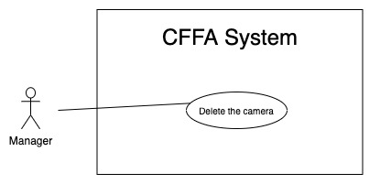

*Figure 29 - <Use Case> Delete the camera*

|  |  |  |  |
| --- | --- | --- | --- |
| ID and Name: | **UC-26 Delete the camera** | | |
| Created By: | HuuDN | Date Created: | 10/05/2021 |
| Primary Actor: | Admin | Secondary Actors: | N/A |
| Description: | This feature allows Admin to delete the camera. | | |
| Trigger: | Admin sends a request to delete the camera. | | |
| Preconditions: | PRE-01. User has logged in the system as manager role.  PRE-02. Admin is on “Camera detail” page. | | |
| Post-conditions: | POST-01. CFFA system updates camera information.  POST-02. CFFA system returns the message. | | |
| Normal Flow: | **26.0 Delete the camera**   1. Admin sends a request to delete the camera. 2. CFFA system shows delete popup with message: "Are you sure?" and two buttons for Admin can select:  * "Yes" button * "No" button   1. Admin clicks on "Yes" button, CFFA system updates camera information and returns the message (MSG-021) (see 26.0.E1).   2. Admin clicks on "No" button, close popup and nothing change. | | |
| Alternative Flows: | N/A | | |
| Exceptions: | **26.E1 The camera does not exist**   1. CFFA system returns a message (MSG-024). 2. CFFA system redirects to manage camera page and terminates this use case. | | |
| Priority: | Medium | | |
| Frequency of Use: | Often | | |
| Business Rules: | BR-032, BR-033, BR-058 | | |
| Other Information: | In case of internet connection failure, Admin cannot finish this use case properly. | | |
| Assumptions: | N/A | | |

*Table 24 - <Use Case> Delete the product*

##### 2.2.3.16 <Admin> Create new camera

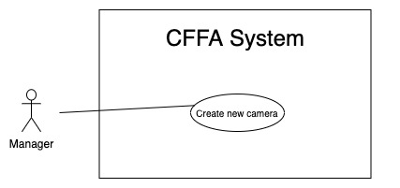

*Figure 30 - <Use Case> Create new camera*

|  |  |  |  |
| --- | --- | --- | --- |
| ID and Name: | **UC-27 Create new product** | | |
| Created By: | HuuDN | Date Created: | 10/05/2021 |
| Primary Actor: | Admin | Secondary Actors: | N/A |
| Description: | This feature allows Admin to create new camera. | | |
| Trigger: | Admin sends a request to create new camera. | | |
| Preconditions: | PRE-01. User has logged in the system as Admin role.  PRE-02. Admin is on “Manage camera” page. | | |
| Post-conditions: | POST-01. CFFA system stores newly created camera information.  POST-02. CFFA system returns the message. | | |
| Normal Flow: | **27.0 Create new camera**   1. Admin sends a request to create new camera. 2. CFFA system requires the camera information:    * "Camera name": input text, blank    * "Image": button    * "Ip address": input text, blank    * "RPST string": input text, blank 3. Admin inputs/selects the required fields. 4. Admin clicks on the "Create" button to create new camera. 5. CFFA system validates the required fields (see 27.0.E1, 27.0.E2). 6. CFFA system stores newly created camera information and returns the message (MSG-013). | | |
| Alternative Flows: | N/A | | |
| Exceptions: | **27.0.E1 Admin does not input/select the required fields**   1. CFFA system returns to Admin to input/select the required fields again (MSG-014, MSG-026, MSG-028, MSG-031). 2. If Admin inputs/selects the required fields again, CFFA system returns to step 3 of normal flow. 3. Else if Admin cancels the login process, then CFFA system terminates this use case.   **27.0.E1 Admin inputs/selects the fields that are not valid**   1. CFFA system returns to Admin to input/select the fields again (MSG-015, MSG-027, MSG-029, MSG-032, MSG-034). 2. If Admin inputs/selects the fields again, CFFA system returns to step 3 of normal flow. 3. Else if Admin cancels the login process, then CFFA system terminates this use case. | | |
| Priority: | Medium | | |
| Frequency of Use: | Often | | |
| Business Rules: | BR-035, BR-055, BR-059, BR-060 | | |
| Other Information: | In case of internet connection failure, Admin cannot finish this use case properly. | | |
| Assumptions: | N/A | | |

*Table 30 - <Use Case> Create new camera*

##### 2.2.3.17 <Admin> Update the category

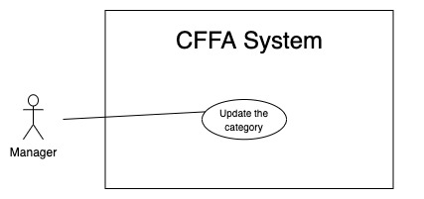

*Figure 33 - <Use Case> Update the category*

|  |  |  |  |
| --- | --- | --- | --- |
| ID and Name: | **UC-30 Update the category** | | |
| Created By: | HuuDN | Date Created: | 18/01/2021 |
| Primary Actor: | Admin | Secondary Actors: | N/A |
| Description: | This feature allows Admin to update category information in CFFA system. | | |
| Trigger: | Admin sends a request to update the category. | | |
| Preconditions: | PRE-01. User has logged in the system as Admin role.  PRE-02. Admin is on “Category detail” page. | | |
| Post-conditions: | POST-01. CFFA system updates category information.  POST-02. CFFA system returns the message. | | |
| Normal Flow: | **30.0 Update the category**   1. Admin sends a request to update the camera. 2. CFFA system requires category information that includes:  * “Category Name”: input text  1. Admin inputs/selects the required fields. 2. Admin clicks on “Save” button. 3. CFFA system validates the fields (see 30.0.E1, 30.0.E2) 4. CFFA system updates camera information and returns the message (MSG-013). | | |
| Alternative Flows: | N/A | | |
| Exceptions: | **30.0.E1 Admin does not input/select the required fields**   1. CFFA system returns to Admin to input/select the required fields again (MSG-014). 2. If Admin inputs/selects the required fields again, CFFA system returns to step 3 of normal flow. 3. Else if Admin cancels the login process, then CFFA system terminates this use case.   **30.0.E2 Admin inputs/selects the fields that are not valid**   1. CFFA system returns to Admin to input/select the fields again (MSG-015, MSG-034). 2. If Admin inputs/selects the fields again, CFFA system returns to step 3 of normal flow. 3. Else if Admin cancels the login process, then CFFA system terminates this use case. | | |
| Priority: | Medium | | |
| Frequency of Use: | Often | | |
| Business Rules: | BR-063 | | |
| Other Information: | In case of internet connection failure, Admin cannot finish this use case properly. | | |
| Assumptions: | N/A | | |

*Table 33 - <Use Case> Update the product*

##### 2.2.3.18 <Admin> Create new category

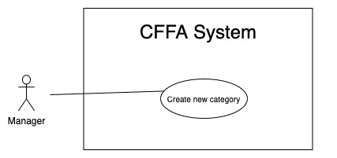

*Figure 35 - <Use Case> Create new category*

|  |  |  |  |
| --- | --- | --- | --- |
| ID and Name: | **UC-31 Create new category** | | |
| Created By: | TruongTN | Date Created: | 10/05/2021 |
| Primary Actor: | Admin | Secondary Actors: | N/A |
| Description: | This feature allows Admin to create new category. | | |
| Trigger: | Admin sends a request to create new category. | | |
| Preconditions: | PRE-01. User has logged in the system as Admin role.  PRE-02. Admin is on “Manage category” page. | | |
| Post-conditions: | POST-01. CFFA system stores newly created category information.  POST-02. CFFA system returns the message. | | |
| Normal Flow: | **31.0 Create new camera**   1. Admin sends a request to create new category. 2. CFFA system requires the category information:    * "Category name": input text, blank 3. Admin inputs the required fields. 4. Admin clicks on the "Create" button to create new category. 5. CFFA system validates the required fields (see 31.0.E1, 31.0.E2). 6. CFFA system stores newly created category information and returns the message (MSG-013). | | |
| Alternative Flows: | N/A | | |
| Exceptions: | **31.0.E1 Admin does not input/select the required fields**   1. CFFA system returns to Admin to input the required fields again (MSG-014). 2. If Admin inputs/selects the required fields again, CFFA system returns to step 3 of normal flow. 3. Else if Admin cancels the login process, then CFFA system terminates this use case.   **31.0.E1 Admin inputs the fields that are not valid**   1. CFFA system returns to Admin to input the fields again (MSG-015, MSG-034). 2. If Admin inputs the fields again, CFFA system returns to step 3 of normal flow. 3. Else if Admin cancels the login process, then CFFA system terminates this use case. | | |
| Priority: | Medium | | |
| Frequency of Use: | Often | | |
| Business Rules: | BR-063 | | |
| Other Information: | In case of internet connection failure, Admin cannot finish this use case properly. | | |
| Assumptions: | N/A | | |

*Table 31 - <Use Case> Create new category*

## 3. Other Requirements

### 3.1 Messages List

|  |  |  |  |  |
| --- | --- | --- | --- | --- |
| **#** | **Message code** | **Message Type** | **Context** | **Content** |
| 1 | MSG-001 | In line, under input form, red text | The username is empty. | Username is required. |
| 2 | MSG-002 | In line, under input form, red text | The password is empty. | Password is required. |
| 3 | MSG-003 | In line, under input form, red text | Invalid username or password. | Invalid username or password. |
| 4 | MSG-004 | In line, under input form, red text | The old password cannot be empty | Old password is required |
| 5 | MSG-005 | In line, under input form, red text | The new password cannot be empty | New password is required |
| 6 | MSG-006 | in line, text field, red text | The retype password cannot be empty | Retype password is required |
| 7 | MSG-007 | in line, text field, red text | The new password and retype password must be matched | New password and retype password must be matched |
| 8 | MSG-008 | In line, under input form, red text | The password must be must contain :  - At least one digit [0-9]. - At least one lowercase Latin character [a-z]. - At least one uppercase Latin character [A-Z]. - At least one special character like ! @ # & ( ). - At least 8 characters and a maximum of 20 characters. | The password must be must contain :  - At least one digit [0-9]. - At least one lowercase Latin character [a-z]. - At least one uppercase Latin character [A-Z]. - At least one special character like ! @ # & ( ). - At least 8 characters and a maximum of 20 characters. |
| 9 | MSG-009 | In line, under input form, red text | The list has no data | No data |
| 10 | MSG-010 | In line, under input form, red text | The report has no data | No data |
| 11 | MSG-011 | in line, text field, red text | The video doesn't exist | No data |
| 12 | MSG-012 | in line, text field, red text | The shelf doesn't exist | This shelf doesn't exist |
| 13 | MSG-013 | in line, text field, red text | The updating process is successful | Updating process is successful |
| 14 | MSG-014 | in line, text field, red text | The name is empty | The name is required |
| 15 | MSG-015 | in line, text field, red text | The fullname is between 1 to 100 characters | The fullname is between 1 to 100 characters |
| 16 | MSG-016 | in line, text field, red text | The description is empty | The description is required |
| 17 | MSG-017 | in line, text field, red text | The description is between 1 to 250 characters | The description is between 1 to 250 characters |
| 18 | MSG-018 | in line, text field, red text | The shelf's maximum of stack is empty | The shelf's maximum of stack is required |
| 19 | MSG-019 | in line, text field, red text | The shelf's maximum of stack is between 1 to 30 stacks | The shelf's maximum of stack is between 1 to 30 stacks |
| 20 | MSG-020 | in line, text field, red text | The camera id can not empty. | The camera id is required. |
| 21 | MSG-021 | in line, text field, red text | The deleting process is successful | Deleting process is successful |
| 22 | MSG-022 | in line, text field, red text | The stack doesn't exist | This stack doesn't exist |
| 23 | MSG-023 | in line, text field, red text | The product doesn't exist | This product doesn't exist |
| 24 | MSG-024 | in line, text field, red text | The camera doesn't exist | This camera doesn't exist |
| 25 | MSG-025 | in line, text field, red text | The shelf has total of stacks equal then maximum of stacks | This shelf is full |
| 26 | MSG-026 | in line, text field, red text | The image is empty | Image is required |
| 27 | MSG-027 | in line, text field, red text | The image is not png, jpg, jpeg format | The image must be png, jpg, jpeg format |
| 28 | MSG-028 | in line, text field, red text | The category is empty | Category is required |
| 29 | MSG-029 | in line, text field, red text | The category does not exist | Category does not exist |
| 30 | MSG-030 | in line, text field, red text | The ip address is empty | The RTSP string is required |
| 31 | MSG-031 | in line, text field, red text |  |  |
| 32 | MSG-032 | in line, text field, red text | The ip address must be x.x.x.x format (x is number between 0 to 255) | The ip address must be x.x.x.x format (x is number between 0 to 255) |
| 33 | MSG-033 | in line, text field, red text | The category doesn't exist | The category doesn't exist |
| 34 | MSG-034 | in line, text field, red text | The name already exist | The name already exist |
| 35 | MSG-035 | in line, text field, red text | The store doesn't exist | The store doesn't exist |
| 36 | MSG-036 | in line, text field, red text | The address is empty | Address is required |
| 37 | MSG-037 | in line, text field, red text | The address is between 1 to 250 characters | Address is between 1 to 250 characters |
| 38 | MSG-038 | in line, text field, red text | City has not been selected | City is required |
| 39 | MSG-039 | in line, text field, red text | District has not been selected | District is required |
| 40 | MSG-040 | in line, text field, red text |  |  |
| 41 | MSG-041 | in line, text field, red text | The manager doesn't exist | The manager doesn't exist |
| 42 | MSG-042 | in line, text field, red text | Employee code is empty | Employee code is required |
| 43 | MSG-043 | in line, text field, red text | Manager already exists | Manager already exists |
| 44 | MSG-044 | in line, text field, red text | Email is empty | Email is required |
| 45 | MSG-045 | in line, text field, red text | Email does not match /^(([^<>()[\]\\.,;:\s@"]+(\.[^<>()[\]\\.,;:\s@"]+)*)|(".+"))@((\[[0-9]{1,3}\.[0-9]{1,3}\.[0-9]{1,3}\.[0-9]{1,3}\])|(([a-zA-Z\-0-9]+\.)+[a-zA-Z]{2,}))$/ regex | Email is wrong format |
| 46 | MSG-046 | in line, text field, red text | Status doesn't exist | Status doesn't exist |
| 47 | MSG-047 | in line, text field, red text | Birthdate is empty | Birthdate is required |
| 48 | MSG-048 | in line, text field, red text | Current year minus birth year is less than 15 | Birthdate is invalid |
| 49 | MSG-049 | in line, text field, red text | Phone is empty | Phone is empty |
| 50 | MSG-050 | in line, text field, red text | Phone is between 10 to 13 digits | Phone is between 10 to 13 digits |
| 51 | MSG-051 | in line, text field, red text | Identity card is empty | Identity card is required |
| 52 | MSG-052 | in line, text field, red text | Identity card includes from 9 to 12 digits | Identity card includes from 9 to 12 digits |
| 53 | MSG-053 | in line, text field, red text | Password is wrong | Password is wrong |
| 54 | MSG-054 | in line, text field, red text | Gender is empty | Gender is required. |
| 55 | MSG-055 | in line, text field, red text | Email is exist. | Email is exist. |
| 56 | MSG-056 | in line, text field, red text | Identify card is exist | Identify card is exist |
| 57 | MSG-057 | in line, text field, red text | IPAddress is exist | IPAddress is exist |
| 58 | MSG-058 | in line, text field, red text | RTSPString is exist | RTSPString is exist |
| 59 | MSG-059 | in line, text field, red text | CategoryName is exist | CategoryName is exist |
| 60 | MSG-060 | in line, text field, red text | ProductName is exist | ProductName is exist |
| 61 | MSG-061 | in line, text field, red text | ShelfName is exist | ShelfName is exist |
| 62 | MSG-062 | in line, text field, red text | StoreName is exist | StoreName is exitst |
| 63 | MSG-063 | in line, text field, red text | The manager does not found. | The manager does not found. |
| 64 | MSG-064 | in line, text field, red text | Create manager successfully. | Create manager successfully. |
| 65 | MSG-065 | in line, text field, red text | This status is not exist. | This status is not exist. |
| 66 | MSG-066 | in line, text field, red text | Changing status must be followed by business rules: - Pending status can be changed to be inactive status if it has an inactive reason and mappings are inactive. - Inactive status only changing to be pending status. | Changing status must be followed by business rules: - Pending status can be changed to be inactive status if it has an inactive reason and mappings are inactive. - Inactive status only changing to be pending status. |
| 67 | MSG-067 | in line, text field, red text | Inactive reason must be from 1 to 250 characters. | Inactive reason must be from 1 to 250 characters. |
| 68 | MSG-068 | in line, text field, red text | The old password is not correct. | The old password is not correct. |
| 69 | MSG-069 | in line, text field, red text | StoreID can not empty. | StoreID can not empty. |
| 70 | MSG-070 | in line, text field, red text | Analyzed time can not empty. | Analyzed time can not empty. |
| 71 | MSG-071 | in line, text field, red text | ShelfId can not empty when get shelf detail | ShelfId can not be empty. |
| 72 | MSG-072 | in line, text field, red text | Wrong time format (hh:mm:ss) | Time must be format (hh:mm:ss) |
| 73 | MSG-073 | in line, text field, red text | BirthDate must be follow by format yyyy-MM-dd HH:mm:ss | BirthDate must be follow by format yyyy-MM-dd HH:mm:ss |
| 74 | MSG-074 | in line, text field, red text | Manager is not found Manager status is not pending | Manager is not available. |
| 75 | MSG-075 | in line, text field, red text | Store is not found Store status is not pending | Store is not available. |
| 76 | MSG-076 | in line, text field, red text | System can not finish this action | System can not finish this action |
| 77 | MSG-077 | in line, text field, red text | Store and Manager is not mapping | Store and manager is not mapping. |
| 78 | MSG-078 | in line, text field, red text | Stack ID is not empty | Stack ID is required. |
| 79 | MSG-079 | in line, text field, red text | Shelf name is empty | Shelf name is required |
| 80 | MSG-080 | in line, text field, red text | Shelf name must be from 1 to 100 characters. | Shelf name must be from 1 to 100 characters. |
| 81 | MSG-081 | in line, text field, red text | Store contain shelfs active or pending. | Store contain shelfs active or pending. |
| 82 | MSG-082 | in line, text field, red text | Camera name can not be empty | Camera name is required. |
| 83 | MSG-083 | in line, text field, red text | Camera name must be from 1 to 100 characters. | Camera name must be from 1 to 100 characters. |
| 84 | MSG-084 | in line, text field, red text | TypeDetect must be 1 or 2. | TypeDetect is not exist. |
| 85 | MSG-085 | in line, text field, red text | Shelf must be exist and not active. | Shelf must be exist and not active. |
| 86 | MSG-086 | in line, text field, red text | Camera must be exist and not active. | Camera must be exist and not active. |
| 87 | MSG-087 | in line, text field, red text | Camera or Shelf is not available. | Camera or Shelf is not available. |
| 88 | MSG-088 | in line, text field, red text | Shelf and Camera is not mapping | Shelf and Camera is not mapping |
| 89 | MSG-089 | in line, text field, red text | Product is not active. | Product is not active. |
| 90 | MSG-090 | in line, text field, red text | Stack is already active or inactive. | Stack is already active or inactive. |
| 91 | MSG-091 | in line, text field, red text | Stack is already have a product. | Stack is already have a product. |
| 92 | MSG-092 | in line, text field, red text | Product and stack is not mapping. | Product and stack is not mapping. |
| 93 | MSG-093 | in line, text field, red text | Camera is already active or inactive. | Camera is already active or inactive. |
| 94 | MSG-094 | in line, text field, red text | Camera and stack is not mapping. | Camera and stack is not mapping. |
| 95 | MSG-095 | in line, text field, red text | Stack contain product. | Stack contain product. |
| 96 | MSG-096 | in line, text field, red text | Product ID is required. | Product ID is required. |
| 97 | MSG-097 | in line, text field, red text | Have stack contain this product. | Have stack contain this product. |
| 98 | MSG-098 | in line, text field, red text | Changing status product must be followed by business rules:\n- Active status can be changed to be inactive status if it has an inactive reason, and no any stack contain it.\n | Changing status product must be followed by business rules:\n- Active status can be changed to be inactive status if it has an inactive reason, and no any stack contain it.\n |
| 99 | MSG-099 | in line, text field, red text | Product name is required. | Product name is required. |
| 100 | MSG-100 | in line, text field, red text | Stack much contain product. | Stack much contain product. |
| 101 | MSG-101 | in line, text field, red text | Stack already active. | Stack already active. |
| 102 | MSG-102 | in line, text field, red text | Catelogy is required. | Catelogy is required. |
| 103 | MSG-103 | in line, text field, red text | Catelogy list at least 1 item, and maximum is 3. | Catelogy list at least 1 item, and maximum is 3. |
| 104 | MSG-104 | in line, text field, red text | Catelogy list contain invalid id. | Catelogy list contain invalid id. |
| 105 | MSG-105 | in line, text field, red text | Catelogy name is required. | Catelogy name is required. |
| 106 | MSG-106 | in line, text field, red text | Store name is required. | Store name is required. |
| 107 | MSG-107 | in line, text field, red text | Store address is required. | Store address is required. |
| 108 | MSG-108 | in line, text field, red text | Store analyzed time is required. | Store analyzed time is required. |
| 109 | MSG-109 | in line, text field, red text | This category is being used. | This category is being used. |
| 110 | MSG-100 | in line, text field, red text | Changing status category must be followed by business rules:\n- Active status can be changed to be inactive status if it has no product using it.\n | Changing status category must be followed by business rules:\n- Active status can be changed to be inactive status if it has no product using it.\n |

# IV. Software Design Description

## 1. Overall Description

aaaa

## 2. System Architecture Design

bbbb

## 3. System Detailed Design

### 3.1 Overall

#### a. Class Diagram

<img class diagram>

#### b. Class Specification

<cac table attribute cua class diagram>

#### c. Sequence Diagram(s)

Unauthenticated user who has not been identified by CFFA system. Unauthenticated user has limited access to the system with the following feature:

##### c1 <Admin> Sequence Diagram(s)

###### c1.1 <Admin> Get the stores

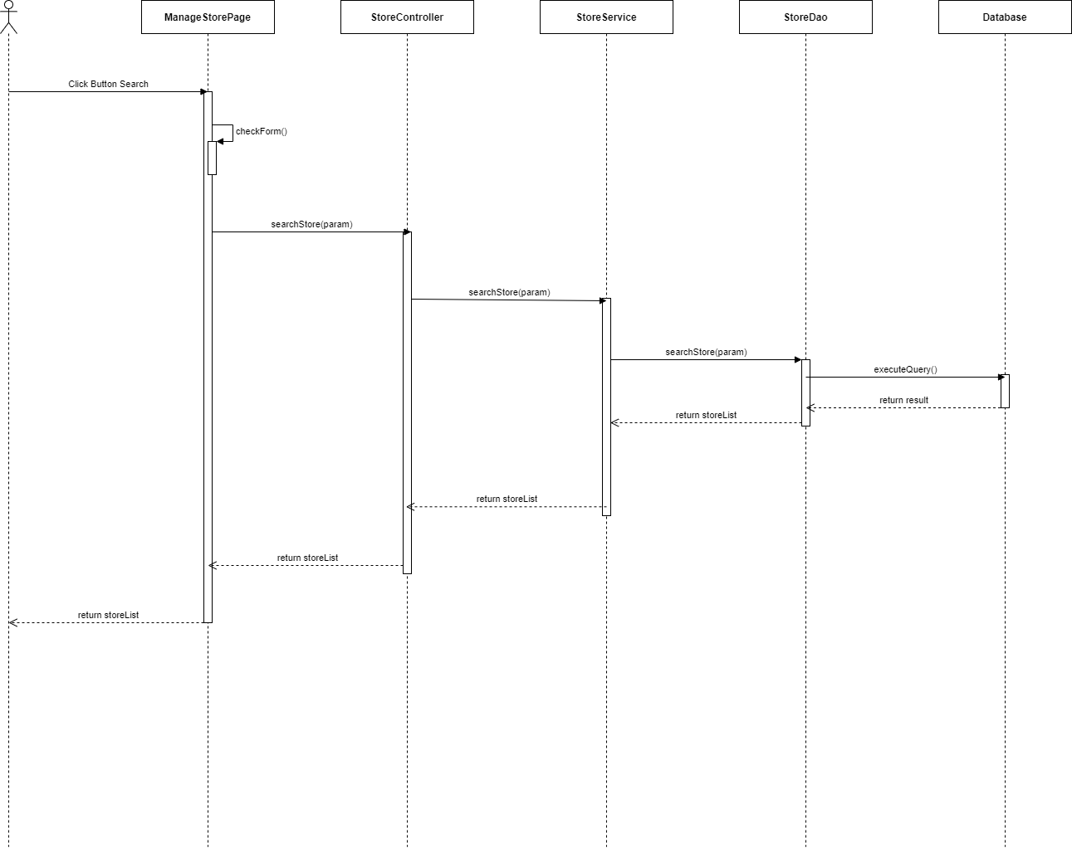

*Figure 1 - <Sequence Diagram> Get the stores*

###### c1.2 <Admin> Get store detail

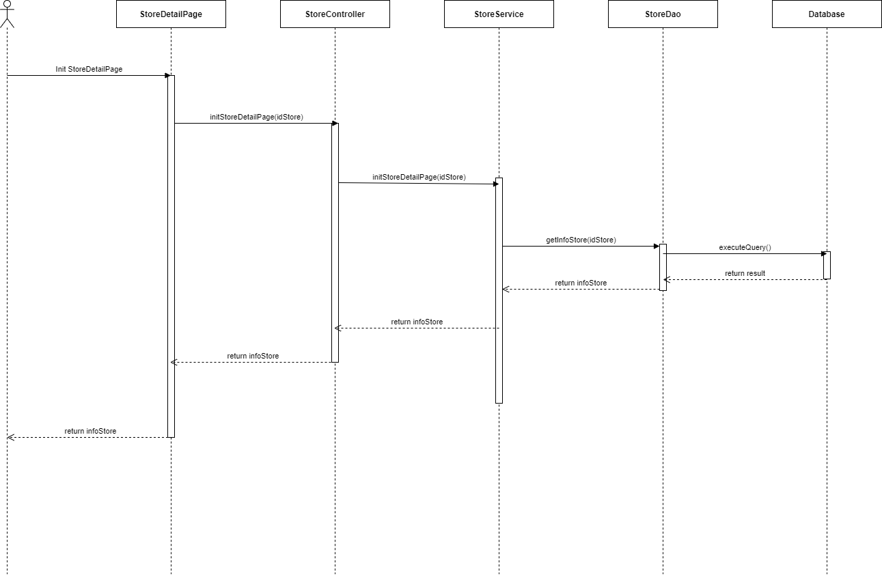

*Figure 1 - <Sequence Diagram> Get store detail*

###### c1.3 <Admin> Update the store

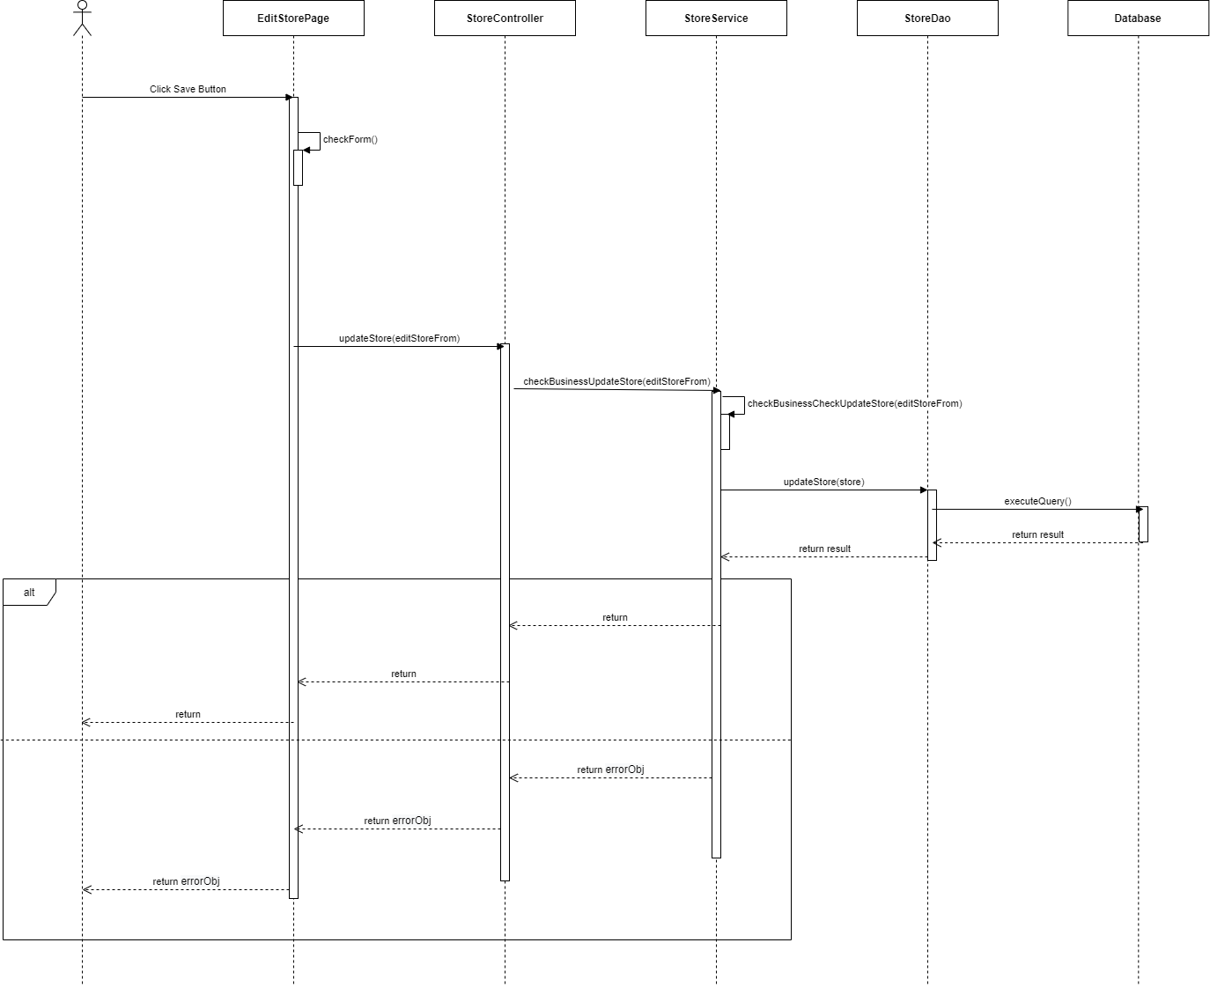

*Figure 1 - <Sequence Diagram> Update the store*

###### c1.4 <Admin> Delete the store

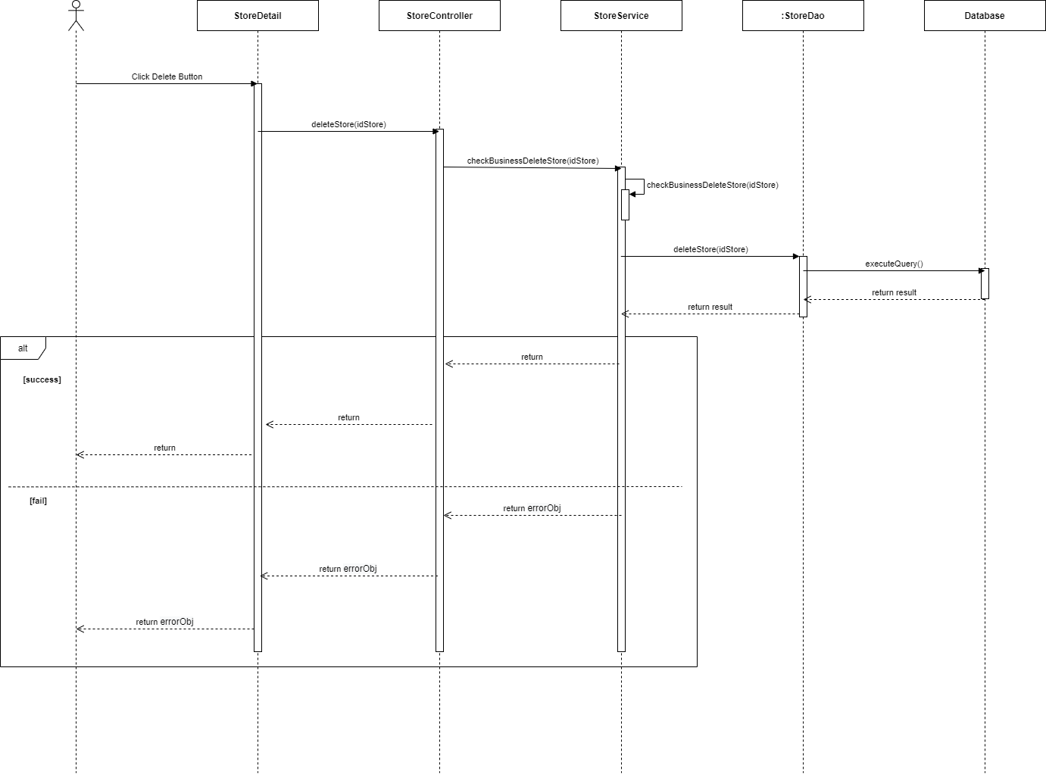

*Figure 1 - <Sequence Diagram> Delete the store*

###### c1.5 <Admin> Create the store

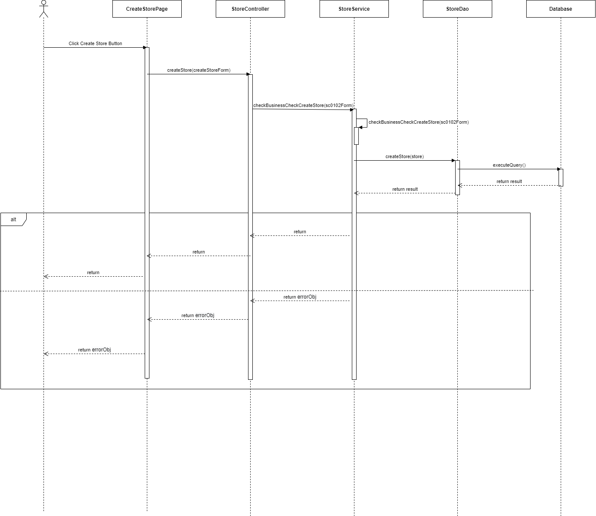

*Figure 1 - <Sequence Diagram> Create the store*

###### c1.6 <Admin> Get the managers

###### c1.7 <Admin> Get manager detail

###### c1.8 <Admin> Update the manager

###### c1.9 <Admin> Delete the manager

###### c1.10 <Admin> Create new manager

###### c1.11 <Admin> Update the product

###### c1.12 <Admin> Delete the product

###### c1.13 <Admin> Create new product

###### c1.14 <Admin> Update the camera

###### c1.15 <Admin> Delete the camera

###### c1.16 <Admin> Create the camera

###### c1.17 <Admin> Update the category

###### c1.18 <Admin> Create new category

##### c2 <Manager> Sequence Diagram(s)

###### c2.1 <Manager> Get the shelves

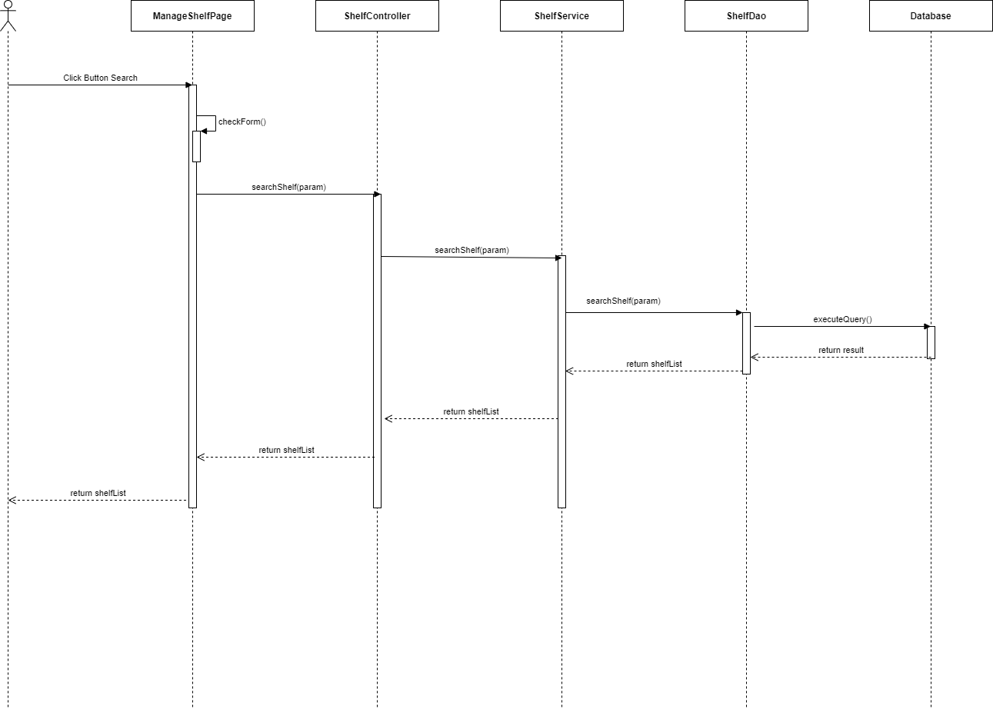

*Figure 1 - <Sequence Diagram> Get the shelves*

###### c2.2 <Manager > Get shelf detail

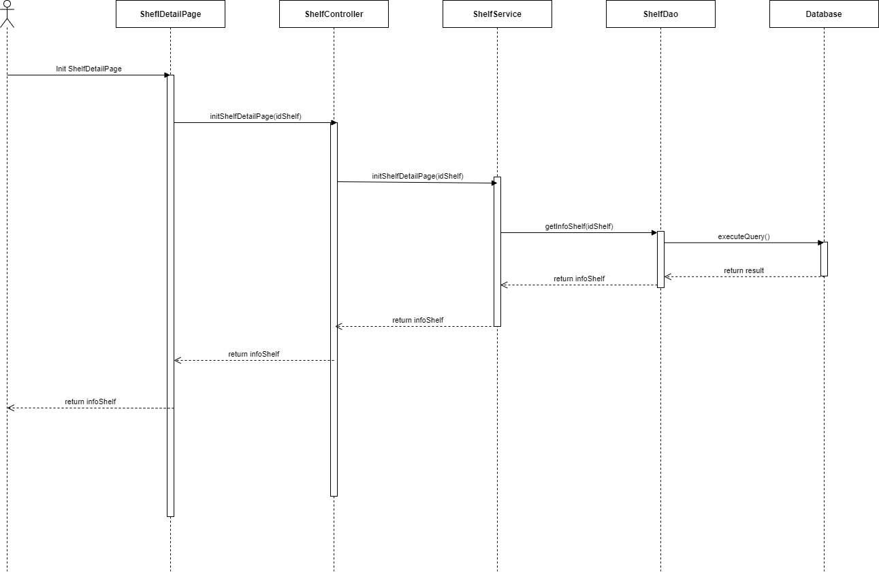

*Figure 1 - <Sequence Diagram> Get shelf detail*

###### c2.3 <Manager> Update the shelf

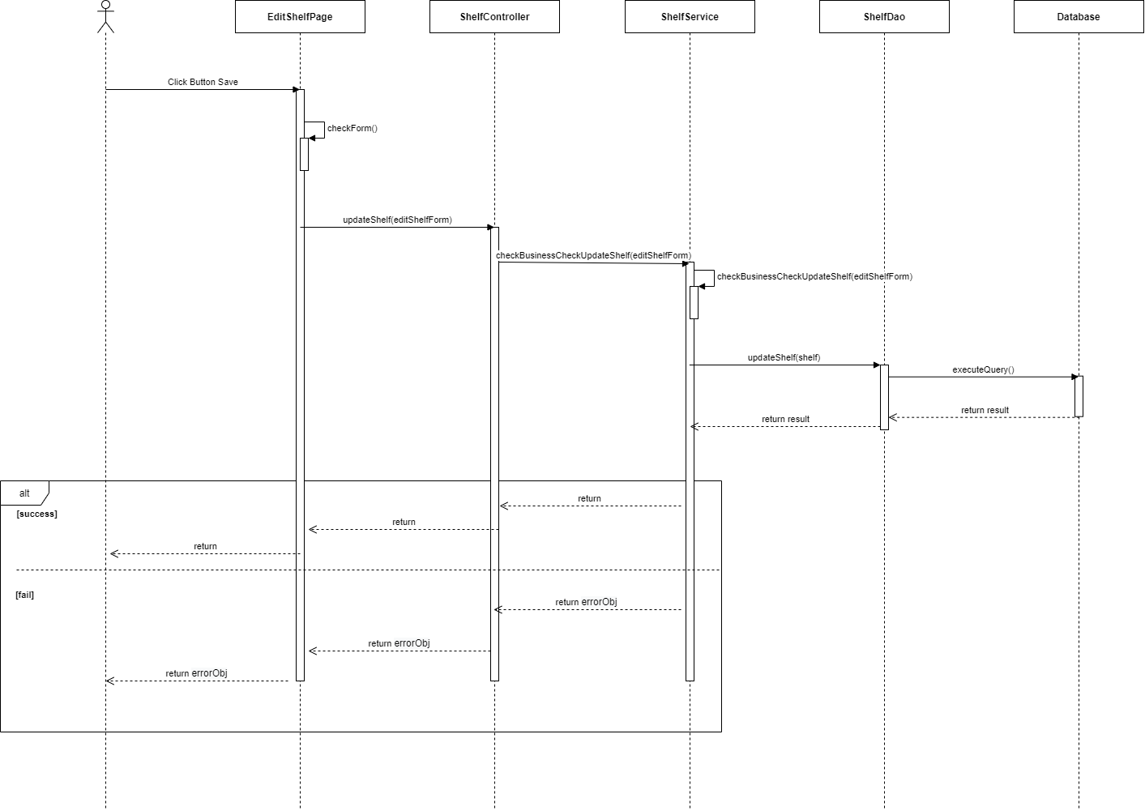

*Figure 1 - <Sequence Diagram> Update the shelf*

###### c2.4 <Manager> Delete the shelf

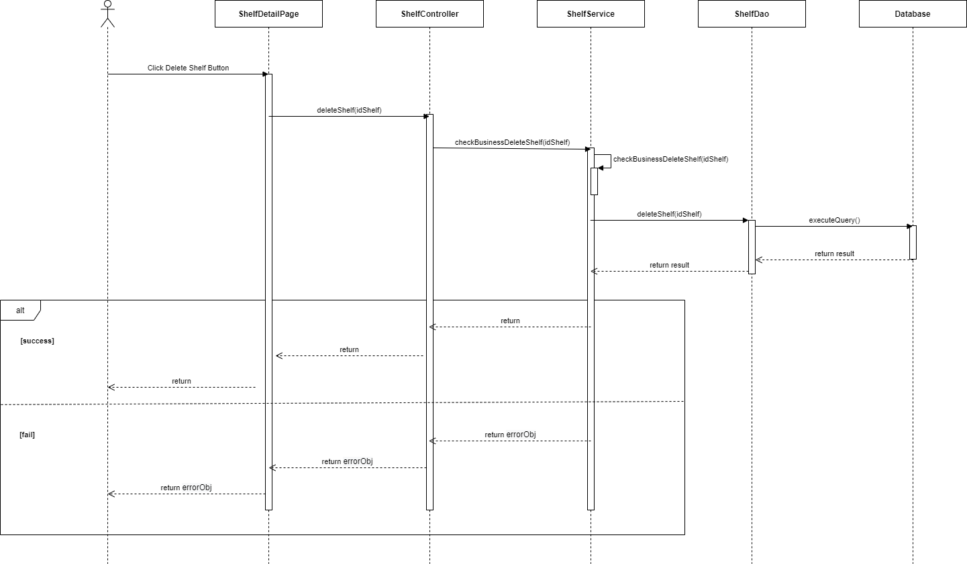

*Figure 1 - <Sequence Diagram> Delete the shelf*

###### c2.5 <Manager> Create new shelf

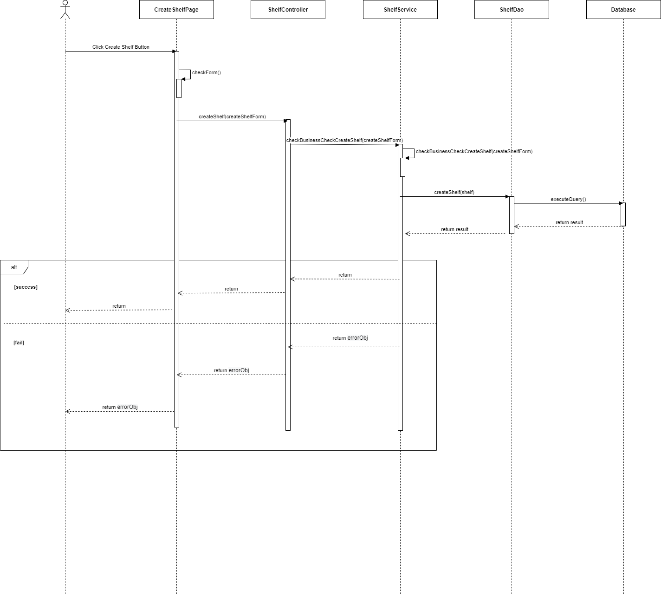

*Figure 1 - <Sequence Diagram> Create new shelf*

###### c2.6 <Manager> Get the stacks

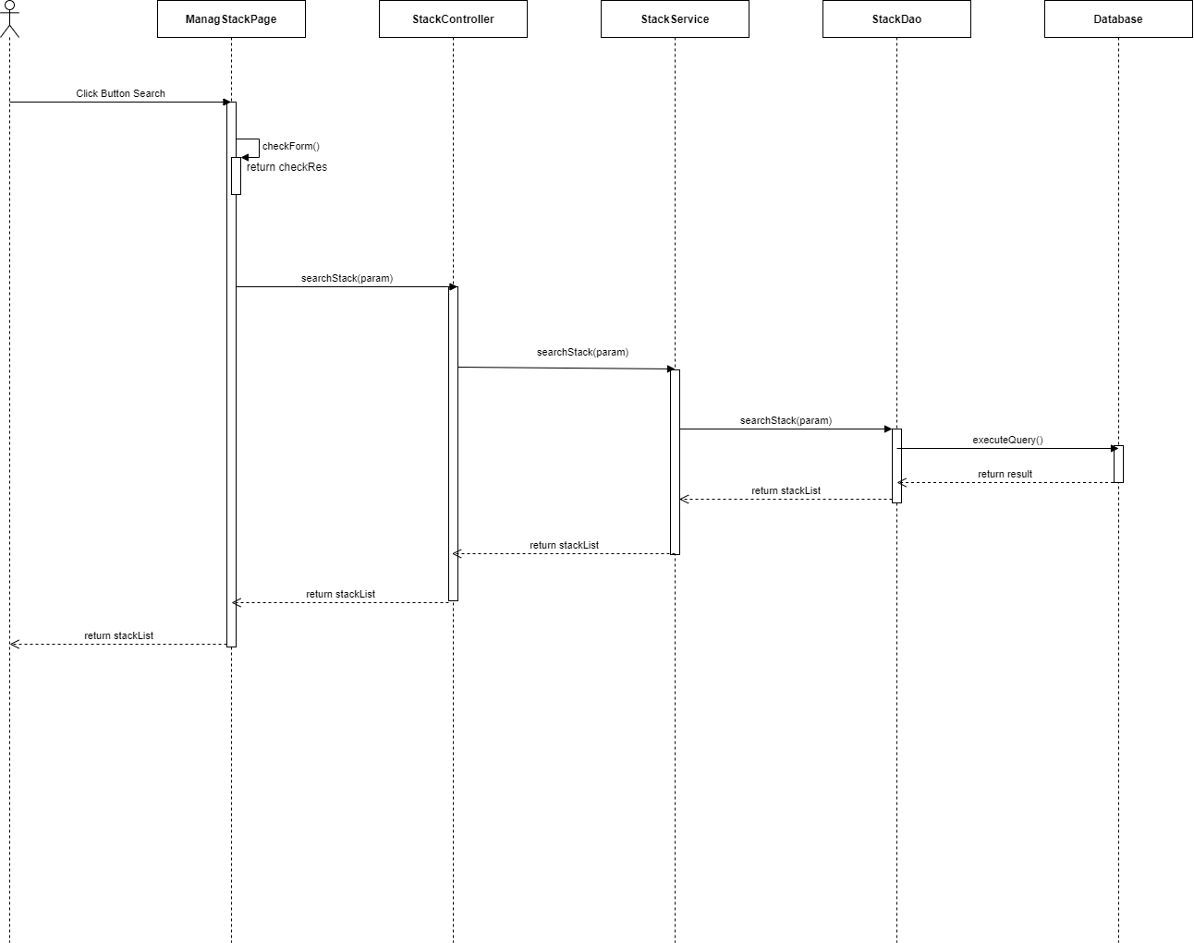

*Figure 1 - <Sequence Diagram> Get the stacks*

###### c2.7 <Manager > Get stack detail

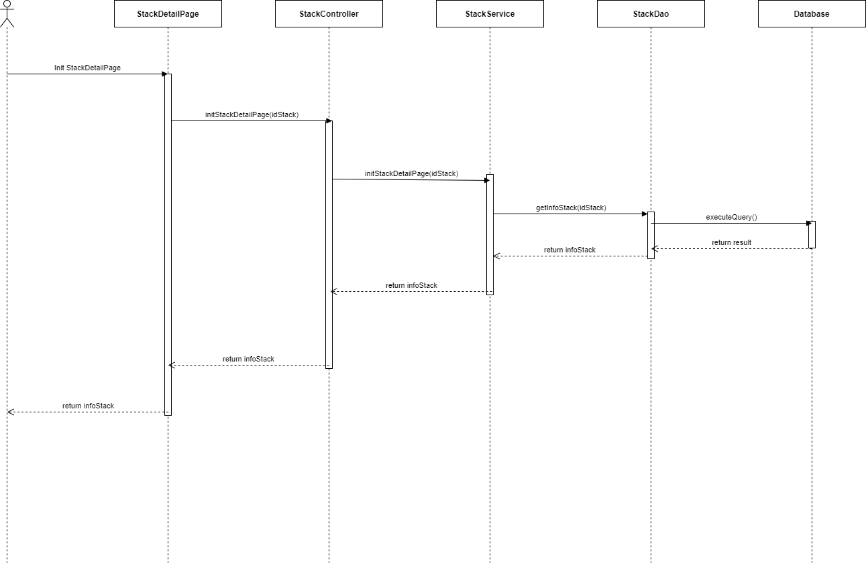

*Figure 1 - <Sequence Diagram> Get stack detail*

###### c2.8 <Manager> Update the stack

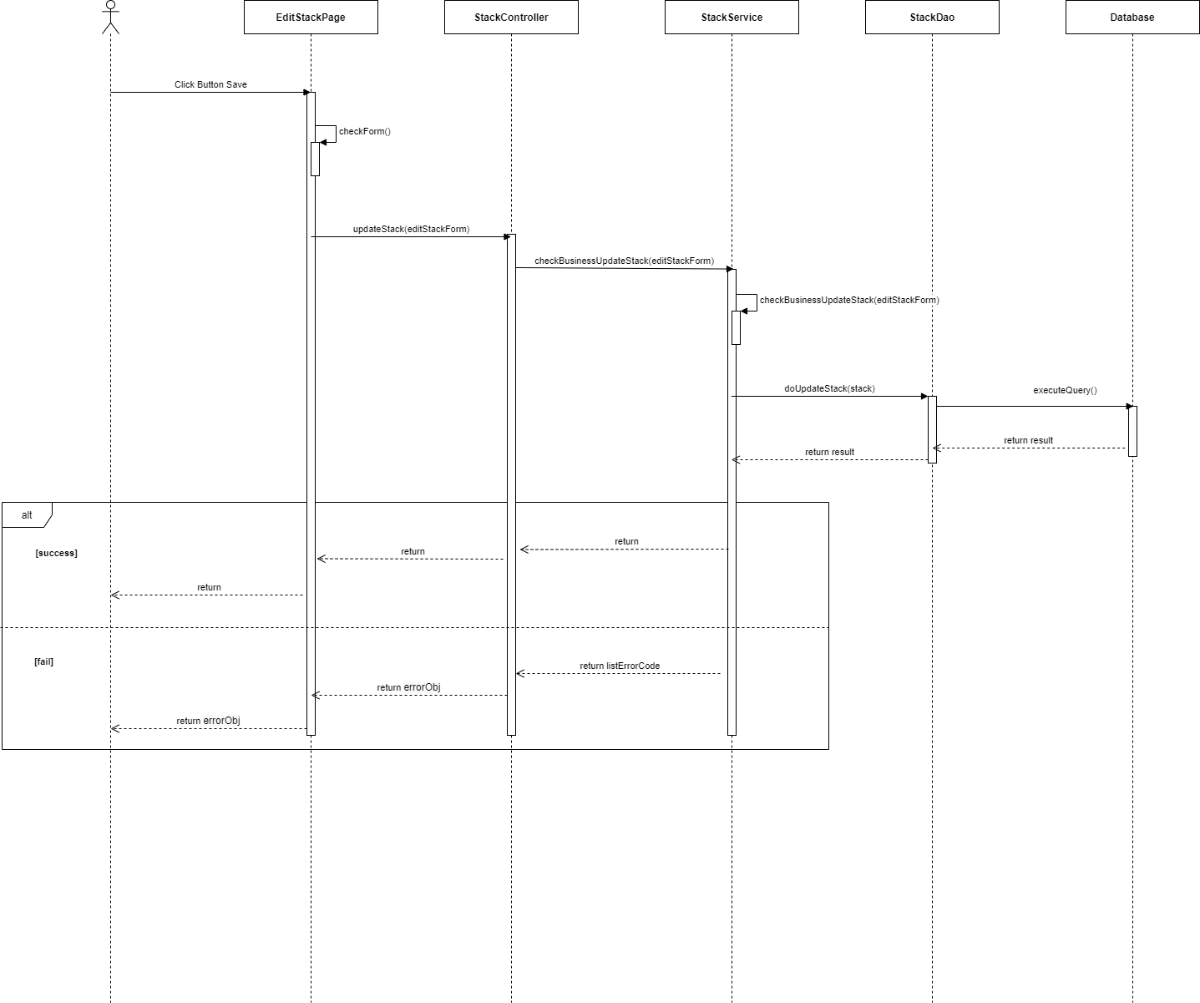

*Figure 1 - <Sequence Diagram> Update the stack*

###### c2.9 <Manager> Delete the stack

###### c2.10 <Manager> Create new stack

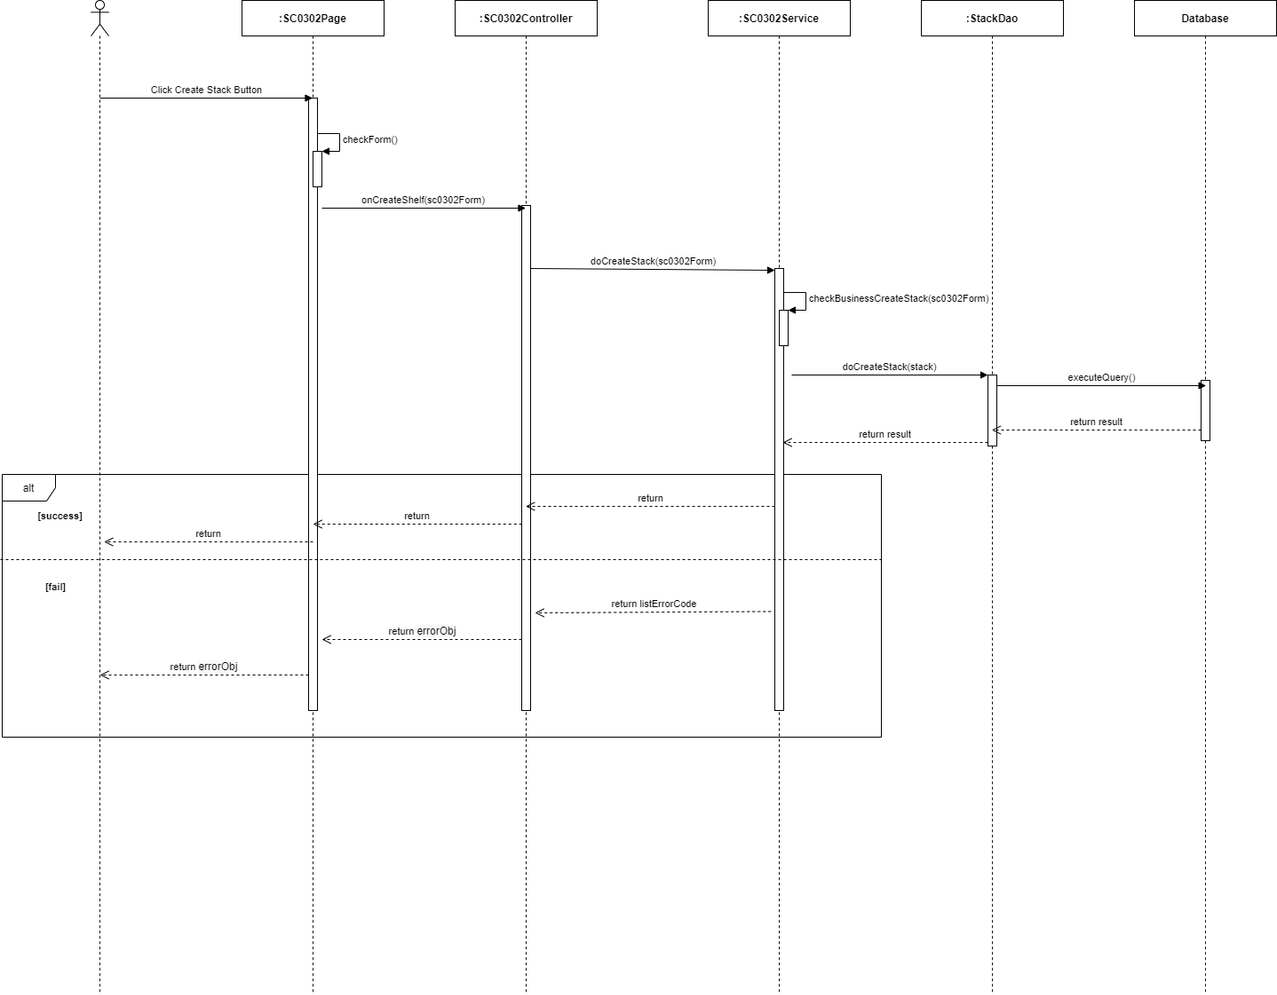

*Figure 1 - <Sequence Diagram> Create new stack*

##### c3 <Authenticated User> Sequence Diagram(s)

###### c3.1 <Authenticated User> Logout

###### c3.2 <Authenticated User> Change account's password

###### c3.3 <Authenticated User> Get the report

###### c3.4 <Authenticated User> Export the report

###### c3.5 <Authenticated User> Get the video

###### c3.6 <Authenticated User> Get the products

###### c3.7 <Authenticated User> Get product detail

###### c3.8 <Authenticated User> Get the categories

###### c3.9 <Authenticated User> Get category detail

###### c3.10 <Authenticated User> Get camera detail

###### c3.11 <Authenticated User> Get the cameras

##### c4 <Unauthenticated User> Sequence Diagram(s)

###### c4.1 <Unauthenticated User> Login by account

#### d. Activity Diagram(s)

##### d1 <Unauthenticated User> Activity Diagram(s)

###### d1.1 <Unauthenticated User> Login by account

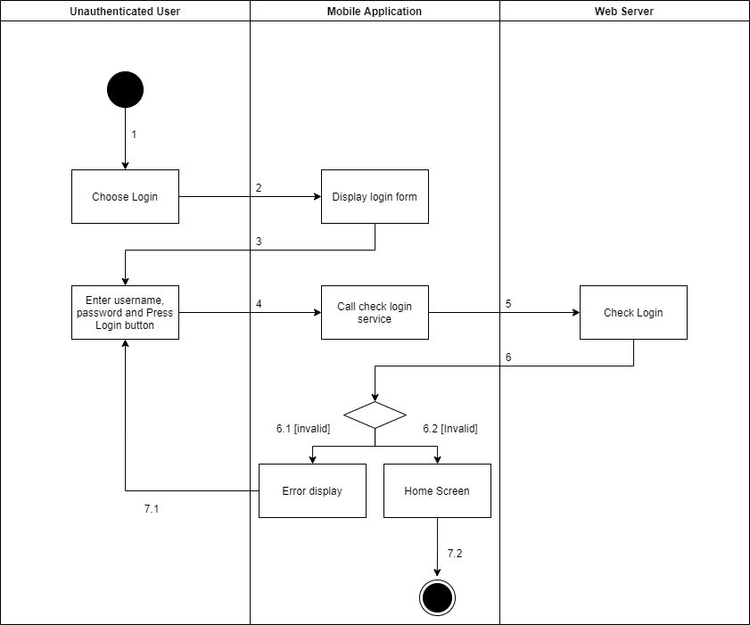

*Figure 1 - <Activity Diagram> Login by account*

##### d2 <Admin> Activity Diagram(s)

###### d2.1 <Admin> Get the stores

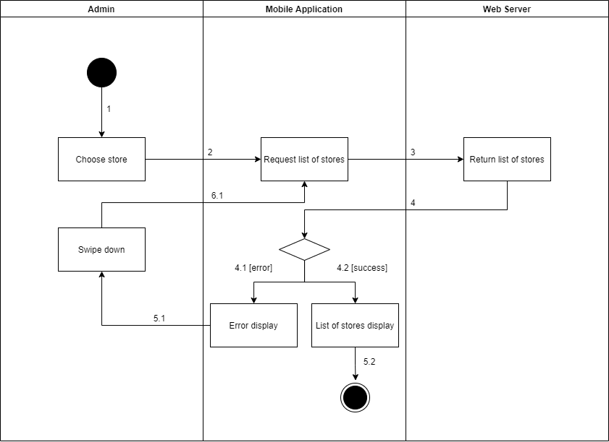

*Figure 1 - <Activity Diagram> Get the stores*

###### d2.2 <Admin> Get store detail

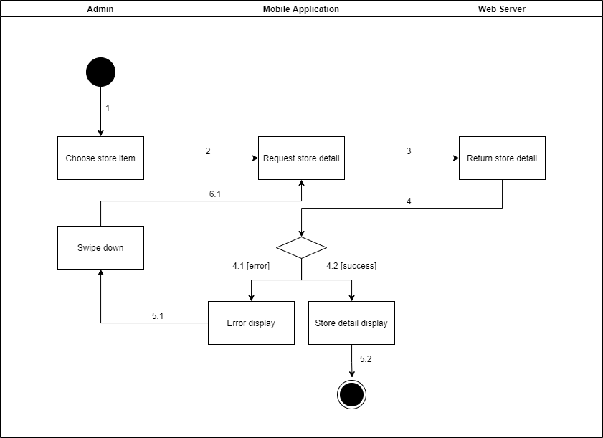

*Figure 1 - <Activity Diagram> Get store detail*

###### d2.3 <Admin> Update the store

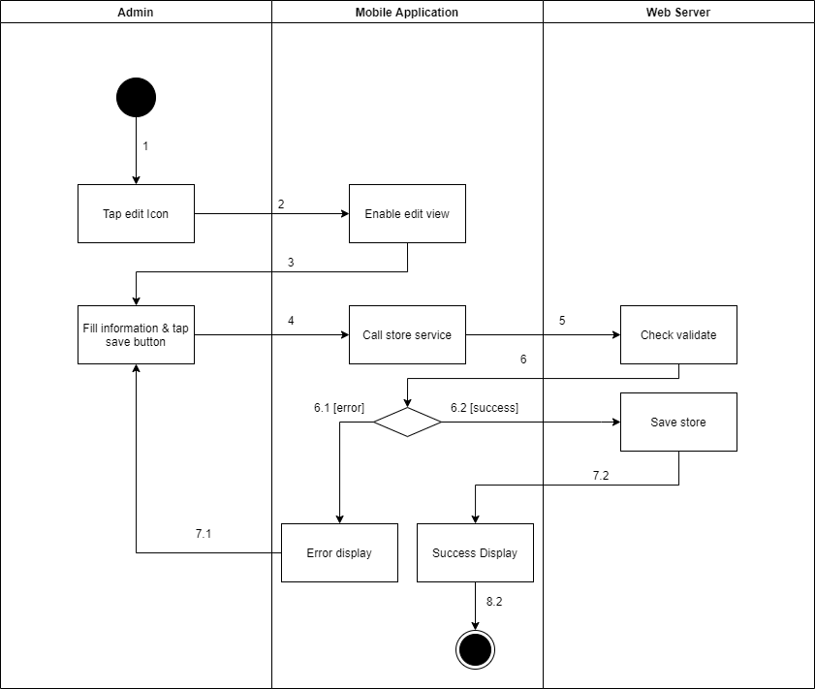

*Figure 1 - <Activity Diagram> Update the store*

###### d2.4 <Admin> Delete the stores

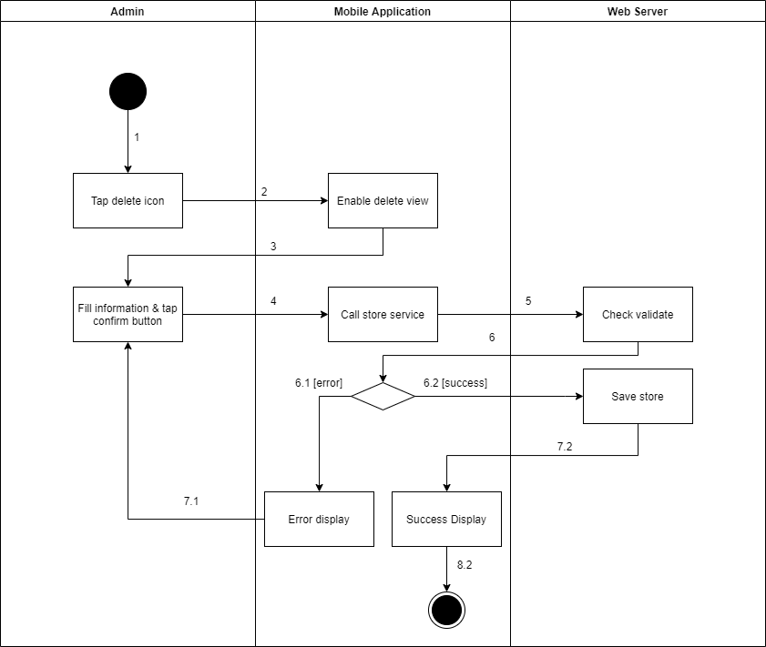

*Figure 1 - <Activity Diagram> Delete the stores*

###### d2.5 <Admin> Create new stores

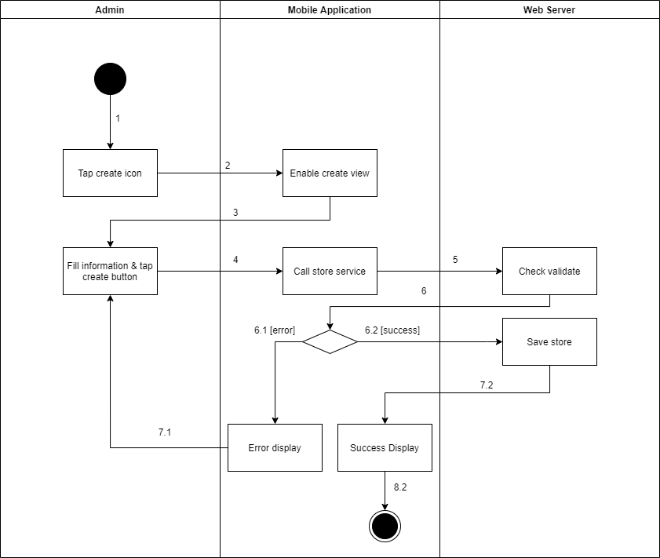

*Figure 1 - <Activity Diagram> Create new stores*

###### d2.6 <Admin> Get the managers

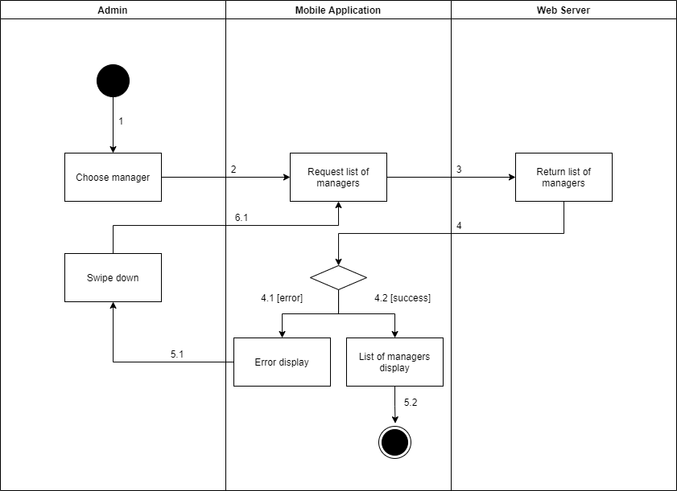

*Figure 1 - <Activity Diagram> Get the managers*

###### d2.7 <Admin> Get manager detail

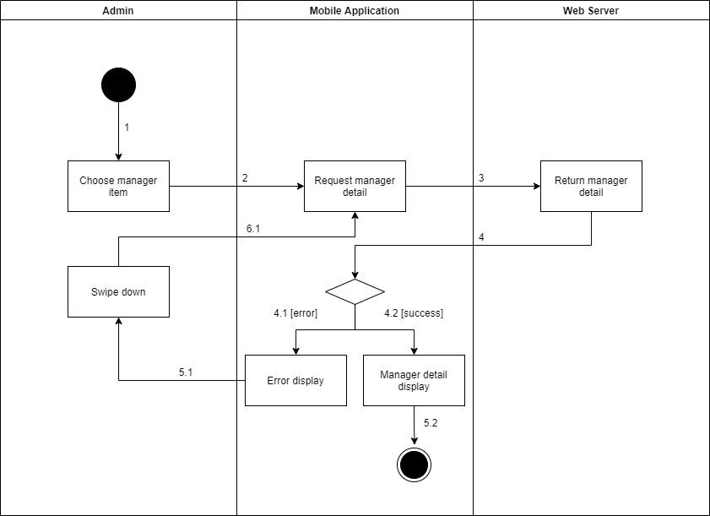

*Figure 1 - <Activity Diagram> Get manager detail*

###### d2.8 <Admin> Update the stores

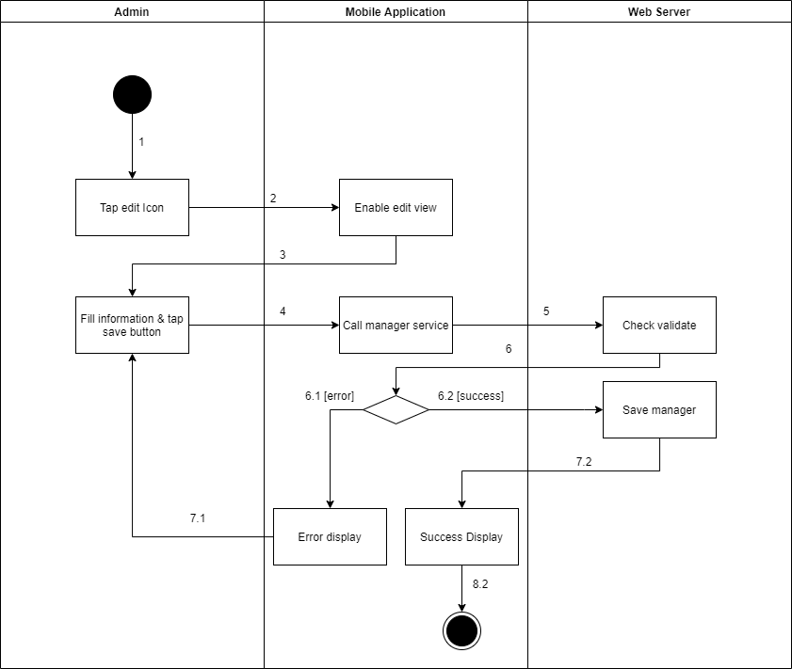

*Figure 1 - <Activity Diagram> Update the stores*

###### d2.9 <Admin> Delete the stores

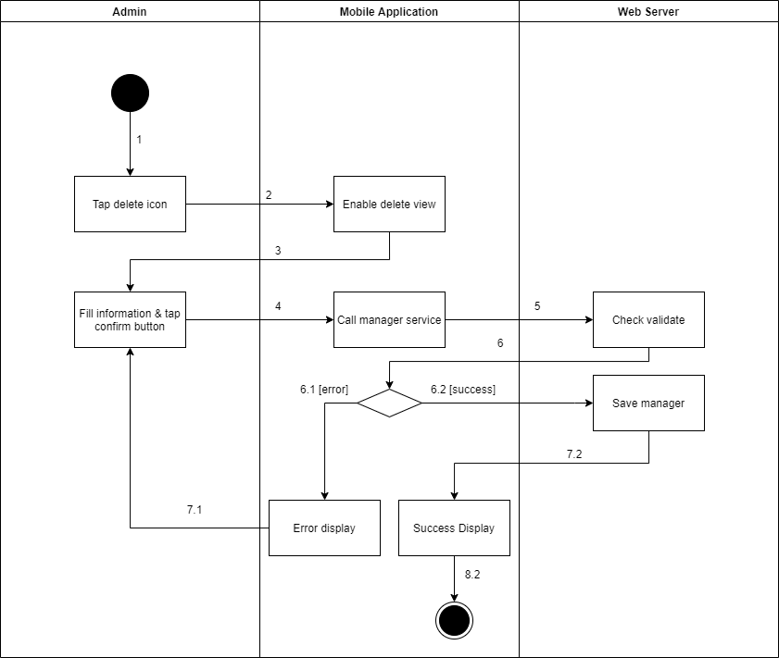

*Figure 1 - <Activity Diagram> Delete the stores*

###### d2.10 <Admin> Create new stores

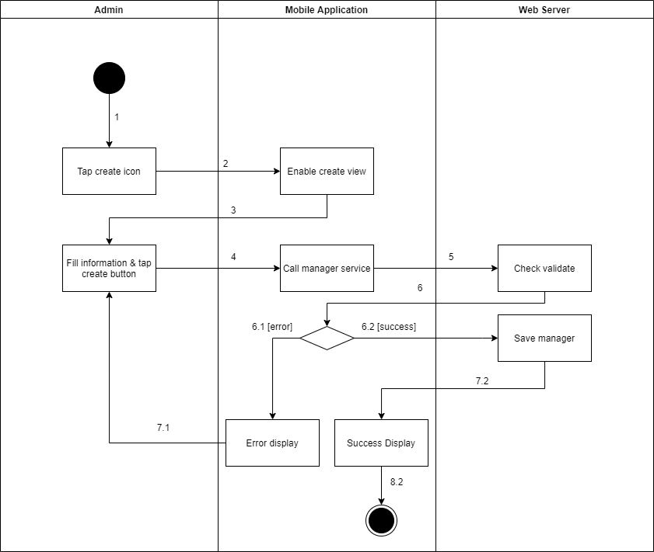

*Figure 1 - <Activity Diagram> Create new stores*

###### d2.11 <Admin> Update the product

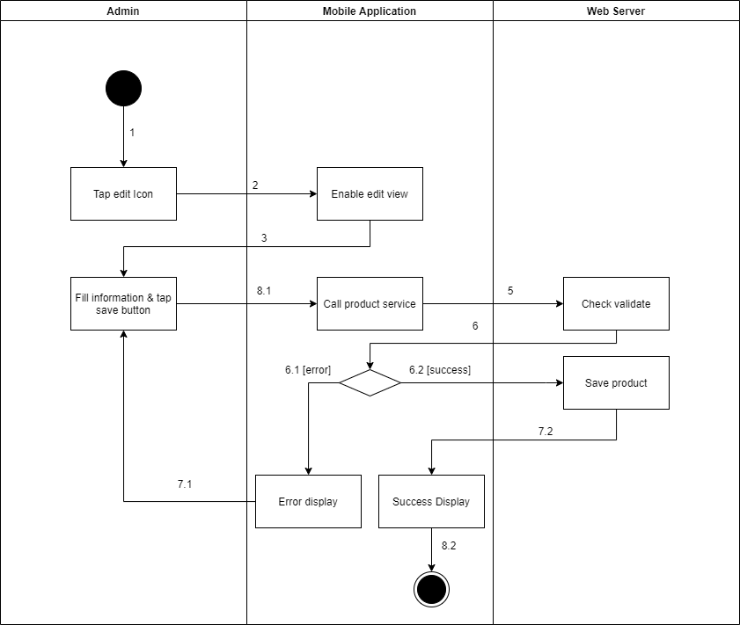

*Figure 1 - <Activity Diagram> Update the product*

###### d2.12 <Admin> Delete the product

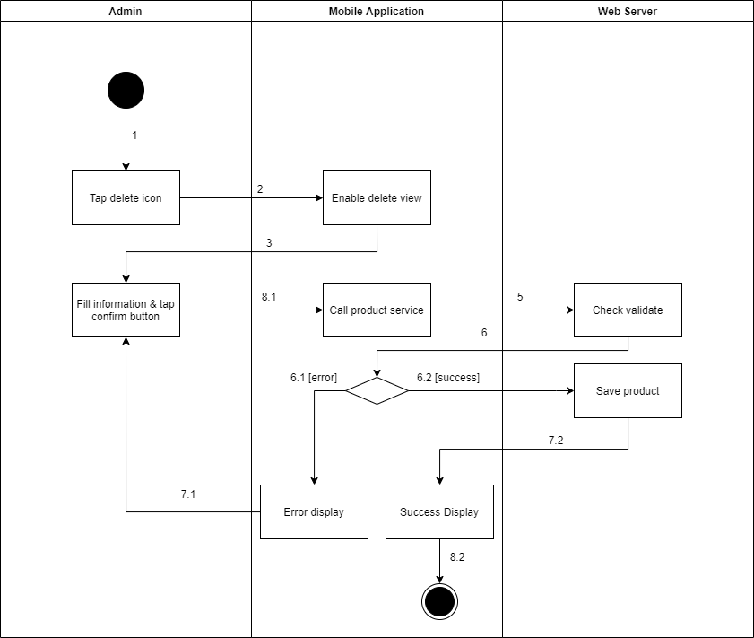

*Figure 1 - <Activity Diagram> Delete the product*

###### d2.13 <Admin> Create new product

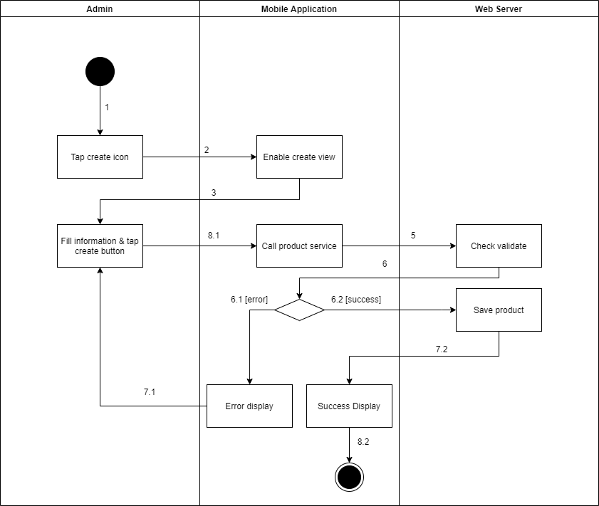

*Figure 1 - <Activity Diagram> Create new product*

###### d2.14 <Admin> Update the camera

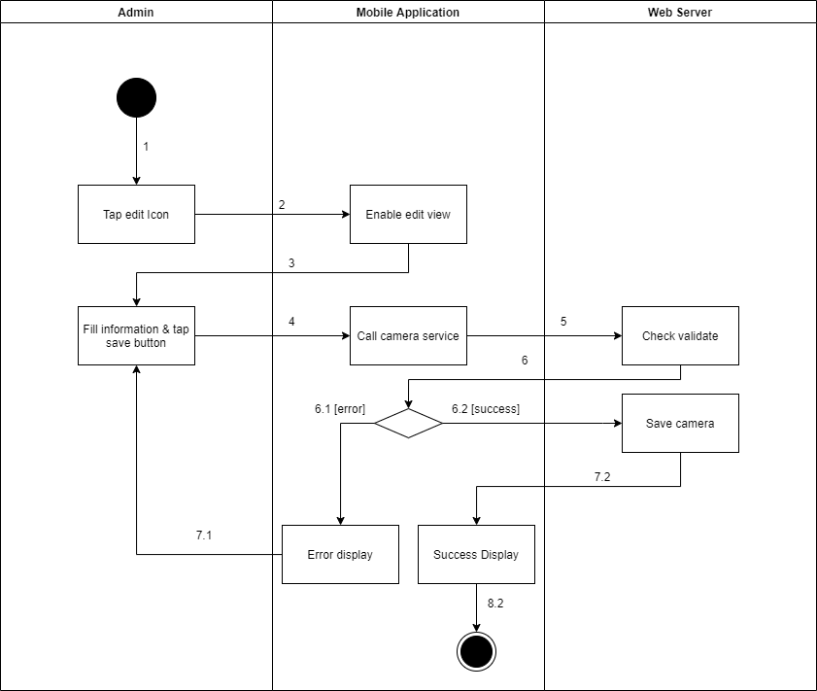

*Figure 1 - <Activity Diagram> Update the camera*

###### d2.15 <Admin> Create new camera

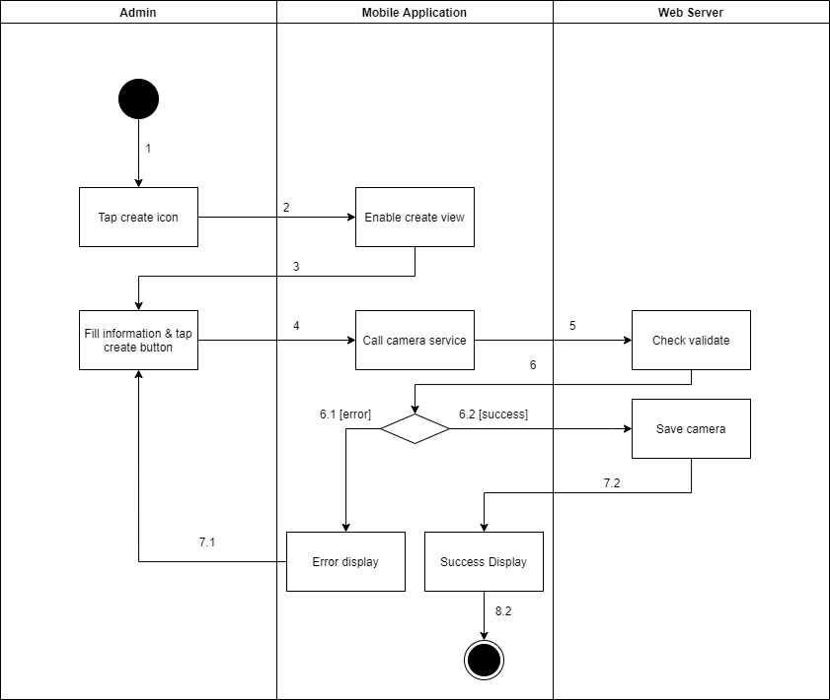

*Figure 1 - <Activity Diagram> Create new camera*

###### d2.16 <Admin> Delete the camera

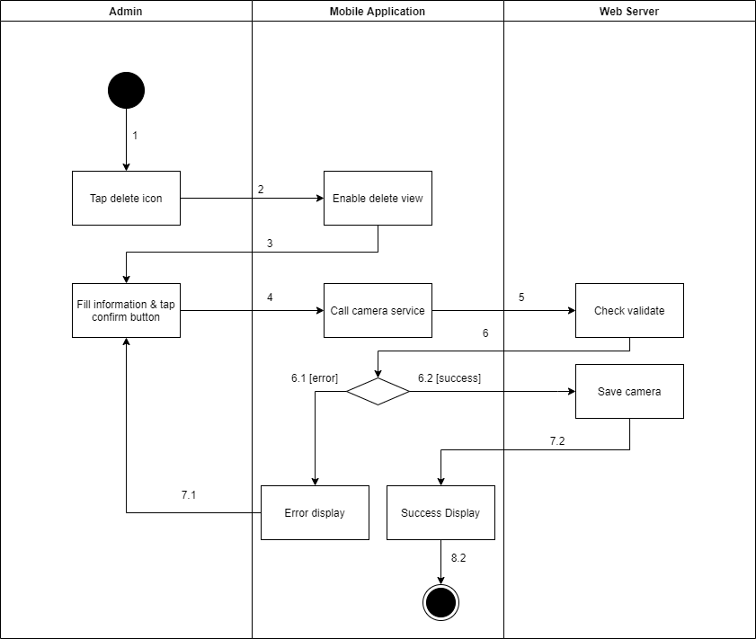

*Figure 1 - <Activity Diagram> Delete the camera*

###### d2.17 <Admin> Update the category

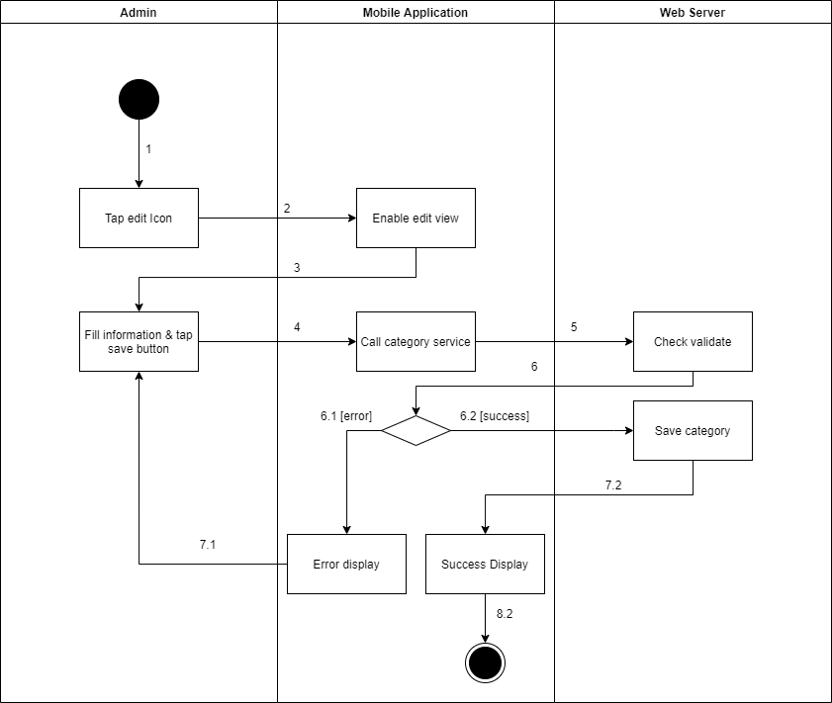

*Figure 1 - <Activity Diagram> Update the category*

###### d2.18 <Admin> Create new category

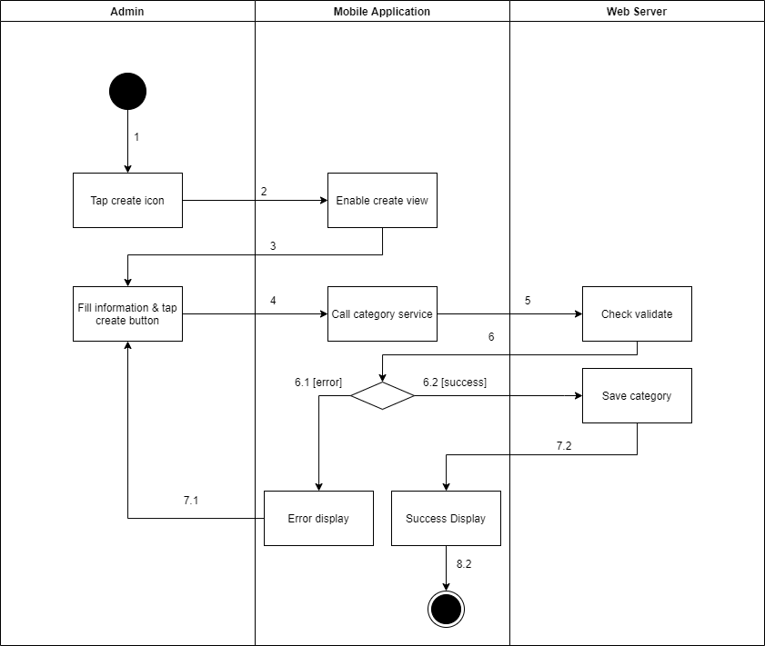

*Figure 1 - <Activity Diagram> Create new category*

##### d3 <Manager> Activity Diagram(s)

###### d3.1 <Manager> Get the shelve

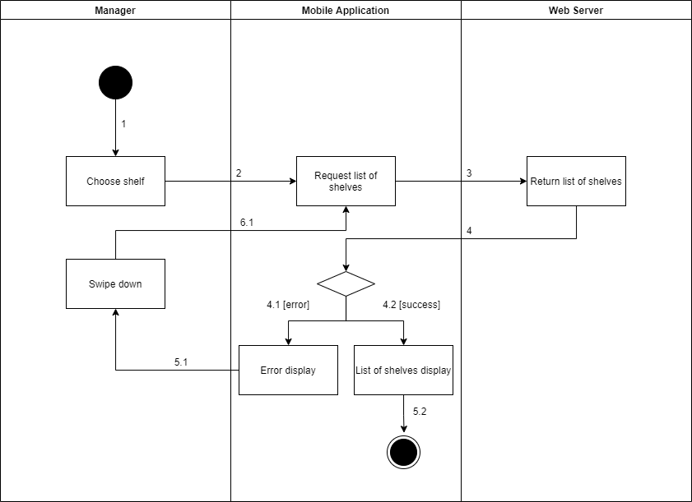

*Figure 1 - <Activity Diagram> Get the shelve*

###### d3.2 <Manager> Get shelf detail

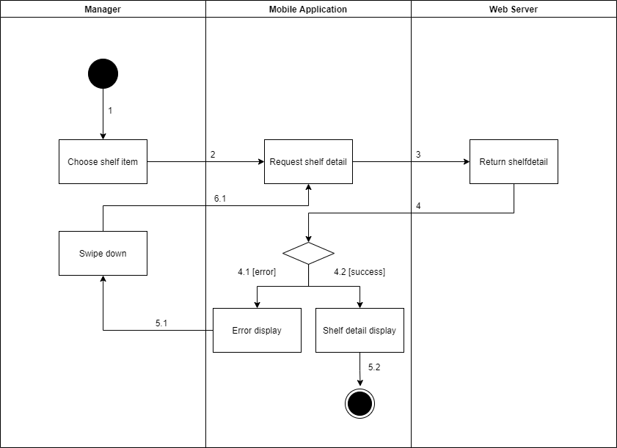

*Figure 1 - <Activity Diagram> Get shelf detail*

###### d3.3 <Manager> Update the shelf

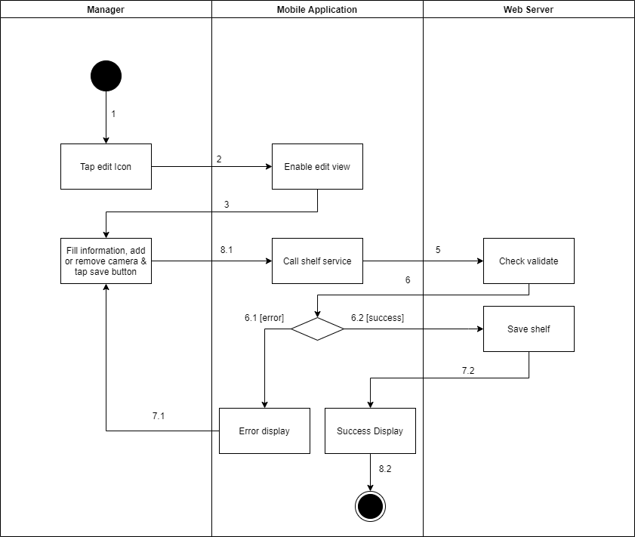

*Figure 1 - <Activity Diagram> Update the shelf*

###### d3.4 <Manager> Delete the shelf

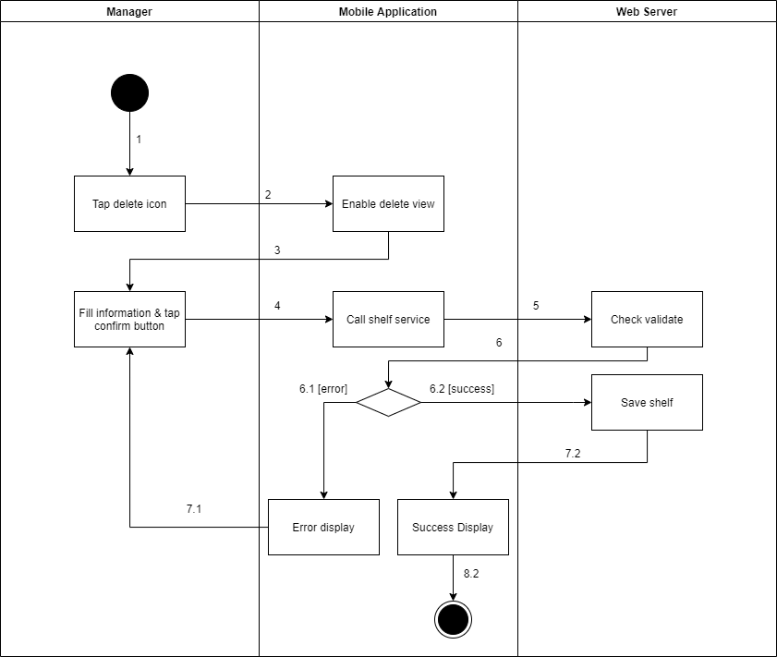

*Figure 1 - <Activity Diagram> Delete the shelf*

###### d3.5 <Manager> Create new shelf

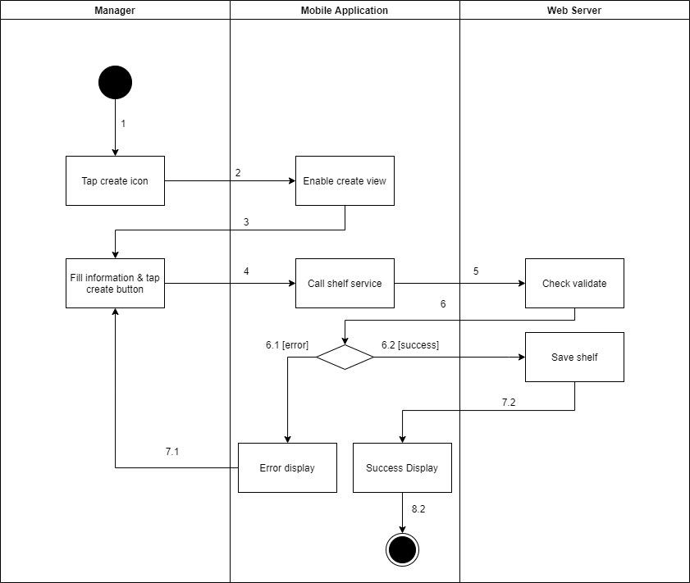

*Figure 1 - <Activity Diagram> Create new shelf*

###### d3.6 <Manager> Get the stacks

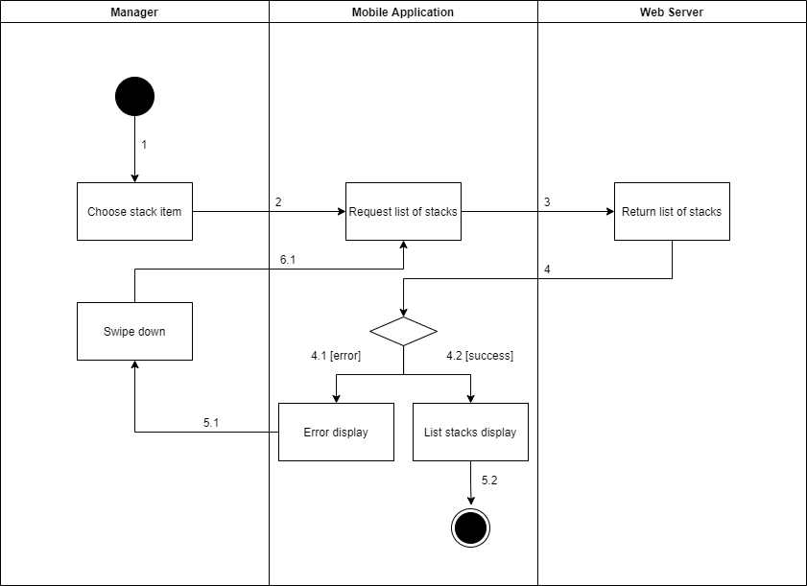

*Figure 1 - <Activity Diagram> Get the stacks*

###### d3.7 <Manager> Get stack detail

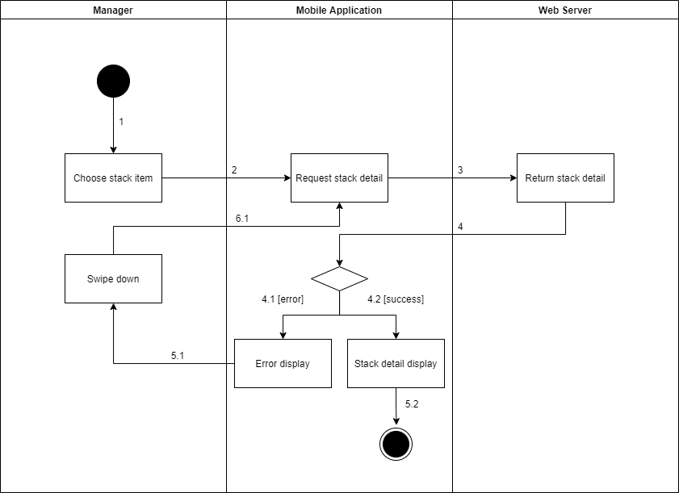

*Figure 1 - <Activity Diagram> Get stack detail*

###### d3.8 <Manager> Update the stack

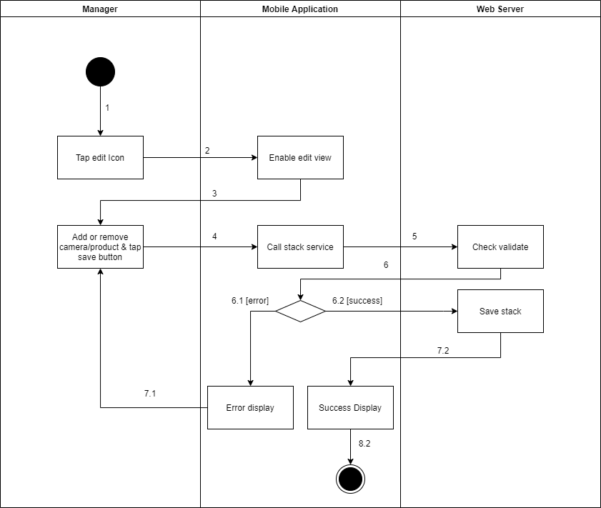

*Figure 1 - <Activity Diagram> Update the stack*

###### d3.9 <Manager> Delete the stack

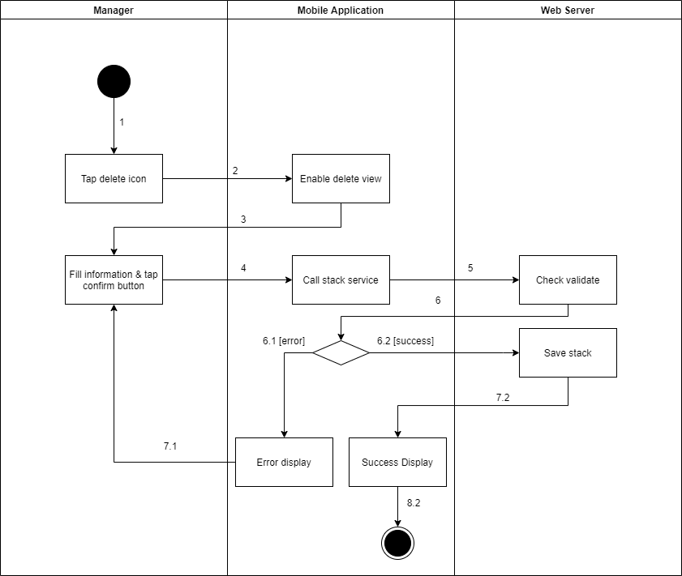

*Figure 1 - <Activity Diagram> Delete the stack*

###### d3.10 <Manager> Create new stack

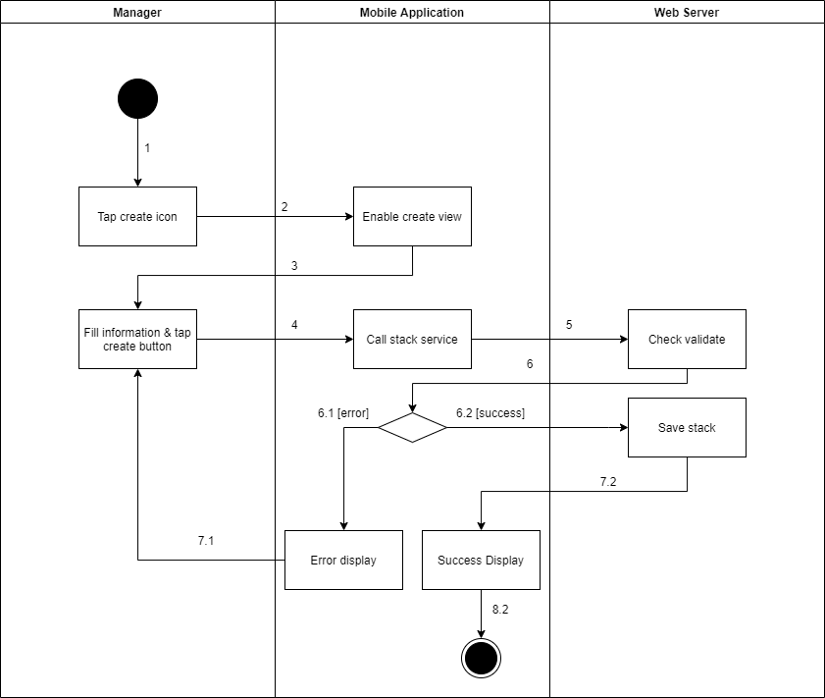

*Figure 1 - <Activity Diagram> Create new stack*

##### d4 <Authenticated User> Activity Diagram(s)

###### d4.1 <Authenticated User> Logout

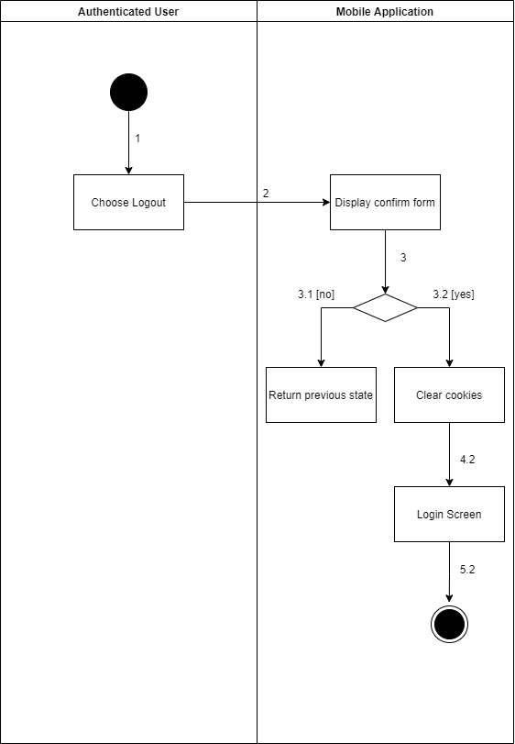

*Figure 1 - <Activity Diagram> Logout*

###### d4.2 <Authenticated User> Change account's password

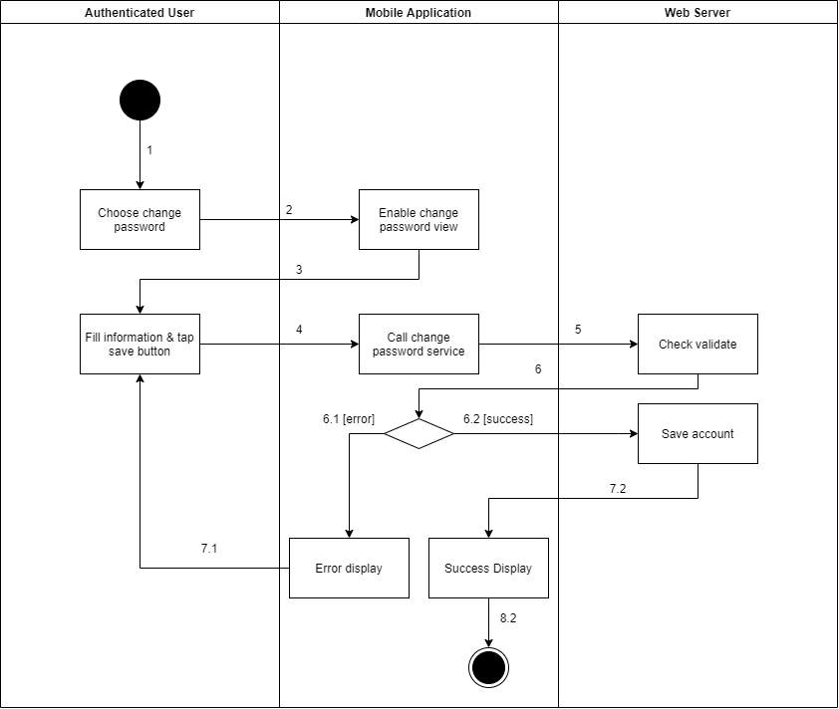

*Figure 1 - <Activity Diagram> Change account's password*

###### d4.3 <Authenticated User> Get the report

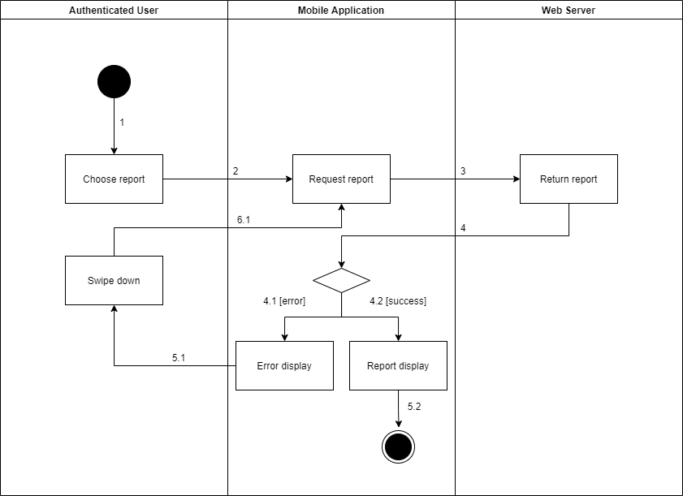

*Figure 1 - <Activity Diagram> Get the report*

###### d4.4 <Authenticated User> Export the report

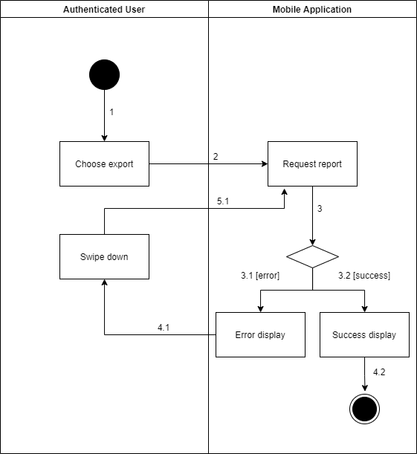

*Figure 1 - <Activity Diagram> Export the report*

###### d4.5 <Authenticated User> Get the video

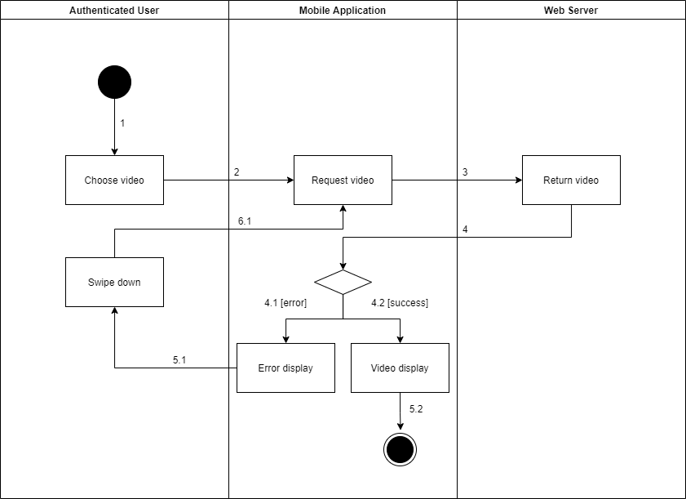

*Figure 1 - <Activity Diagram> Get the video*

###### d4.6 <Authenticated User> Get the products

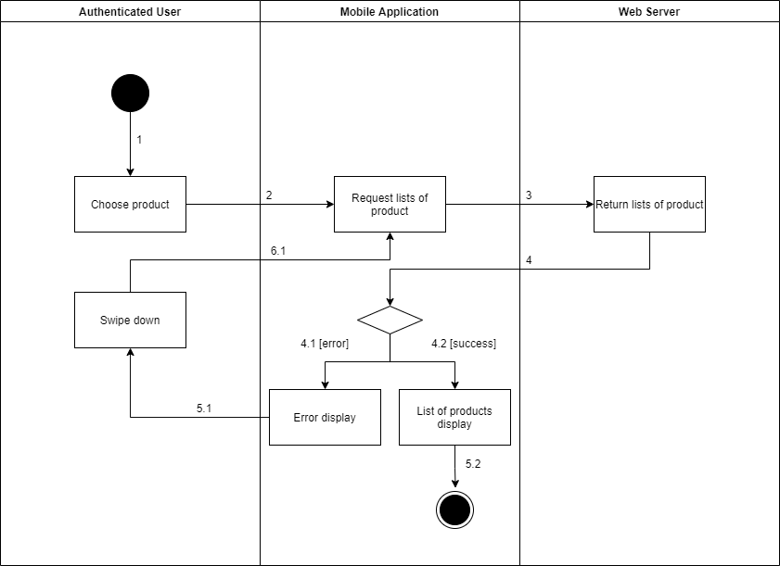

*Figure 1 - <Activity Diagram> Get the products*

###### d4.7 <Authenticated User> Get product detail

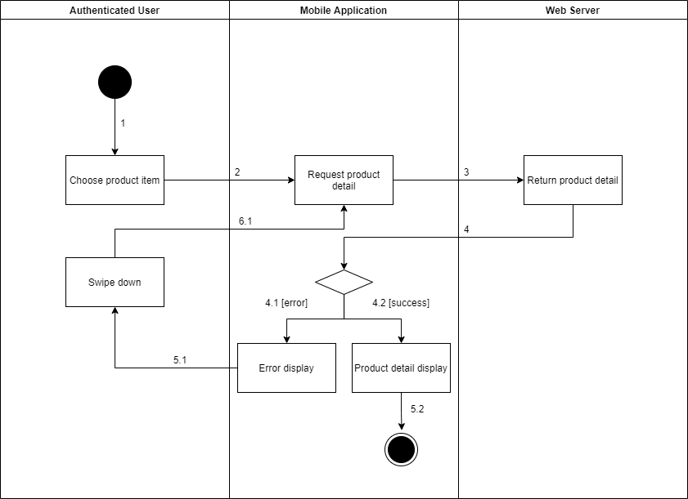

*Figure 1 - <Activity Diagram> Get product detail*

###### d4.8 <Authenticated User> Get the categories

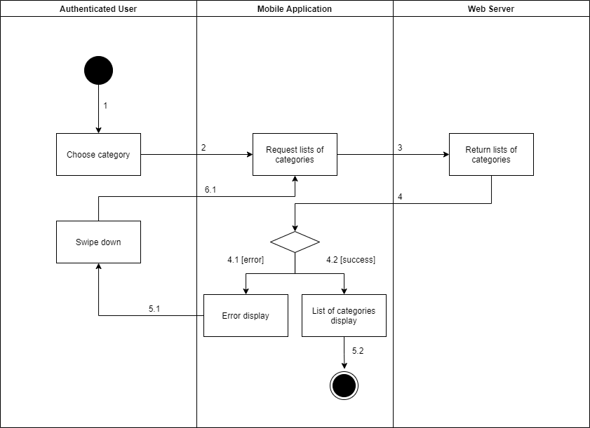

*Figure 1 - <Activity Diagram> Get the categories*

###### d4.9 <Authenticated User> Get category detail

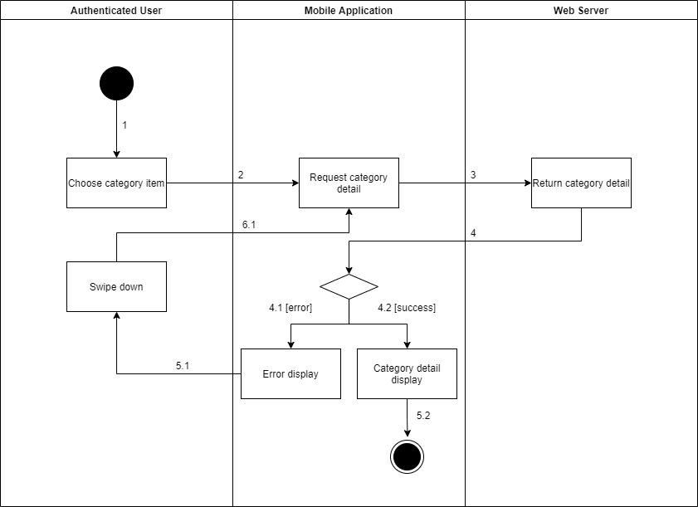

*Figure 1 - <Activity Diagram> Get category detail*

###### d4.10 <Authenticated User> Get camera detail

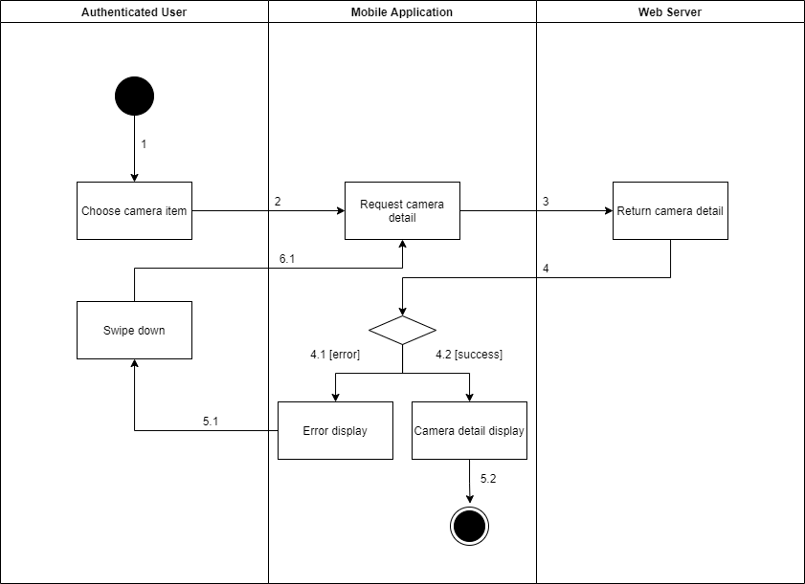

*Figure 1 - <Activity Diagram> Get camera detail*

###### d4.11 <Authenticated User> Get the cameras

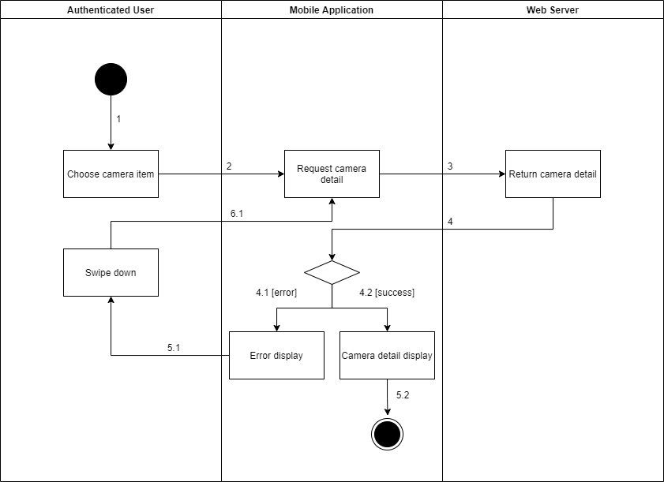

*Figure 1 - <Activity Diagram> Get the cameras*

## 4. Data & Database Design

### 4.1 Database Design

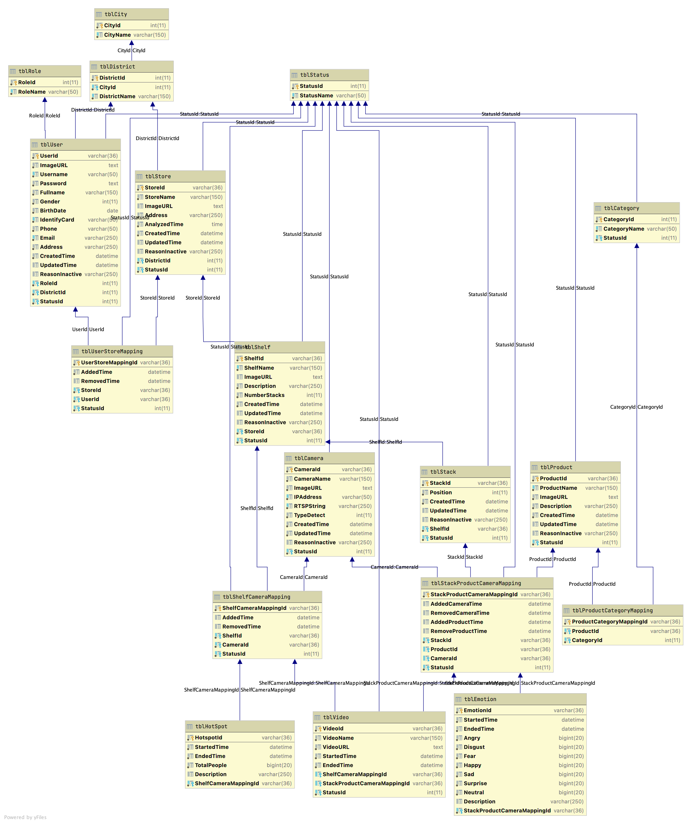

*Figure 1 – Database Design*

#### 3.1.1 tblCity

|  |  |  |  |  |  |  |
| --- | --- | --- | --- | --- | --- | --- |
| **Field name** | **Type** | **Size** | **Unique** | **Not Null** | **PK/FK** | **Notes** |
| CityId | int | 11 | Yes | Yes | PK |  |
| CityName | varchar | 150 | Yes | Yes |  |  |

#### 3.1.2 tblDistrict

|  |  |  |  |  |  |  |
| --- | --- | --- | --- | --- | --- | --- |
| **Field name** | **Type** | **Size** | **Unique** | **Not Null** | **PK/FK** | **Notes** |
| DistrictId | int | 11 | Yes | Yes | PK |  |
| CityId | int | 11 | Yes | Yes | FK |  |
| DistrictName | varchar | 150 | No | Yes |  |  |

#### 3.1.3 tblRole

|  |  |  |  |  |  |  |
| --- | --- | --- | --- | --- | --- | --- |
| **Field name** | **Type** | **Size** | **Unique** | **Not Null** | **PK/FK** | **Notes** |
| RoleId | int | 11 | Yes | Yes | PK |  |
| RoleName | varchar | 50 | Yes | Yes |  |  |

#### 3.1.4 tblStatus

|  |  |  |  |  |  |  |
| --- | --- | --- | --- | --- | --- | --- |
| **Field name** | **Type** | **Size** | **Unique** | **Not Null** | **PK/FK** | **Notes** |
| StatusId | int | 11 | Yes | Yes | PK |  |
| StatusName | varchar | 50 | Yes | Yes |  |  |

#### 3.1.5 tblUser

|  |  |  |  |  |  |  |
| --- | --- | --- | --- | --- | --- | --- |
| **Field name** | **Type** | **Size** | **Unique** | **Not Null** | **PK/FK** | **Notes** |
| UserId | varchar | 36 | Yes | Yes | PK |  |
| ImageURL | text |  | No | Yes |  |  |
| UserName |  |  | Yes | Yes |  |  |
| Password |  |  | No | Yes |  |  |
| Fullname |  |  | No | Yes |  |  |
| Gender |  |  | No | Yes |  |  |
| BirthDay |  |  | No | Yes |  |  |
| IdentifyCard |  |  | Yes | Yes |  |  |
| Phone |  |  | No | Yes |  |  |
| Email |  |  | Yes | Yes |  |  |
| Address |  |  | No | Yes |  |  |
| CreatedTime |  |  | No | Yes |  |  |
| UpdatedTime |  |  | No | No |  |  |
| ReasonInactive |  |  | No | No |  |  |
| RoleId |  |  | Yes | Yes | FK |  |
| DistrictId |  |  | Yes | Yes | FK |  |
| StatusId |  |  | Yes | Yes | FK |  |

#### 3.1.5 tblStore

|  |  |  |  |  |  |  |
| --- | --- | --- | --- | --- | --- | --- |
| **Field name** | **Type** | **Size** | **Unique** | **Not Null** | **PK/FK** | **Notes** |
| StoreId | varchar | 36 | Yes | Yes | PK |  |
| StoreName |  |  | Yes | Yes |  |  |
| ImageURL |  |  | No | No |  |  |
| Fullname |  |  | No | Yes |  |  |
| Gender |  |  | No | Yes |  |  |
| BirthDay |  |  | No | Yes |  |  |
| IdentifyCard |  |  | Yes | Yes |  |  |
| Phone |  |  | No | Yes |  |  |
| Email |  |  | Yes | Yes |  |  |
| Address |  |  | No | Yes |  |  |
| CreatedTime |  |  | No | Yes |  |  |
| UpdatedTime |  |  | No | No |  |  |
| ReasonInactive |  |  | No | No |  |  |
| RoleId |  |  | Yes | Yes | FK |  |
| DistrictId |  |  | Yes | Yes | FK |  |
| StatusId |  |  | Yes | Yes | FK |  |